CHUTE Match Intelligence Terminal

System Design Proposal

STATUS  [Draft / Proposed / Approved] |  | OWNER  [Team Name] |  | LAST UPDATED  [Month, DD, YYYY]

Authors | [Name(s)]
Reviewers | [Reviewer names, roles, or groups]
Related docs | [Link to related docs]
Scope | [One-sentence description of what this design covers]

1. Abstract
CHUTE is a Telegram-native football quiz and match-intelligence product. It converts validated TxLINE snapshots into shared questions, scores against a frozen participant snapshot, ranks participants and optionally anchors a proof memo on Solana.
The proposed terminal component layer changes presentation and interaction without changing scoring, snapshot, proof or fail-closed guarantees.

2. Goals and Non-Goals
Goals | Non-goals
[Goal 1: measurable outcome this design must achieve] | [Non-goal 1: explicitly excluded capability or outcome]
[Goal 2: reliability, scale, security, or user outcome] | [Non-goal 2: adjacent problem deferred to a later phase]
[Goal 3: required platform, policy, or operational capability] | [Non-goal 3: unsupported workflow, audience, or interface]
[Goal 4: rollout, reversibility, or blast-radius constraint] | [Non-goal 4: guarantee the design cannot or will not provide]

Goals: premium mobile terminal feel; evidence-backed metrics; accessible interactions; preserved replay, predictive, ranking, wallet and proof contracts.
Non-goals: replacing the backend contract, fabricating live data, enabling real-money wagering, or copying third-party branding.
3. Background and Problem Statement

CHUTE has strong product mechanics and a consolidated Neo Arcade CSS system, but the current visual language is more arcade than analytical. The reference demonstrates a higher level of hierarchy, density and mobile interaction polish.

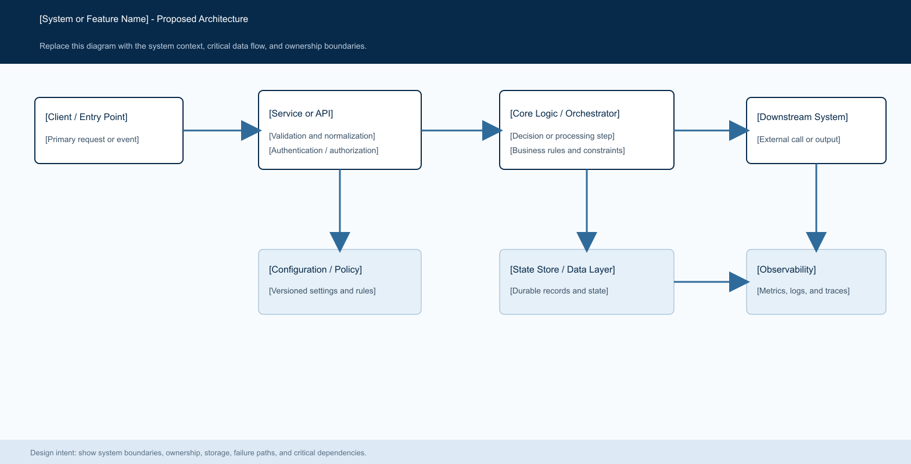
The design principle is: one dominant metric, one decisive action and one visible evidence state per screen.

4. Proposed Architecture

Component | Responsibility | Primary storage | Failure behavior
[Component A] | [Describe its responsibility, inputs, and outputs.] | [Primary datastore or dependency] | [Describe behavior when this component fails.]
[Component B] | [Describe the core decision or processing responsibility.] | [Configuration, policy, or metadata store] | [Describe fail-open, fail-closed, or fallback behavior.]
[Component C] | [Describe downstream execution and response handling.] | [Queue, cache, adapter, or service dependency] | [Describe timeout, retry, and terminal failure behavior.]
[Component D] | [Describe durable state, audit, or lifecycle responsibilities.] | [Primary operational datastore] | [Describe write failure and recovery behavior.]
[Component E] | [Describe metrics, logs, traces, and alerting responsibilities.] | [Telemetry and analytics backend] | [Describe degraded-mode monitoring and escalation.]

Telegram Mini App → TerminalShell → MatchHeader/MetricHero, SignalChart, ThesisCard/QuizStepper, RevealCard, RankingRail and ProofCapsule/WalletSheet. The API and TxLINE worker remain the source of truth.
- Figure 1. Proposed CHUTE Match Intelligence Terminal architecture.
- Core components
- TerminalShell; MetricHero; SignalChart; ThesisCard; QuizStepper; RevealCard; ProofCapsule; RankingRail.
- 5. Request Lifecycle
- The client loads fixture insights and quiz metadata.
- The API validates authentication, snapshot completeness and tier availability.
- The session freezes the snapshot/content hash before scoring.

The API returns one question, validates the answer and writes the idempotent ledger.

Completion returns score, ranking and proof metadata before optional anchor side effects.

Field | Type | Required | Description
field_name_1 | [Type] | [Yes / No] | [Describe meaning, validation, ownership, and lifecycle.]
field_name_2 | [Type] | [Yes / No] | [Describe the source and permitted values.]
field_name_3 | [Type] | [Yes / No] | [Describe versioning or compatibility requirements.]
field_name_4 | [Type] | [Yes / No] | [Describe relationship to other identifiers or records.]
field_name_5 | [Type] | [Yes / No] | [Describe privacy, retention, or audit constraints.]
field_name_6 | [Type] | [Yes / No] | [Describe array, object, or nested structure semantics.]
field_name_7 | [Type] | [Yes / No] | [Describe how this field affects system behavior.]

The client displays final state and operational status.

- 6. API and Data Contracts
- Primary data contract
- The existing API remains authoritative for fixture, snapshot, quiz, answer, result, ranking, predictive progress, wallet and anchor metadata.
- Contract guarantees
Question order is shared and stable.
Answer requests are idempotent by request ID.

Snapshot and content hash are captured for replay.

UI is not a source of truth for metrics.
Scenario | Expected behavior | Reasoning
[Duplicate, replayed, or repeated input] | [Describe the stable response and state transition.] | [Explain how duplicate work or side effects are prevented.]
[Required write or dependency fails] | [Describe the error, retryability, and side-effect behavior.] | [Explain why the failure mode is safe and observable.]
[Timeout, partial failure, or downstream error] | [Describe retry, fallback, and budget behavior.] | [Explain how auditability and consistency are maintained.]
[Configuration changes during execution] | [Describe which version remains authoritative.] | [Explain how mid-request behavior changes are prevented.]

The versioned interface definition is published at

- the existing API routes and backend models; update them with each contract release.
- 7. Consistency, Idempotency, and Replay
- Participant sessions score against a frozen snapshot. Predictive answers remain frozen until TxLINE resolution. Ranking is durable and replayable from SQLite state.
- 8. Security and Privacy Considerations
- Keep Telegram identity and wallet boundaries explicit.

Do not ship secrets or RPC credentials to the client.
Signal | SLO or alert | Owner | Launch gate
[Success or completion rate] | [Target, measurement window, and page threshold] | [Owning team] | [Required / Recommended]
[Latency or processing time] | [Percentile target, alert threshold, and duration] | [Owning team] | [Required / Recommended]
[Fallback, retry, or error rate] | [Warning and paging thresholds by workload class] | [Owning team] | [Required / Recommended]
[Configuration or deployment drift] | [Condition that indicates unsafe divergence] | [Owning team] | [Required / Recommended]
[Recovery, replay, or integrity check] | [Synthetic or sampled validation cadence and target] | [Owning team] | [Required / Recommended]
Rollout constraint: [Describe dry-run, canary, feature-flag, validation, rollback, and promotion requirements before production launch.]

Treat proof metadata as public audit data and minimize personal data in memos.

Alternative | Why it was considered | Why it was not selected
[Alternative 1] | [Describe the main benefit or reason to consider it.] | [Describe the decisive tradeoff or unmet requirement.]
[Alternative 2] | [Describe the relevant capability or simplicity.] | [Describe added complexity, risk, cost, or scope.]
[Alternative 3] | [Describe the potential performance or product benefit.] | [Describe explainability, maturity, or operational concerns.]
[Alternative 4] | [Describe the consistency or implementation appeal.] | [Describe the technical boundary that makes it unsuitable.]

Keep ingest and administrative routes authenticated.
- Maintain clear devnet/paper labels.
- 9. Operational Readiness
- Run front-end tests/builds and backend tests with the complete dependency set. Monitor missing data, rejected answers, resolution latency and anchor failures.
- 10. Alternatives Considered

A full visual-kit replacement was rejected because it would erase Neo Arcade identity. CSS-only motion is insufficient for coordinated layout/reveal transitions. A full charting platform is deferred; Recharts is sufficient for the first evidence-backed charts.
[State the recommended decision and summarize the implementation sequence. Name the first milestone, the validation or dry-run stage, the initial production audience, and the conditions that must be met before broader rollout.]
Milestone | Deliverable | Exit criteria
M1 | [Foundational implementation or dry-run capability] | [Measurable evidence that the foundation works safely]
M2 | [Validation, tooling, migration, or audit capability] | [Acceptance test or reconstruction criteria]
M3 | [Limited production rollout] | [Stability period and severity threshold]
M4 | [Broader customer or workload rollout] | [SLOs met, rollback tested, and approvals complete]

Use footnotes for definitions, assumptions, or terms that need precision without interrupting the main narrative.

