CS 148 Database Design for the Web
Drew Guild
Assignment Four
Personal Blog: Burlington Adventures
Version <1.0>

Time Log
Date | Time Spent (in hours) |  | Description
10/7/13 | 3.0 |  | First Version of Software Requirements
10/09/13 | 2 |  | Updated Software Requirements
10/15/13 | 0.5 |  | Create pages, enter schema
10/15/13 | 2 |  | Develop register.php
10/16/13 | 1 |  | Style site layout
10/17/13 | 1 |  | Develop post retrieval system
10/20/13 | 3 |  | Develop make-entry.php
10/20/13 | 1 |  | Debug post retrieval system
10/22/13 | 2 |  | Create/develop categories/retrieval by category option
10/27/13 | 1 |  | Final touch ups
10/28/13 | 0.5 |  | Enter some posts
 | 17 |  | Total time

Table Of Contents
Software Requirements Specifications 10
Introduction 10
Purpose 10
Definitions, acronyms, and abbreviations 10
Overview 10
Overall Description 11
Data Dictionary 11
E-R Diagram 11
Schema 11
Story Board 11
Specific requirements 11

Software Requirements Specifications

Introduction

Purpose
The purpose of this document is to describe the requirement specification for the web site “Burlington Adventures”, a personal blog to serve as a journal.

Definitions, acronyms, and abbreviations
HTML – Hypertext markup language – used to define your conent.
PHP – Personal Home Page – language that helps to customize html.
CSS – Cascading Style Sheets – used to define the look of a web site.
W3 Validation – refers to both Html and CSS validation tool provided by the W3c.org. the html validator is located at:
http://validator.w3.org/
with the CSS validator located at:
http://jigsaw.w3.org/css-validator/

Overview
The rest of this document contains an overall description of the Burlington Adventures web site.

Overall Description
Burlington Adventures is a blog in the style of a personal journal. It should chronologically log separate entries about locales and events in the greater Burlington, Vt area. The main page is a list of entries that visitors of the site can view. There should also be a page of pictures, which can be filtered by category. The site should also include a page for the blog administrator to enter new journal entries.

Data Dictionary

TblCategories
Field | Type | Null | Key | Default | Extra
pkCategoryID | INT | Not | PRI |  | auto-increment
fldCategoryName | VARCHAR | Not

TblEntries
Field | Type | Null | Key | Default | Extra
pkEntryID | INT | Not | PRI |  | auto-increment
fldEntryTitle | VARCHAR | Not
fldEntryDate | Date | Not
fldEntryText | TEXT | Not

E-R Diagram
Categories
Entries
CategoryID
CategoryName
EntryID
EntryTitle
Date
Text

Schema

CREATE TABLE tblCategories (
pkCategoryID INT(2) PRIMARY KEY NOT NULL AUTO_INCREMENT,
fldCategoryName VARCHAR(20) NOT NULL
);

CREATE TABLE tblEntries (
pkEntryID INT(3) PRIMARY KEY NOT NULL AUTO_INCREMENT,
fldEntryTitle VARCHAR(50) NOT NULL,
fldEntryDate DATE NOT NULL,
fldEntryText TEXT NOT NULL
);

CREATE TABLE tblCategoriesEntries (
fkCategoryID INT(2) NOT NULL REFERENCES tblCategories(pkCategoryID),
fkEntryID INT(3) NOT NULL REFERENCES tblEntries(pkEntryID),
PRIMARY KEY (fkCategoryID, fkEntryID)
);

Story Board
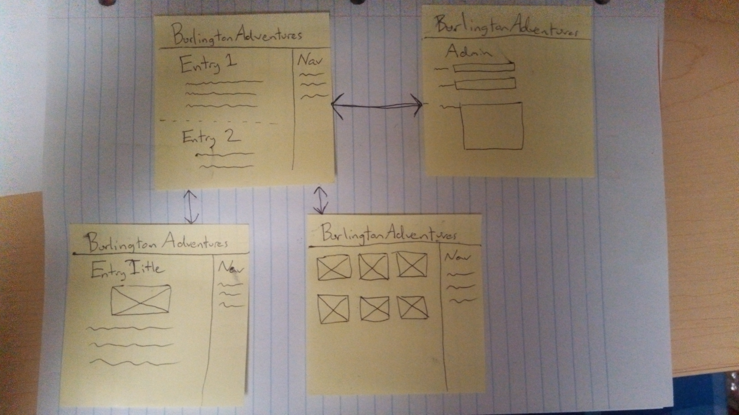

Specific requirements
Here is just a list of things I will require you really need to write the specific requirements as they relate to your project.
- Location – all files will be located at uvm.edu/~dguild/cs148/assignment4.1
- Html Validation – All pages will pass W3C Html validation for html 5.
- CSS Validation – All pages will pass W3C 3.0 CSS validation.
- Meta Information – All pages will contain a proper title tag, Meta tags (author, character set and description).
- CSS – all pages will have a linked style sheet.
- MySQL – the content of the site will be populated by data from a MySQL database
- PHP – The site will use PHP to retrieve data from the database and write the pages
- Pages:
  - Home – the landing page will be a list of snippets of entries which link to the individual entries
  - Entry – the entry page will be a single page that can be uniquely populated using php
  - Pictures – there will be a page that serves as a gallery of images
  - Admin – the admin page should allow the blog owner to insert new entries via a web form

