CS 148 Database Design for the Web
Matthew Beal & Drew Guild
Final Project
News Website
Version <1.0>

Time Log
Date | Time Spent (in hours) |  | Description
10/7/13 | 3.0 |  | First Version of Software Requirements
 |  |  | Your estimated time to complete assignment ______30___ hours
 | 1 |  | Update Project Specs
 | 2 |  | Set up git repos for Matt and Drew
 | 3 |  | Started register.php
 | 3 |  | Started submit.php
 | 1 |  | Started userlogin.php
 | 1 |  | Created include files
 | 0.5 |  | Created home, article, category page
 | 3 |  | Started edit.php
 | 1 |  | Revised userlogin
 | 0.5 |  | Revised header to show login, and logout ability
 | 1.5 |  | Revised form pages for authorization and validation checks
 | 2.5 |  | Revised submit for categories
 | 1 |  | Programmed home and category pages to retrieve appropriate data
 | 0.5 |  | Create delete.php
 | 1 |  | Create basic css
 | 2 |  | Tweak overall functionality
 | 0.5 |  | Tweak css
 | 27 |  | Total

Table Of Contents
Software Requirements Specifications 10
Introduction 10
Purpose 10
Definitions, acronyms, and abbreviations 10
Overview 10
Overall Description 11
Data Dictionary 11
E-R Diagram 11
Schema 11
Story Board 11
Specific requirements 11

Software Requirements Specifications

Introduction

Purpose
The purpose of this document is to describe the requirement specification for the web site “Matt's & Drew's World News”. This site will only news content (articles ,etc) regarding news stories that Matt and Drew find noteworthy.

Definitions, acronyms, and abbreviations
HTML – Hypertext markup language – used to define your conent.
PHP – Personal Home Page – language that helps to customize html.
CSS – Cascading Style Sheets – used to define the look of a web site.
W3 Validation – refers to both Html and CSS validation tool provided by the W3c.org. the html validator is located at:
http://validator.w3.org/
with the CSS validator located at:
http://jigsaw.w3.org/css-validator/

Overview
The rest of this document contains an overall description of the Matt's and Drew's World News web site.

Overall Description
Matt's and Drew's World News is supposed to be a mock news site. It will host imaginary news stories from a variety of topics (Politics, Sports, etc). News stories will be crowdsourced, so the site will allow users to register. Once registered, anyone can submit a news story.

Data Dictionary

tblCategory
Table comments: tblCategory
Column | Type | Null | Default | Comments | MIME
pkName | varchar(20) | No

tblNews
Table comments: tblNews
Column | Type | Null | Default | Links to | Comments | MIME
pkNewsId | int(5) | No
fldTitle | varchar(100) | No
fldContent | text | No
fldDate | timestamp | No | CURRENT_TIMESTAMP
fkEmail | varchar(50) | No |  | tblUser -> pkEmail

tblNewsCategory
Table comments: tblNewsCategory
Column | Type | Null | Default | Links to | Comments | MIME
fkNewsId | int(5) | No |  | tblNews -> pkNewsId
fkName | varchar(20) | No |  | tblCategory -> pkName

tblUser
Table comments: tblUser
Column | Type | Null | Default | Comments | MIME
pkEmail | varchar(50) | No
fldFirstName | varchar(20) | No
fldLastName | varchar(20) | No

E-R Diagram

Schema
SET SQL_MODE="NO_AUTO_VALUE_ON_ZERO";
SET time_zone = "+00:00";

CREATE TABLE IF NOT EXISTS `tblCategory` (
`pkName` varchar(20) NOT NULL,
PRIMARY KEY (`pkName`)
) ENGINE=InnoDB DEFAULT CHARSET=utf8;

CREATE TABLE IF NOT EXISTS `tblNews` (
`pkNewsId` int(5) NOT NULL AUTO_INCREMENT,
`fldTitle` varchar(100) NOT NULL,
`fldContent` text NOT NULL,
`fldDate` timestamp NOT NULL DEFAULT CURRENT_TIMESTAMP ON UPDATE CURRENT_TIMESTAMP,
`fkEmail` varchar(50) NOT NULL,
PRIMARY KEY (`pkNewsId`),
KEY `fkEmail` (`fkEmail`),
KEY `fkEmail_2` (`fkEmail`)
) ENGINE=InnoDB DEFAULT CHARSET=utf8 AUTO_INCREMENT=1 ;

CREATE TABLE IF NOT EXISTS `tblNewsCategory` (
`fkNewsId` int(5) NOT NULL,
`fkName` varchar(20) NOT NULL,
KEY `fkNewsId` (`fkNewsId`),
KEY `fkName` (`fkName`)
) ENGINE=InnoDB DEFAULT CHARSET=utf8;

CREATE TABLE IF NOT EXISTS `tblUser` (
`pkEmail` varchar(50) NOT NULL,
`fldFirstName` varchar(20) NOT NULL,
`fldLastName` varchar(20) NOT NULL,
PRIMARY KEY (`pkEmail`)
) ENGINE=InnoDB DEFAULT CHARSET=utf8;

ALTER TABLE `tblNews`
ADD CONSTRAINT `tblNews_ibfk_1` FOREIGN KEY (`fkEmail`) REFERENCES `tblUser` (`pkEmail`);

ALTER TABLE `tblNewsCategory`
ADD CONSTRAINT `tblNewsCategory_ibfk_2` FOREIGN KEY (`fkName`) REFERENCES `tblCategory` (`pkName`),
ADD CONSTRAINT `tblNewsCategory_ibfk_1` FOREIGN KEY (`fkNewsId`) REFERENCES `tblNews` (`pkNewsId`);

Story Board

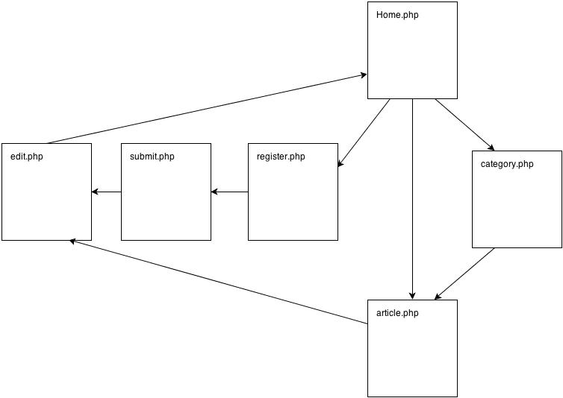

Specific requirements
Here is just a list of things I will require you really need to write the specific requirements as they relate to your project.
- Location – all files will be located in the public folder of your uvm account. The assignment web page and the submit process will detail the exact location. Failure to have your site located in the correct folder by the due dates will result in a zero on the assignment. Be sure to pay attention to the lowercase letters.
- Html Validation – All pages will pass W3C Html validation for html 5.
- CSS Validation – All pages will pass W3C 3.0 CSS validation.
- Meta Information – All pages will contain a proper title tag, Meta tags (author, character set and description).
- CSS – all pages will have a linked style sheet.
- Navigation – All pages will contain navigation to all other pages on the site.
- Browser compatibility - This site will be checked on Firefox, Safari, Chrome .
- Pages
  - home.php – Serves as landing page, displays recent articles and provides navigation to other parts of site
  - category.php – Displays articles by category
  - article.php – Displays specific articles
  - register.php - Allows users to register to write articles
  - submit.php – Allows users to submit articles
  - edit.php – Allows users to edit or delete articles

