* **Suitable workloads**:

The question about containers is whether or not they can be used for stateful apps, so apps that persist data.

A stateful app or a stateful service is one that absolutely has to remember stuff. Like if a stateful app stops or crashes or the nodes it’s running on dies, it has to come up without forgetting anything, and a database is the usual example.

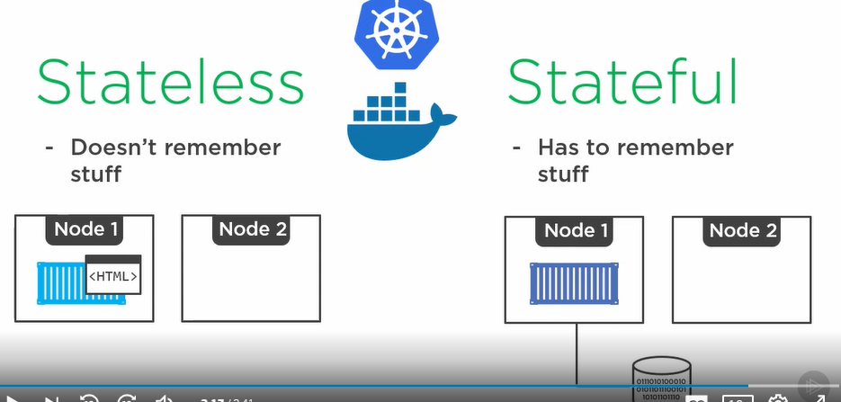

For that node uses volume.

Stateless applications don’t remember any stuff.

Hypervisor virtualization let us lift our existing applications from the physical world and drop them straight into the virtualized world.