**Containers:**

In Earlier days we were doing one app per server. Which brings upfront CapEx cost, also nobody ever knew how big or fast a server had to be.

So the Vmware came into picture. Instaed of dedicating one physical server to one lonely app, we could safely and securely run tons of apps on a single physical server.

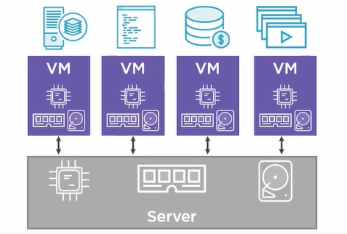

So to run 4 different apps on a single server we create 4 virtual machines, and each one is essentially a slice of the physical server’s hardware.

Each of these virtual machines need their very own dedicated operating system and steals a lot of underlying resources.

So the containers came into picture.

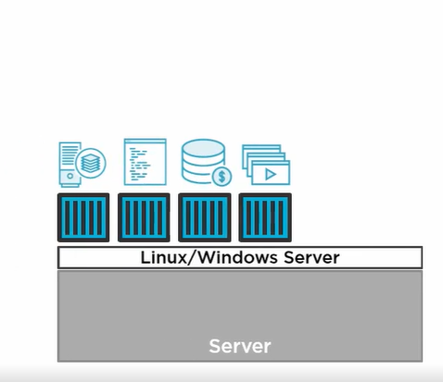

Containers are very light weight and consumes little underlying resources.

It only has one operating system.

To run container on deocker platform run below command.

$ docker container run –d –name web –p 8080:8080 nigelpoulton/ctr-demo:1