1. **Why Helm?**

If we want to install our application in k8s then we need to put the application in containers inside the pod. But that is not enough, you need more k8s objects for your application like service, Ingress, configmap, secrets, volumes etc.

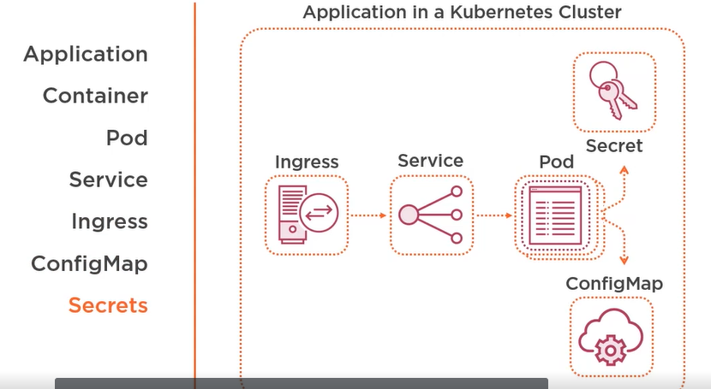

But how do we install those objects in k8s cluster? The entrypoint to k8s cluster is k8s API, which we can access either directly using REST client, or high level client such as GO client,or using command line tool Kubectl.

Limitations of not using Helm:

Packaging:

You define all these objects in yaml files .These objects are not deployed as single atomic objects rather as indivisual objects.

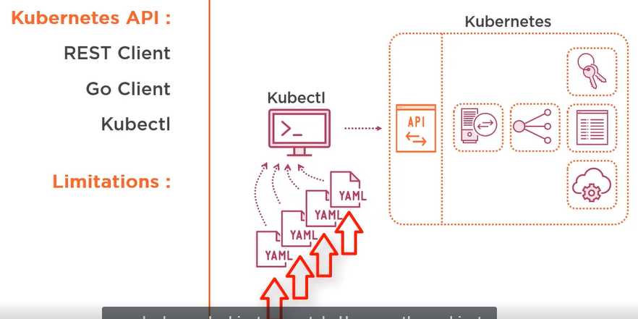

1. **What is Helm?**

Helm is package manager for K8s. When you have to deal with a lot of resources, source codes or binary files in computer science, you usually use packages. And when you have to deal with alot of packages which has dependencies, you need a package manager.

For eg. Maven is a package manager and jar,ear,war are packages.

Similarly Helm is a package manager and charts are packages.