* **Docker:**

Docker,Inc. company is a technology startup from san Francisco. And it’s the main sponsor behind the open source container technology with the same name.

Containers are like fast lightweight virtual machines, and docker makes running our apps inside of containers really easy.

We usually take code and build it into a Docker image.

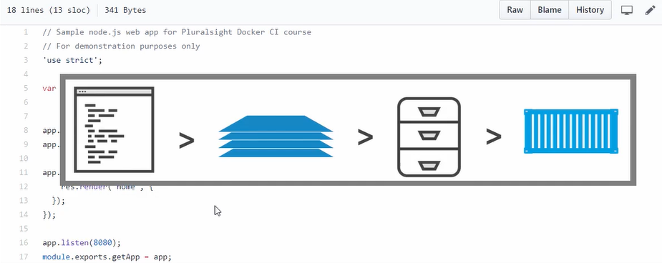

Now the image is like a stopped container, or maybe a template for how to build a container. So we build an image and push that to a registry.

After that we start a container from it, that’s easy.

To build a docker image:

$ docker image build –t nigelpoulton/ctr-demo:2 .

To push image to docker hub:

$ docker image push nigelpoulton/ctr-demo:2

To run container:

$ docker container run –d –name web –p 8080:8080 nigelpoulton/ctr-demo:2

* **Kubernetes:**

Docker at its core provides the mechanics for starting and stopping indivisual containers, which in the grand scheme of things, is pretty low-level stuff.

Kubernetes doesn’t care about low-level stuff like that. Kubernetes cares about high level stuff, like how many containers to run in, maybe which nodes to run them onto, and things like knowing when to scale them up or down or even how to update the containers without downtime.

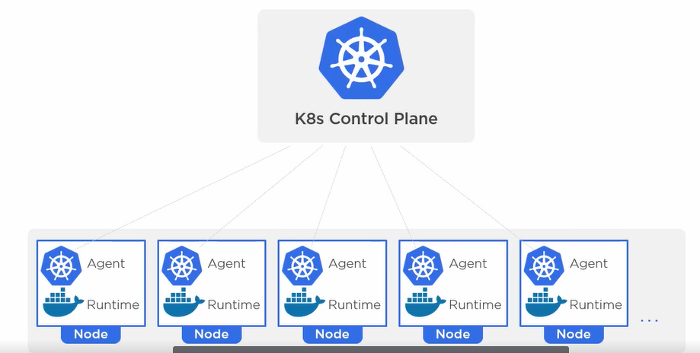

Each of the kubernetes nodes is running some k8s software and a container runtime. Usually the container runtime is docker but other also do exist.

Then sitting above this is the brain of kubernetes, the control plane.