**Ec2 Creation in terraform:**

To create EC2 instance define the below code in .tf files

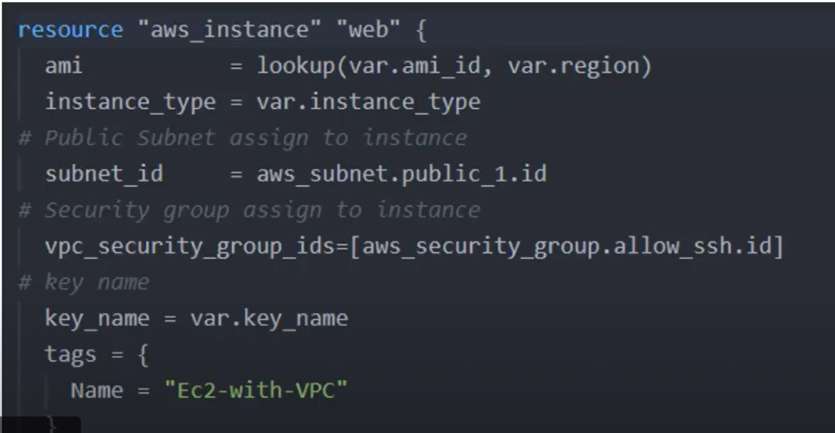

**Security Group:**

* Security Group is a firewall for Ec2 instance
* Security group controls how traffic allow into or out of Ec2 instance.
* 0.0.0.0 to allow for all outbound traffic.

To create security group consider below code:

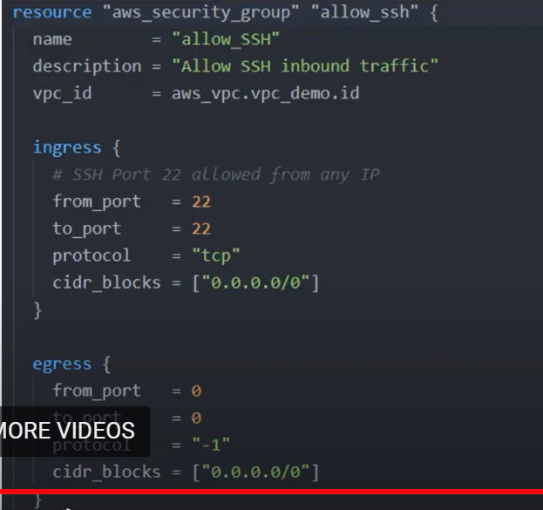

To create security group we need to define, name, description, and vpc_id. Apart from that we also need to define the ingress and egress rules. Ingress means inbound traffic and egress means outbound traffic.

**EBS:**

Amazon EBS allows you to create storage volumes and attach them to amazon EC2 instances, once attached you can create a file system on top of these volumes, run a database, or use them in any other way you would use a block device.

Amazon EBS volumes are placed in a specific availability zone, where they are automatically replicated to protect you from the failure of a single component.

* It is like a disk in the cloud.
* It gets attached to ec2 instance.
* You can have OS, database installed.
* You can attach multiple EBS device to a single ec2 instance.
* But you can’t attach one EBS to multiple instances.

You can create EBS volume using the below code.

