**Helm Functions and pipelines:**

There are 2 different syntaxes to achieve the same goal, namely, run simple logic in your template.

With the function syntax , you write the function name first, then the argument.

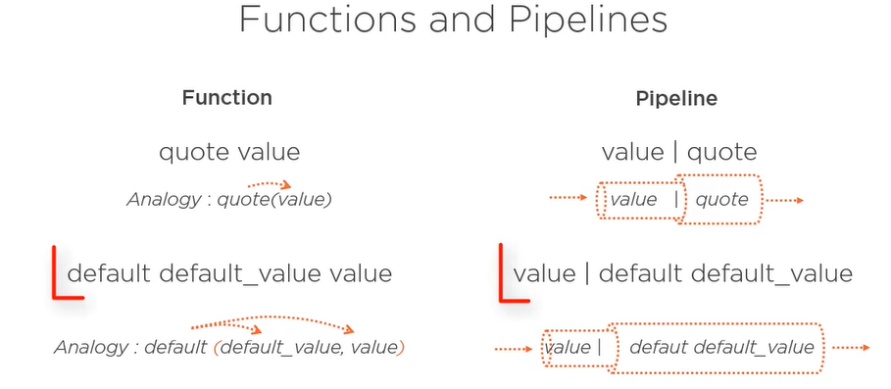

For eg. Quote value is a function that puts the value in quotes. Infact you can see that this syntax is similar to what you can in any function and language, but without the parenthesis.

Pipeline works the opposite way. You write the value first, and that value is trimmed from one pipe to another.

Both functions and pipeline can be used with more than one argument.

**Modifying Scope Using “With”:**

We saw that values are organized in a nested way. Sometimes you may want to work with a subset of values without repeating the complete path from the root to the value every time.

Here is how to do it using scopes. without specifying the scope or template looks like below :

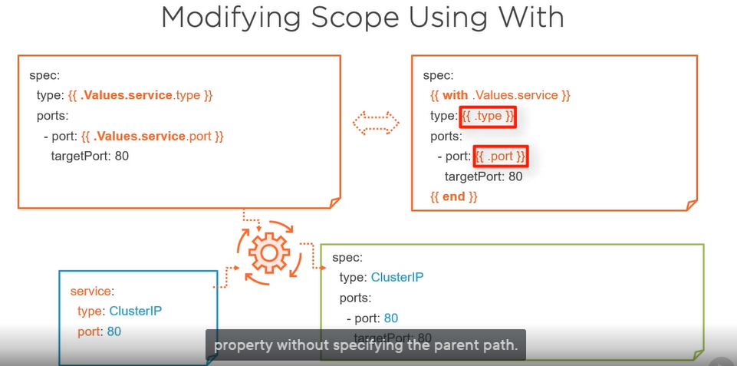

Each property is accessed from the root value, and you have to repeat the full path in each directive.

By defining the scope with the with function, you can restrict the scope to the service property. And from there, all properties are accessed relative to that service property without specifying the parent path.

The manifests generated by the two templates are the same.