1. **Helm chart structure**

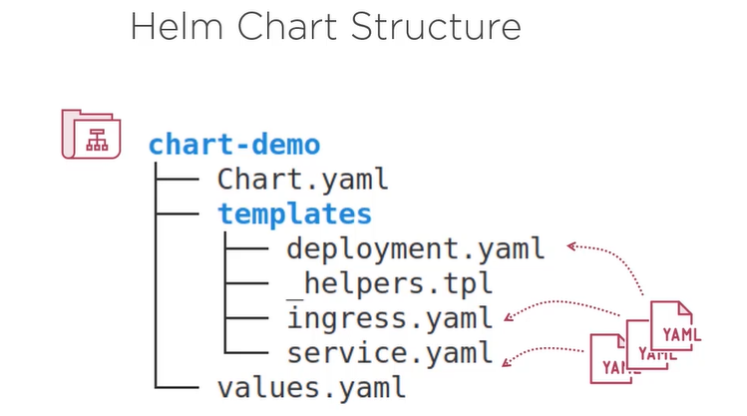

--By convention folder name has the name of the chart.

--The chart properties are stored in chart.yaml file. In it you can find the chart name, chart version and other metadata.

-- The templates subfolder contains your k8s object definition files, so your yaml files.

The chart can be documented in README markdown file. The License file which is optional , ofcourse contains the license of the chart.

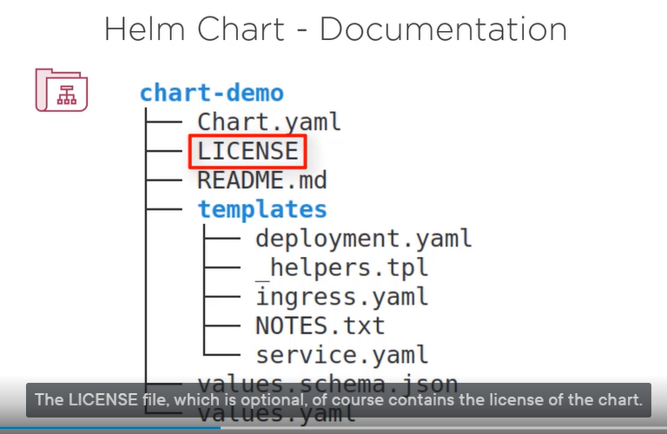

Helm commands:

* Install a release 🡪 helm install [release] [chart]
* Upgrade a release revision 🡪 helm upgrade [release][chart]
* Rollback to a release revision 🡪 helm rollback [release] [revision]
* Print release history 🡪 helm history [release]
* Display release status 🡪 helm status [release]
* Show details of a release 🡪 helm get all [release]
* Uninstall a release 🡪 helm uninstall [release]
* List releases 🡪 helm list

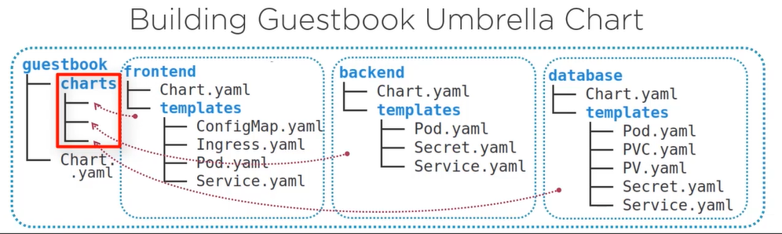

Then, those three charts are embedded into a wrapping guestbook chart.

This can be done by moving them into the charts subdirectory. That kind of chart is commonly named an umbrella chart.