JFrog:

First step of building software starts with development team. Every developer declares some dependencies while developing code. And use build tools like maven, gradle etc to build their code.

But from where do we get these dependencies?

If we don’t have binary repository manager in place then our outbound communication will look like below

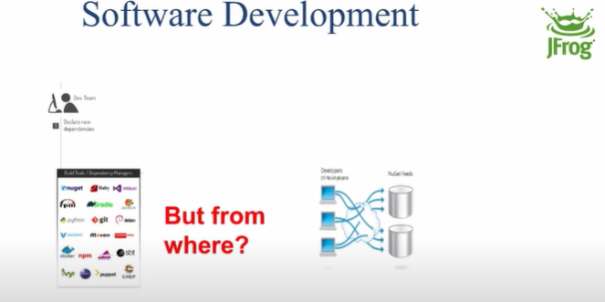

So all the developers will move to external repositories for these dependencies.

So there will be a security concern because we will not have any control on packages and versions we bring.

So here is what Artifactory comes into picture.

**What is artifact Repository?**

* It is a Binary repository manager, a place where you store all your binaries. Everything that is other than source code is kept inside Artifactory. It is like a git for your binaries.
* Main benefit of Artifactory is to manage the third party artifacts giving you the continuous integration, continuous delivery and deployment.
* It also proxies your central repository server, that way you can speed up your builds with local cache. It also allows your security team to see what kind of binaries are being used.

Setup:

In order to run maven projects, and publish our artifacts back into artifactory, we need to configure maven client w.r.t Artifactory.

We can set it up either directly through dashboard using set me up tab or go to the artifacts tab and click on set me up tab.

Go toparticular repository and there click on set me up tab and fill in various details as below:

