**Software build process:**

Building a software project typically consists of such tasks as writing the source code in an IDE, downloading dependencies, compiling source code into binary code, running tests, packaging compiled code into deployable artifacts such as JAR, WAR,APK and ZIP files, and deploying these artifacts to an application server or pushing them to repositories like Nexus, Jfrog to be used as dependency for other projects.

**Build Automation:**

It is the process of automating the creation of a software build and the associated processes including : compiling the source code into binary code, packaging binary code, running automated tests and deploying it.

**Continuous Integration:**

* Continuous Integration(CI) is a developmemt practice that requires developers to integrate code into a shared repository several times a day.
* Each check-in is then verified by an automated build, test, allowing teams to detect problems early.
* Integrate changes back to the main branch as often as possible.

**Continuous Testing:**

* Continuous testing is a software testing process that involves testing at every stage of the development life cycle.
* The goal of continuous testing is to evaluate the quality of the software as part of a continuous delivery process, by testing early and often.
* Automated testing is the essential backbone of all continuous engineering practices.

**Continuous Delivery:**

* Extension of Continuous Integration
* Automatic deployment of all code changes to a testing, QA, stage and/or production environment after the changes have been merged(after automated testing).
* Often times, the release to production may be managed by a release manager and governed by a compliance process to ensure organizational processes are being met.

**Continuous deployment:**

* Continuous deployment takes the process one step further than continuous delivery.
* Here, all the changes that pass the verification steps at each stage in the pipeline are released to production.

**Various CI/CD tools are:**

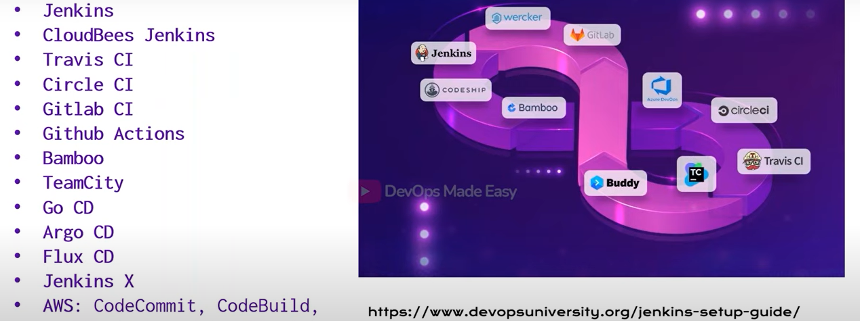

**GITOPS:**

Gitops is a deployment methodology centralized around a git repository, where any new code merged to a git repos triggera a deployment to various environments and clusters in real-time.

