**Jenkins Job Creation:**

To create a new job go to new item in Jenkins then select the project name and type as given below:

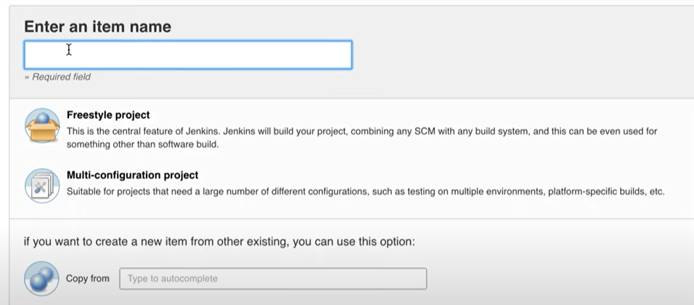

To configure the source code management we need plugins corresponding to it, so that we can give path of source code management from where to pull the code.

Build Triggers:

* Poll SCM: It means as soon as any new code gets checked in in SCM then build will get triggered automatically.
* Build periodically: In this we provide some expression and based on that expression our build gets triggered at some particular time intervals.

After we are done with configurations, we can build our job and if the output is blue it means a success, if red then failure , if grey means not executed even once as shown below:

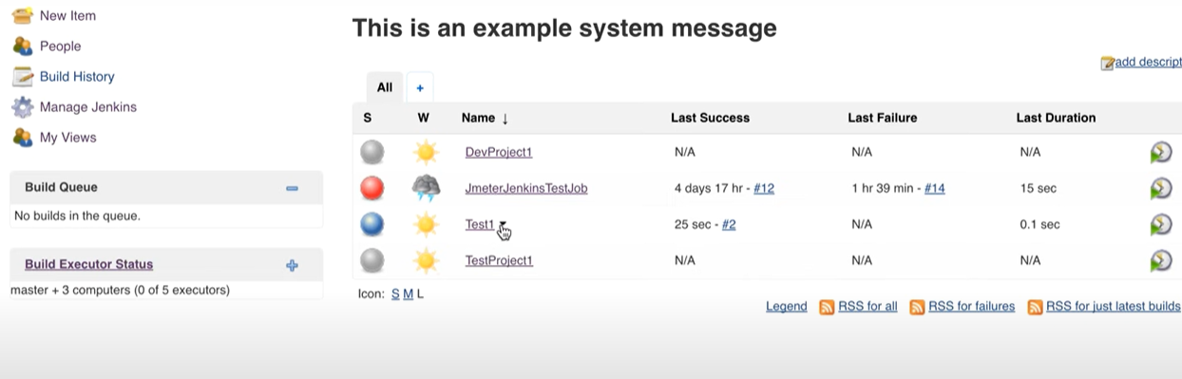

Here second column tells about the whether forecast for last 5 builds.

**Build Job Remotely:**

To build job remotely first of all we need to change the configuration of particular job. Select trigger build remotely under build triggers section.

There you need to provide an authentication token. And in the URL generated we need to provide the Jenkins URL and that token we provided.

Now we can trigger build remotely from any server.

**How to chain job executions:**

To execute jobs one after the other, we can mention in job that trigger this build after other build is successful.

And in post build actions we can define what build needs to be triggered once this particular job is completed.