* **Kubectl:**

The kubernetes command line tool is called kubectl. It is a program you can run on your laptop or wherever and access and manage your kubernetes clusters.

There are various ways to install it:

* On a mac with Homebrew ,it is as simple as brew install kubectl.
* For windows below are the options.

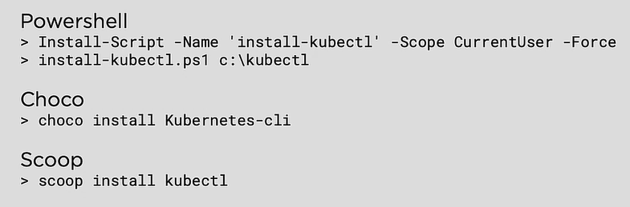

Getting k8s on laptop:

* Either using Docker Desktop
* Using Minikube

Getting k8s in the cloud:

* Linode Kubernetes Engine
* Google kubernetes engine

**Working with Pods:**

You start out with app code, build it into a container image, store that in a repo, define it in a kubernetes manifest and then post that to the API server.