**Packing a chart:**

Until now we have only worked with exported forms of charts as unpacked folders. But before publishing a chart in a repository, it has to be packed. Helm chart packages are simple unix tar gzip compressed archives.

You could build it with the tar command line. For this helm provides a special command

$ helm package chart_name

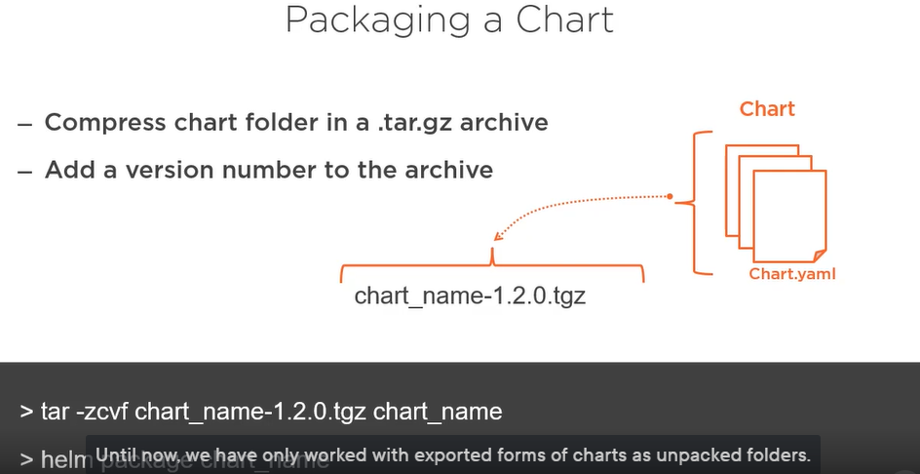

**Chart Dependencies:**

Until now we were copying the unpacked subcharts into the charts subfolder. We could also copy the charts as compressed archive in the charts folder. This is a manual way of managing dependencies. But sooner or later we have to deal with a lot of dependencies between versions.

So we need an automatic way to manage dependencies between charts. The dependencies can be defined in chart.yaml file.

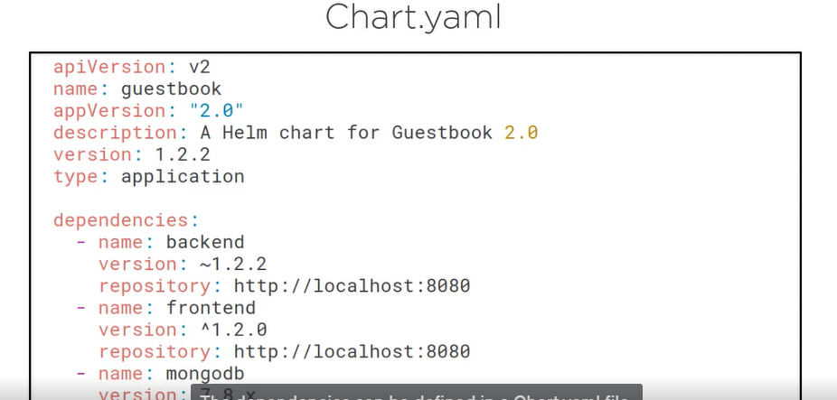

Add dependency property, and under that property, set one or multiple dependency definitions.

The dependency block defines the subchart name, the version range compatible with your chart, and the repository URL where the archive of the chart can be downloaded.