**Working with Pods:**

You start out with app code, build it into a container image, store that in a repo, define it in a kubernetes manifest and then post that to the API server.

Below is the pod manifest file:

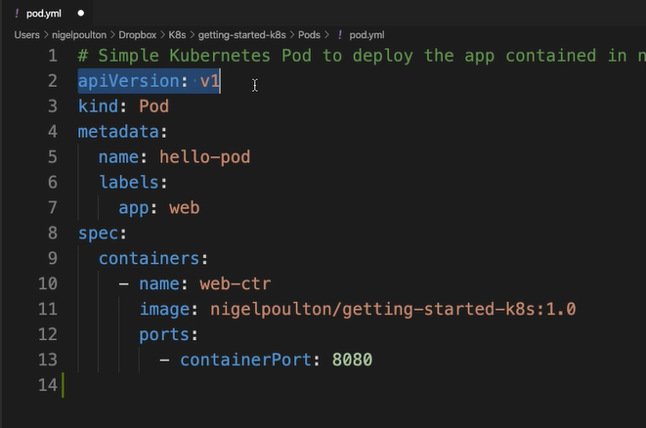

To deploy a pod, execute below command:

$ kubectl apply –f pod.yaml

When we execute above command then, kubectl is going to post that file there to the API server.

The request will be authenticated and authorized.

The config will get persisted to the cluster store, and the scheduler will assign the pod to a node.

To get the pod:

$ kubectl get pods –watch

Or $ kubectl get pods –o wide.

To describe pod execute below command:

$ kubectl describe pods hello-pod

Below is the multi container pod example:

