**Terraform Modules:**

* Terraform provides modules which allows us to abstract away reusable parts, which we can configure once and use everywhere.
* You can use modules to make terraform more organized.
* Modules allows us to group resources together, define input variables which are used to change needed resource configuration parameters, define output variables that other resources or modules can use.

**How to use terraform modules:**

1. Use module from git

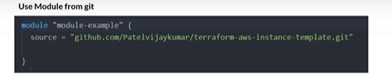

1. Use module Local

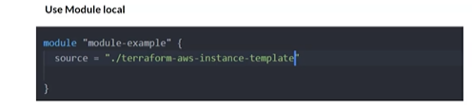

Example of passing Argument to module:

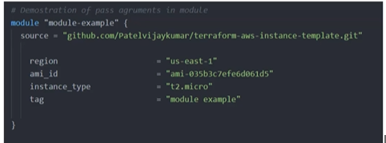

Modules contain 3 core files i.e

* Main.tf
* Variables.tf
* Output.tf

Use the output from the module in your code as below:

