* **Services:**

A Kubernetes service is **a logical abstraction for a deployed group of pods in a cluster** (which all perform the same function). Since pods are ephemeral, a service enables a group of pods, which provide specific functions (web services, image processing, etc.) to be assigned a name and unique IP address (clusterIP).

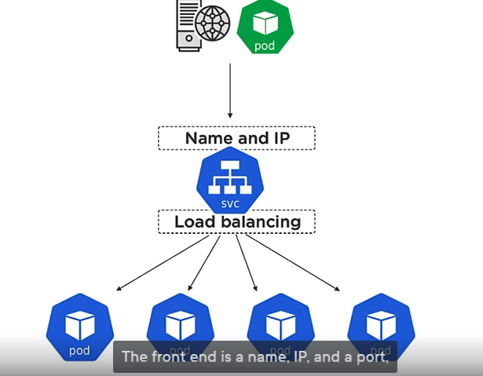

Now we can define service as below. Use the same label in service definition file as given in pod definition file .

Consider below to define a service in service.yaml file.

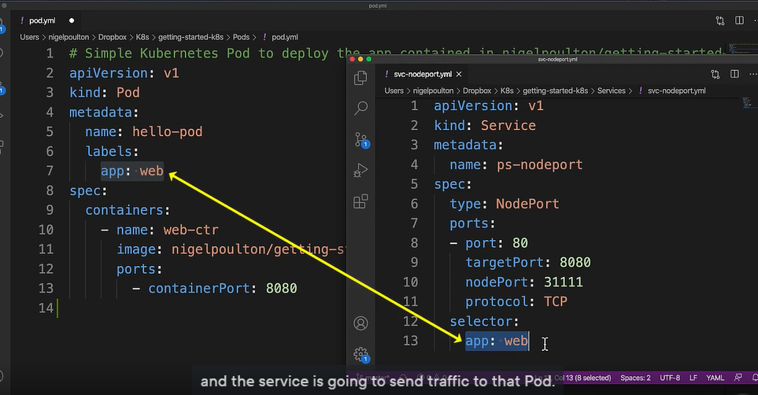

Everytime you creates a service, kubernetes automatically creates an endpoint object depending on the version of your k8s.

We’ve hinted that a service also gets a network port. That port can be mapped on every cluster node to point back to the cluster IP.

**Types of services:**

* ClusterIP. Exposes a service which is only accessible from within the cluster.
* NodePort. Exposes a service via a static port on each node's IP.
* LoadBalancer. Exposes the service via the cloud provider's load balancer.

**Deplyment:**

A Kubernetes Deployment is **used to tell Kubernetes how to create or modify instances of the pods that hold a containerized application**. Deployments can scale the number of replica pods, enable rollout of updated code in a controlled manner, or roll back to an earlier deployment version if necessary.

Deployment file can be created as:

