**Terraform Autoscaling:**

* In AWS Autoscaling groups can be created to automatically add/Remove instances when certain thresholds are reached.
* E.g you application layer can be scaled out when you have more visitors.
* To set up autoscaling in AWS you need to setup atleast 2 resources:
* An AWS launch configuration
* Specifies the property of the instance to be launched (AMI ID, security Group etc.)
* An Autoscaling group
* Specifies the scaling properties( min instances, max instances, health checks)

To make an autoscaling group using terraform we need to define launch configuration and Autoscaling group using the terraform code.

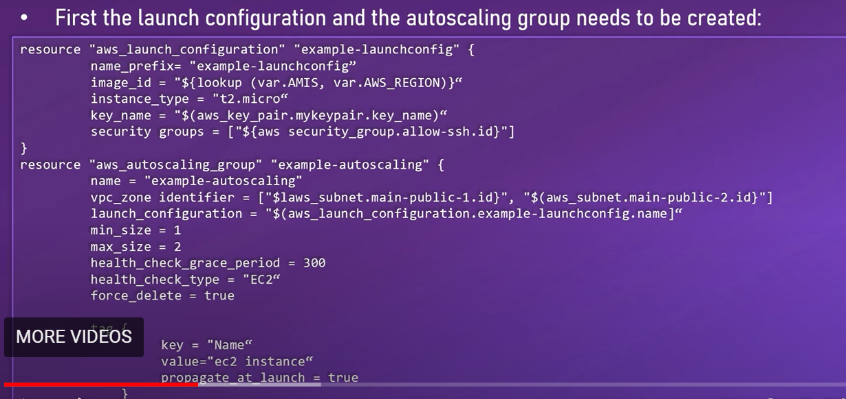

To create a policy you need a aws_autoscaling policy:

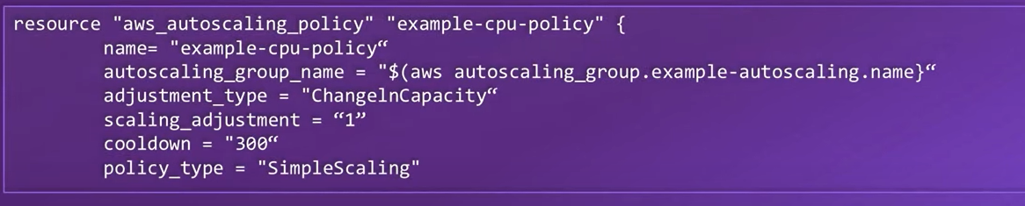

Then you can create a cloudwatch alarm which will trigger the autoscaling policy as below:

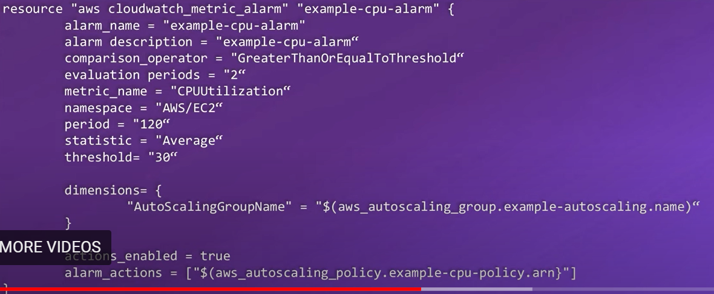

If you want to receive an alert (e.g email) when autoscaling is invoked , you need to create a SNS topic(simple notification service).

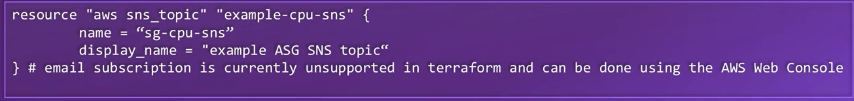

Then SNS topic needs to be attached to the Autoscaling group:

