**Creating resources in Terraform using Azure:**

1. To create Azurerm resource group: create main.tf and mention below code

Resource group is basically like a container where all other resources are kept.

Resource “azurerm_resource_group” “example”

{

Name = “example”

Location = “west europe”

}

1. We can define the provider in provider.tf file like below:

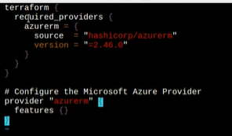

Once we define the resources that needs to be created in .tf files execute belo commands

$ terraform init

$ terraform plan

$ terraform apply

Once all three commands gets executed then resources will be created in the azure cloud.

After we do terraform apply below listed files also gets generated inside the folder:

