**Private IP:**

* Instances have public and private IP.
* Private IP gets auto assign to instances.
* Public Ip are publically assigned and gets removed or changed when you stop or reboot an instance.

You can define private IP manually also:

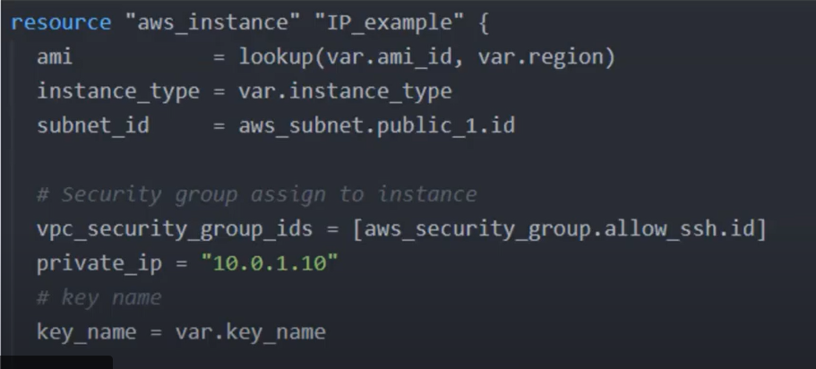

**Elastic IP:**

Elastic IP is like a static IP which do not change on reboot. We can create Elastic IP as below:

