**What is terraform?**

Terraform is a tool for building infrastructure as code. It is a open source tool created by hashicorp. It also maintains the infrastructure change history using the version control system like git.

**How terraform Helps?**

* Easy writing Automation.
* Modification of infrastructure easily.
* Replicate to multiple environment.
* Maintains the state of infrastructure.
* Maintains the infrastructure change history using the version control system like GIT.

**How terraform work?**

* Connect to AWS( cloud provider).
* Create infrastructure as defined.

Basically there is a component called Terraform core which takes 2 input parameters like terraform config file(TF-config) and state file.

Terraform core plans what needs to be create/Modify/Destroy and also compares the current state vs desssired state.

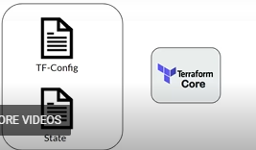

We need to provide a provider to tell terraform which provider it has to connect with.

temp11_ss.PNG