R53 with Terraform:

R53 is a highly scalable and available domain name system service. The domain name system works on port number 53. So R53 has taken the 53 number from domain name system.

* IP address is hard to remember hence hostname is used.
* DNS is used for mapping hostname to IP address.
* DNS works on 53 port number.
* Route 53 is aws DNS service with route 53 you can
* Host domain name
* Register domain name
* Create zone and add DNS record.

Key points about R53:

1. The A record maps a name to one or more IP addresses when the IP are known and stable.
2. The CNAME record maps a name to another name, used when there are no other records on that name.
3. The ALIAS record maps a name to another name, but can co-exist with other records on that name.

We can create R53 record using terraform as below:

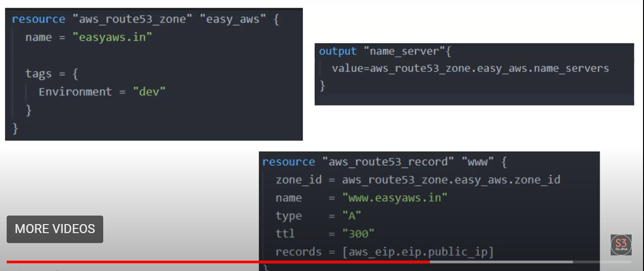

So after executing the above code below entries will get generated inside the Route 53. Easyaws.in is the zone name and [www.easyaws.in](http://www.easyaws.in) is the A record set created.

