**AWS RDS:**

* RDS is Relational database service.
* It manages database services.
* It can setup Replication (high availability)
* It can take automated snapshot for backup
* Has automated security upgrade
* Has easy instance scaling.

**AWS RDS Databases:**

* MySQL
* Maria DB
* PostgresSQL
* MicrosoftSQL
* Oracle

**AWS RDS with Terraform:**

* Will be creating below resource to deploy RDS service.
* Subnet Group
* Where to deploy database service within Region.
* Parameter Group
* Allow you to specify the parameter to change setting in database.
* Create security group that allow incoming traffic to the RDS instance.
* At last create RDS instance.

Consider below code to create DB parameter group.

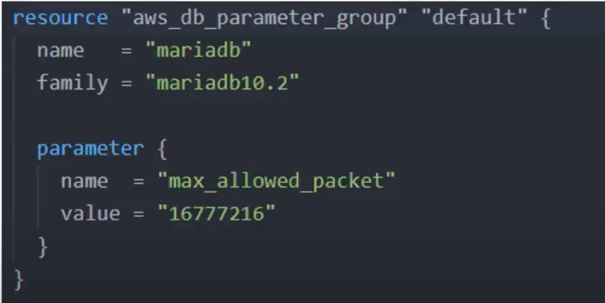

Then DB subnet can be created as below:

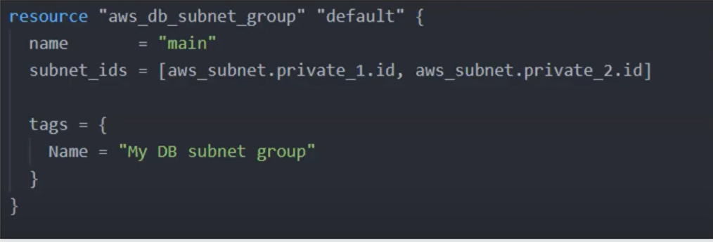

We can create security group using the code below:

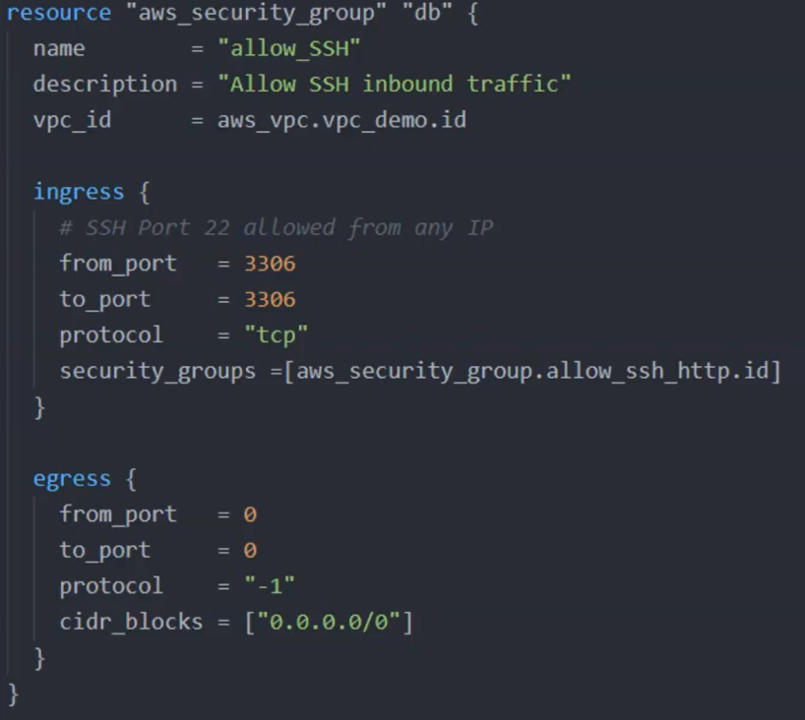

Finally the database instance can be created as below:

