**AWS Dynamo DB:**

Amazon Dynamo DB is a key value and document database that delivers single digit millisecond performance at any scale.

* Fast and flexible NoSQL database service for all the applications that need to be consistent.
* It is fully managed database and supports both document and key-value data models.
* It’s flexible data model and reliable performance makes it a great fit for mobile, web, gaming, ad-tech, IOT, and many other application.

AWS Dynamo DB provides

* Managed service
* Built-in-security
* Backup
* No servers to manage
* Performance at scale

**DynamoDB creation using Terraform:**

Below is the code snippet illustrating the creation of Dynamo DB using terraform.

For creating the Dynamo DB we need to provide the name, billing mode, read and write capacity units, hash key and range key.

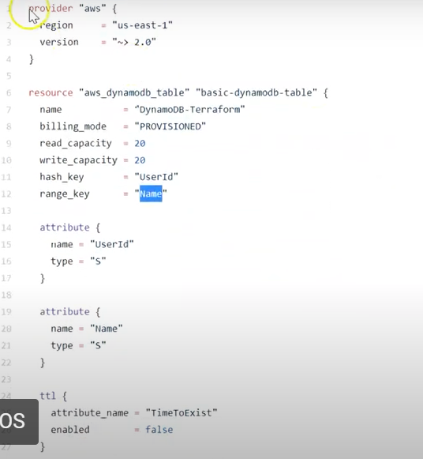

We can use the AWS CLI to view the dynamo DB table created as below and to run some other specific commands.

