**Terraform Infrastructure:**

To create infrastructure using terraform we need to create various resources like, vpc, public and private subnets, internet gateway, route tables etc.

To create the internet gateway we have to write below code:

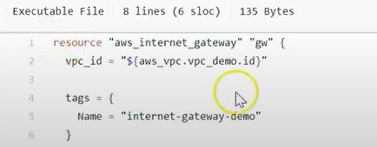

For creating the internet gateway we need to mention the vpc_id that in which particular vpc we want to attach the internet gateway.

Apart from that we can define tags like what should be the name of the internet gateway that has been created.

For creating the Route table we need to define below code in route.tf

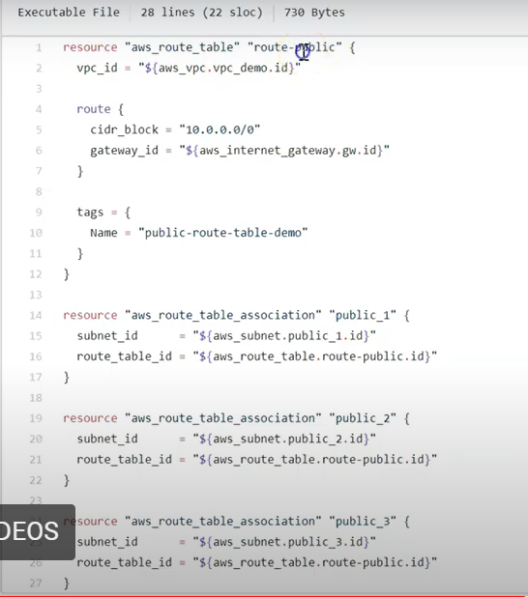

For creating the route table we need to define the vpc_id and the route.

Inside route we can define about cidr block in which the route will be created and the internet gateway id and also need to define the tags.

Apart from that we can also create the nat gateway, although the internet gateway and nat gateway have different puposes .To understand how we can create the nat gateway using code in terraform, consider below code snippet:

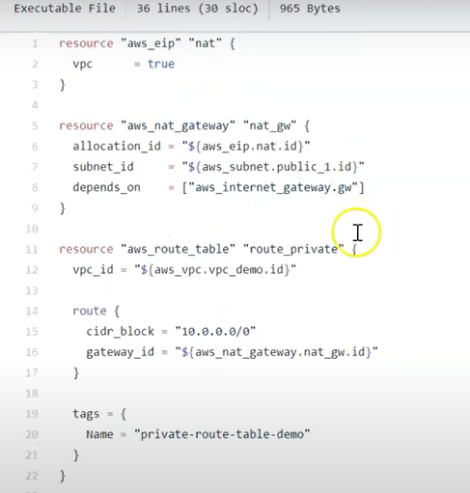

For creating the nat gateway we need to create the elastic ip first and then associate it to the nat gateway .