**Terraform Output:**

Outputs can be used to print the output to the console.

* Many resources dependent with other resource attributes like
* Resource Name
* Resource arn
* EC2 IP(public IP)
* EC2 DNS name
* Terraform keeps attribute of all resources which terraform creates.

We can define output as below:

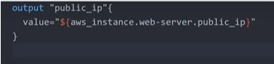

You can also mention about the attribute directly, as below

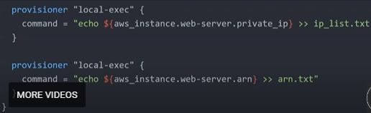

**Terraform state:**

Maintaining of state file is very important.

* Terraform keep remote state of infrastructure.
* State will be stored on terraform.tfstate file.
* Terraform.tfstate.backup for previous state file.
* Terraform state file can be in remote, using backend functionality.
* Default backend is local
* Other backend are
* S3
* consul

**Terraform Backend config:**

* Add the backend in main.tf file.
* Run initialize process.

Consider below code snippet to configure backend:

1. For consul:

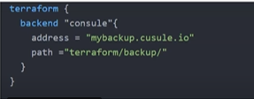

1. For s3:

