If we have defined ami in aws-instance-example.tf file as

Ami= “${lookup(var.ami_id, var.region)}”

Then in variables.tf we can define like

Variable “ami_id” {

Type = “map”

Default = {

Us-east-1 = “ami-979675h8hd”

Eu-west-2 = “ami-273t3y7g4uhi”

Eu-central-1 = “ami-fh7tvf6tfby”

}

}

**Terraform software provisioning:**

When an instance is created we need configuration for the instance. So instance need the server configuration, api configuration or the database configuration.

So the terraform also supports the software configuration for your specific needs.

This can be achieved by:

* Build your own AMI with required software Application. Means take some AMI and install all your configuration on top of it and take backup of newly created AMI , which can then be used for all further instance creation.

There are 3 ways for configuration:

* File uploads:

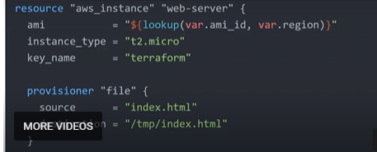

We can use above provisioner to upload file from source to destination to the server at time of creation.

Then we need to provide the connection details with which file will get uploaded to server as below:

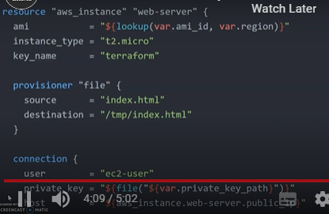

Next way is to use remote-exec to execute or install some of the packages.

