**Terraform state locking:**

In order to implement the state locking feature, we need to create a s3 bucket in AWS and also create a Dynamo DB table for maintaining the locking state.

Then mention below code in the .tf file

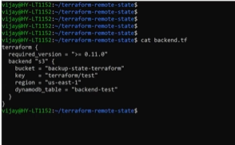

You need to do the init after adding the backend.

While the lock is acquired the entry gets created inside the dynamo DB table. And after the lock is released the info in table gets converted to digest having hash id.

**Terraform Data Sources:**

* Data sources provide a dynamic information.
* Many information of AWS are needed dynamically without creating new resources.
* Terraform exposes this information using data sources.
* Example
* VPC ID
* Security ID
* AMI List
* Availability Zone.

Consider below code for creating the data source:

