**EC2 User Data:**

User data is a mechanism provided by aws where you can configure prerequisitions, you can install software, run commands in your instance.

* User_data is used for virtual machine customization at the time of launch.
* With user_data we can
* Update packages
* Install software
* Execute scripts
* Mount EBS volume

To pass user data there are 2 ways, either we can directly pass the the userdata in the instance creation block or by passing a file .

1. To pass userdata directly

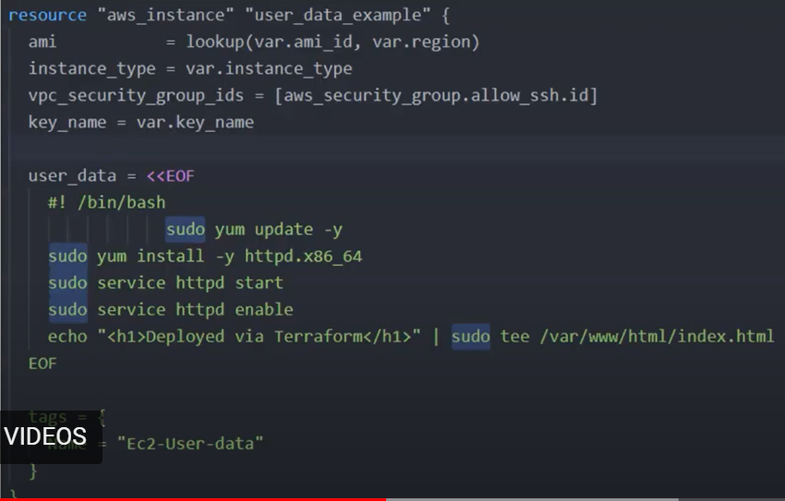

1. To pass userdata through file:

