**AWS VPC:**

* VPC is virtual data center in the cloud.
* Amazon VPC is a commercial cloud computing service that provides users a virtual private cloud, by “provisioning a logically isolated section of Amazon web services cloud”.
* Launch instance into subnet of your choice.
* Assign custom IP address range in each subnet.
* On AWS you have a default VPC created by AWS to launch instance.
* An instance launched in one VPC can’t communicate with an instance in other VPC using their private ip address (they can use public ip but it is not recommended.)
* VPC peering is used for communication between 2 VPC.

To create VPC consider below VPC diagram:

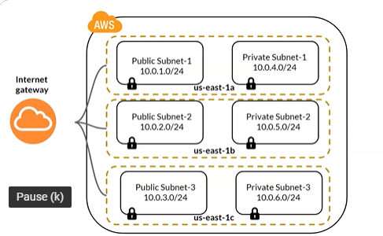

To create above VPC the below code needs to be considered.

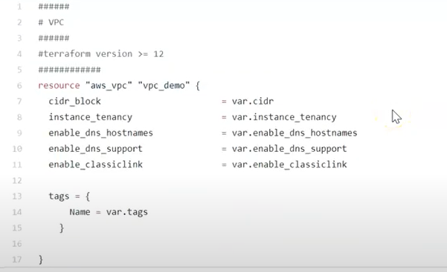

To create subnets consider below code:

