**Jenkins Basic configurations:**

To do any configurations go to

Manage Jenkins🡪 configure system

1. Home directory:

This tells you your home directory where Jenkins will store all configurations , plugins, job etc. information.

1. System message:

In this whatever message you write that will display on Jenkins home page when you login to Jenkins. You can apply HTML tags also and preview how it looks before applying like <h1> this is system message </h1>

As shown below:

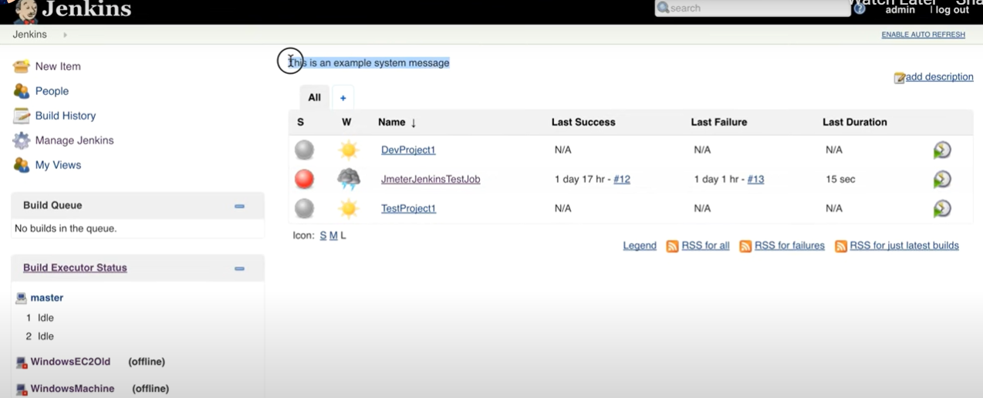

1. # of executors:

This means no. of parallel jobs that this particular Jenkins instance can run.

1. Labels:

Labels are used to give a particular label to a machine. We can give this label during job configuration like inside the parameter for :

Restrict where this project can be run

1. Usage:

Here we can choose option like choose this node as much as possible.

1. Quiet Period:

This is the time for which Jenkins node should wait before triggering the job.