* **What is Kubernetes?**

Kubernetes (also known as k8s or “kube”) is an open source container orchestration platform that automates many of the manual processes involved in deploying, managing, and scaling containerized applications. It is opensource under the Apache 2.0 license.

**Kubernetes Architecture**:

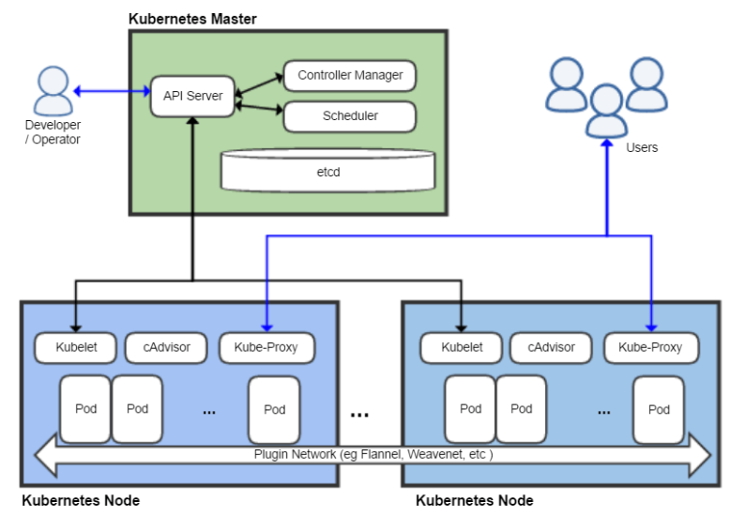

The Kubernetes master is the main controlling unit of the cluster, managing its workload and directing communication across the system. The Kubernetes control plane consists of various components, each its own process, that can run both on a single master node or on multiple masters supporting high-availability clusters. The various components of the Kubernetes control plane are as follows:

* **Etcd**  is a persistent, lightweight, distributed, key-value data store  that CoreOs has developed. It reliably stores the configuration data of the cluster, representing the overall state of the cluster at any given point of time. etcd favors consistency over availability in the event of a network partition .
* The **API server** , which provides both the internal and external interface to Kubernetes. The API server processes and validates REST requests and updates the state of the API objects in etcd, thereby allowing clients to configure workloads and containers across worker nodes.
* The **scheduler** is the extensible component that selects on which node an unscheduled pod (the basic entity managed by the scheduler) runs, based on resource availability. The scheduler tracks resource use on each node to ensure that workload is not scheduled in excess of available resources. The scheduler's role is to match resource "supply" to workload "demand".
* A **controller** is a reconciliation loop that drives the actual cluster state toward the desired state, communicating with the API server to create, update, and delete the resources it manages (e.g., pods or service endpoints). One kind of controller is a Replication Controller, which handles replication and scaling by running a specified number of copies of a pod across the cluster. It also handles creating replacement pods if the underlying node fails. Other controllers that are part of the core Kubernetes system include a DaemonSet Controller for running exactly one pod on every machine (or some subset of machines), and a Job Controller for running pods that run to completion, e.g. as part of a batch job.

* The **controller manager** is a process that manages a set of core Kubernetes controllers.