Name: DHANESVARAN M. | Register No.: RA2311026050277 | Section: 4th Year AIML-D
PS No. and Title: PS-49 Hand Gesture Recognition for Touchless Control
Date: October 23, 2026 | GitHub Link: https://github.com/DHANESVARAN/Human-Centred-Vision
1. Problem and Objective
The objective is to classify near-infrared images from a Leap Motion sensor into 10 distinct hand gestures for touchless control systems. A critical requirement is evaluating the model's ability to generalize to an entirely unseen person to ensure real-world robustness. Success is defined by achieving high classification accuracy on the isolated subject's data.
2. Dataset and Pre-processing
The dataset utilized is the Hand Gesture Recognition Database (LeapGestRecog) sourced from Kaggle, consisting of 20,000 images across 10 classes and 10 subjects. To strictly prevent data leakage and evaluate real-world generalization, data was split by subject: Subjects 00-07 for training, Subject 08 for validation, and Subject 09 completely isolated for testing. Images were resized to 256x256, center-cropped to 224x224, converted to PyTorch tensors, and normalized. The training set additionally incorporated random resized crops and horizontal flips for augmentation to mitigate overfitting.
3. Methodology
A Convolutional Neural Network (CNN) based on the ResNet18 architecture was implemented using PyTorch. Transfer learning was leveraged by utilizing the pre-trained weights for feature extraction, while the final fully connected layer was fine-tuned specifically for the 10 gesture classes. The model was trained over 10 epochs utilizing the Adam optimizer.
Table 1: Hyperparameters
Hyperparameter | Value
Architecture | ResNet18
Optimizer | Adam
Learning Rate | 0.001
Batch Size | 32
Loss Function | CrossEntropyLoss
Epochs | 10

4. Results
The model achieved high accuracy across all validation phases and demonstrated exceptional generalization to the unseen test subject (Person 09).
Table 2: Test Set Performance
Metric | Value
Model | ResNet18
Test Accuracy (Unseen Subject 09) | 98.95%
Training Time | ~9.5 Minutes
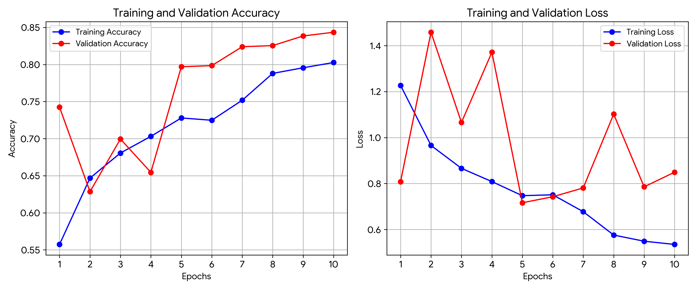
Figure 1: Training and Validation Accuracy/Loss over 10 Epochs.
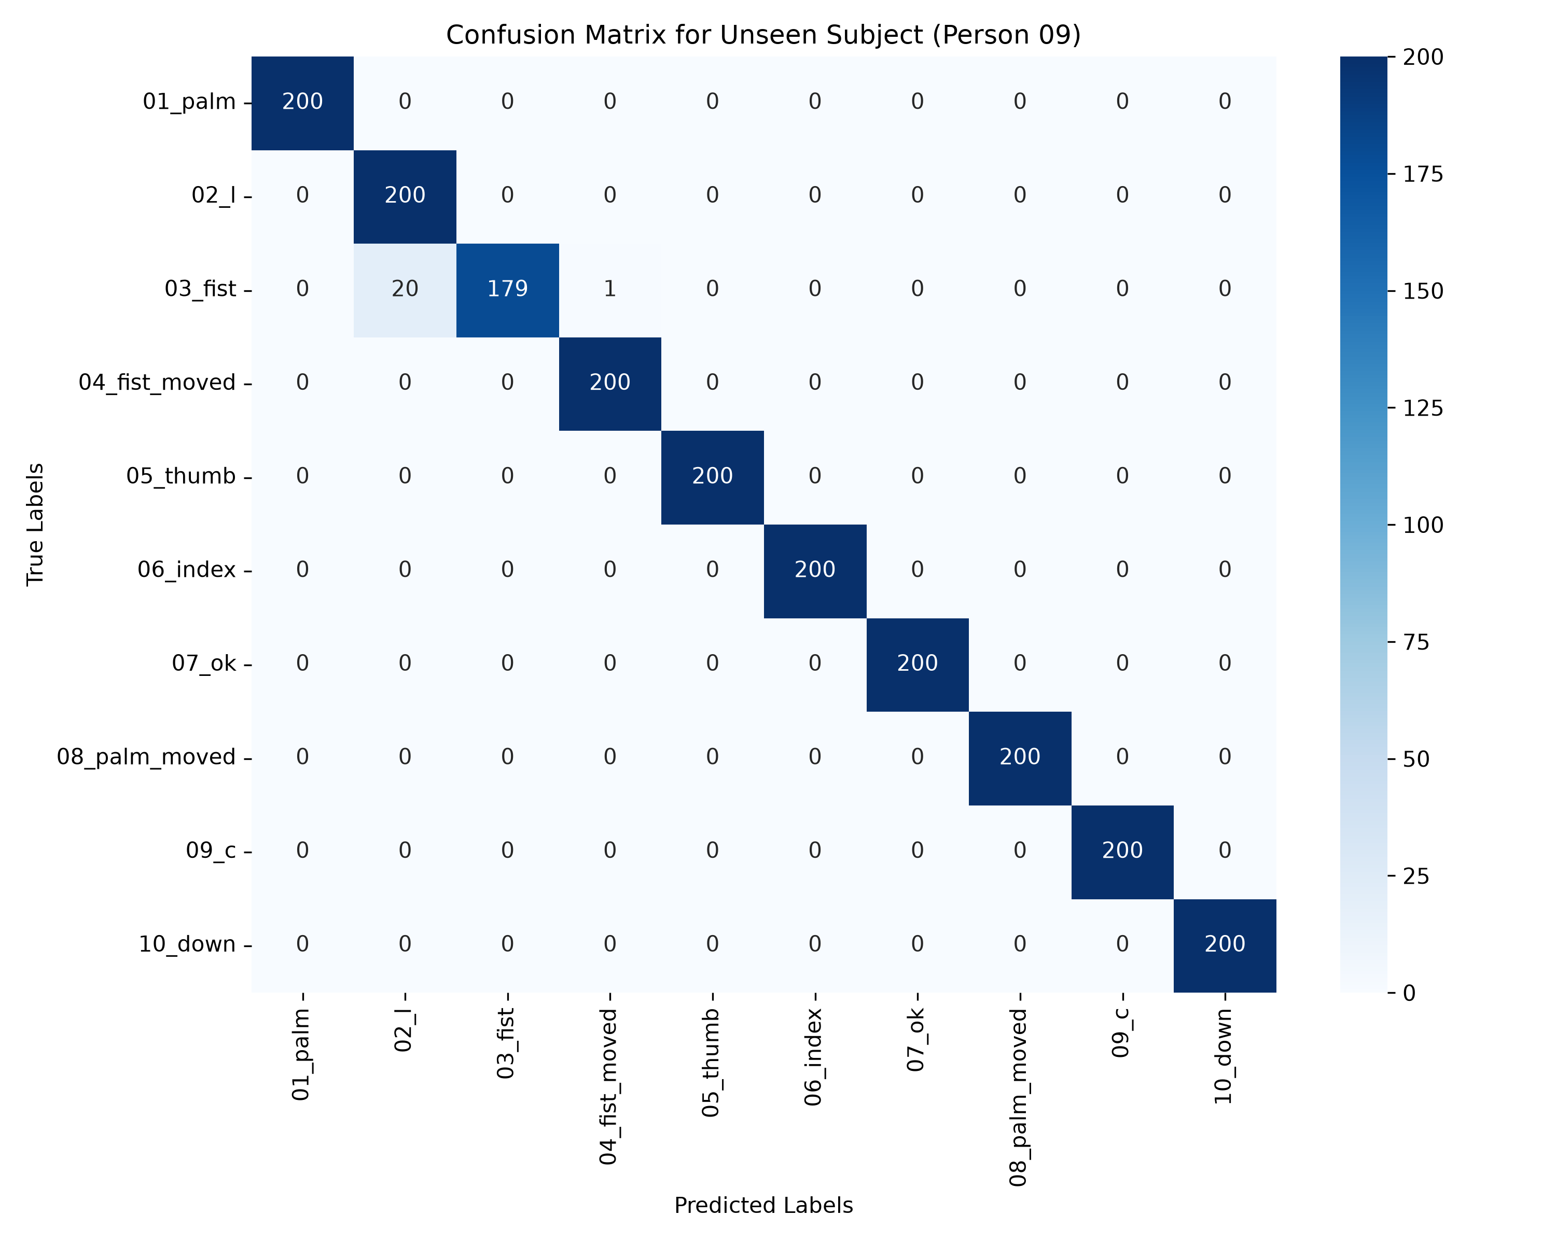
Figure 2: Confusion Matrix for the Unseen Subject (Person 09).
5. Analysis and Discussion
The training logs indicated steady convergence, with training accuracy reaching 80.27% and validation accuracy at 84.35%. Most importantly, the model achieved a remarkable 98.95% classification accuracy on the entirely unseen test subject (Person 09). This exceptional performance confirms that the subject-wise splitting strategy successfully prevented data leakage. The model successfully learned generalized gesture features rather than overfitting to subject-specific artifacts such as hand size, skin tone, or camera angle.
6. Real-world Relevance, Limitations and Ethics
This model demonstrates high potential for deployment in touchless User Interfaces (UIs) for sterile healthcare environments, automotive infotainment systems, and accessible computing. Ethically, touchless systems must perform equally well across different demographic traits. Testing rigorously on unseen subjects is a critical step in verifying this fairness. Furthermore, all model development and training was conducted entirely locally inside a secure, sandboxed environment (Fedora KDE) leveraging local GPU acceleration. During the development phase, a local Large Language Model (codellama:7B) was utilized for reference and structural assistance, ensuring complete data privacy and self-sufficiency without reliance on external cloud APIs.
7. Conclusion and Future Work
The fine-tuned ResNet18 model successfully classified near-infrared hand gestures with 98.95% accuracy on an unseen subject, proving its robustness for real-world touchless interfaces. Future work could explore lighter model architectures, such as MobileNetV3, to enable ultra-low-latency inference directly on edge devices with constrained compute resources.
Dataset Citation: Hand Gesture Recognition Database, LeapGestRecog (Kaggle). https://www.kaggle.com/datasets/gti-upm/leapgestrecog

