SMART ATTENDANCE SYSTEM

A report of the project work ***Submitted by* DHARANESHWARAN B**

**TABLE OF CONTENTS**

|  |  |  |
| --- | --- | --- |
| **CHAPTER NO** | **TITLE** | **PAGE NO** |
|  | **ABSTRACT** | **iii** |
|  | **LIST OF FIGURES** | **iv** |
|  | **LIST OF ABBREVATION** | **v** |
| **1** | **INTRODUCTION** |  |
|  | **1.1 OVERVIEW** | **1** |
|  | **1.2 MOTIVATION** | **2** |
|  | **1.3 SMART ATTENDANCE SYSTEM** | **3** |
| **2** | **LITERATURE REVIEW** | **4** |
| **3** | **FACE RECOGINITION ALGORITHM** | **6** |
|  | **3.1 HOG ALGORITHM** | **7** |
|  | **3.2 POSING AND PROJECTING FACES** | **9** |
|  | **3.3 ENCODING FACE** | **11** |
|  | **3.4 SUPPORT VECTOR MACHINE** | **12** |
| **4** | **METHODOLOGY AND SYSTEM DESIGN** |  |
|  | **4.1 ENROLLMENT OF STUDENTS** | **13** |
|  | **4.2 TRAIN THE SYSTEM** | **14** |
|  | **4.3 FACE DETECTION** | **14** |
|  | **4.4 FACE ALIGNMENT** | **15** |
|  | **4.5 FACE ENCODING** | **15** |
|  | **4.6 SYSTEM ARCHITECTURE** | **16** |
| **5** | **SYSTEM REQUIREMENTS** |  |
|  | **5.1 HARDWARE REQUIREMENTS** | **18** |
|  | **5.2 SOFTWARE REQUIREMENTS** | **18** |
|  | **5.3 DESCRIPTION REQUIREMENTS** | **8** |
|  | **5.3 PYTHON** | **19** |
|  | **5.3 NUMPY** | **20** |
|  | **5.3 OPENCV** | **20** |
|  | **5.3 PIL** | **20** |
|  | **5.4 VISUAL STUDIO** | **21** |
|  | **IMPLEMENTATION MODULES** |  |
| **5.5 WEB APPLICATION DEVELOPMENT** | **21** |
| **5.6 LOGIN PAGE** | **22** |
| **6** | **CONCLUSION AND FUTURE WORK** | **25** |
|  | **REFERENCE** | **26** |

## ABSTRACT

In this project, an approach for accurate smart attendance system designed on the basis of deep learning algorithm has been addressed. This approach will monitor the entry and exit of people into a school or college. When a person approaches a surveillance camera near the entrance, automatically his/her face will be recognized and the entry time will be stored. Similarly while exiting, their faces will be recognized in another deep learning model embedded surveillance camera and the exit time will be stored. Our approach will help the college to provide attendance even for attending a lecture for a percentage of time.

Face is the crucial part of the human body that uniquely identifies a person. Using the face characteristics as biometric, the face recognition system can be implemented. The most demanding task in any organization is attendance marking. In traditional attendance system, the students are called out by the teachers and their presence or absence is marked accordingly. However, these traditional techniques are time consuming and tedious. In this project, the Open CV based face recognition approach has been proposed. This model integrates a camera that captures an input image, an algorithm for detecting face from an input image, encoding and identifying the face, marking the attendance in a spreadsheet on daily basis

## LIST OF FIGURES

|  |  |  |
| --- | --- | --- |
| **FIGURE NO** | **FIGURE NAME** | **PAGE NO** |
| **3.1** | **ALGORITHM WORKING PROCESS** | **7** |
| **3.2** | **FINDING EVERY SINGLE PIXEL** | **7** |
| **3.3** | **REPLACING PIXEL WITH**  **GRADIENTS** | **8** |
| **3.4** | **HOG FACE PATTERN GENERATOR** | **9** |
| **3.5** | **FACE POSING AND PROJECTING** | **9** |
| **3.6** | **FACE LANDMARK** | **10** |
| **3.7** | **FACE COMPARISION** | **11** |
| **3.8** | **LAYERS OF CNN** | **2** |
| **4.1** | **ARCHITECTURE IMAGE** | **16** |
| **4.2** | **WORKING LAYERS** | **17** |
| **5.1** | **LOGIN PAGE** | **22** |
| **5.2** | **HOME PAGE** | **22** |
| **5.3** | **DETAILS PAGE** | **23** |
| **5.4** | **DETECTED IMAGE** | **23** |
| **5.5** | **ATTENDANCE MARKED** | **24** |

**LIST OF ABBREVIATIONS**

|  |  |
| --- | --- |
| DL | Deep Learning |
| CNN | Convolutional Neural Network |
| SVM | Support Vector Machine |
| HOG | Histogram of Oriented Gradients |
| GUI | Graphical User Interface |
| OPENCV | Open Source Computer Vision Library |
| HTML | Hypertext Markup Language |
| CSS | Cascading Style Sheets |

## CHAPTER 1 INTRODUCTION

* 1. **OVERVIEW**

Face recognition system is the most researched area nowadays. Many new methods have been discovered for efficient face recognition. Face recognition is being widely used in areas like security systems. It can also be used for taking attendance in a classroom. It is a tedious and time consuming task to take the attendance manually. Every classroom has on an average 60 students and each period is of approximately 50 minutes. If we calculate average time wasted for marking attendance in a single day is roughly 1 hour. Many solutions have been proposed to make this system smart, but they have several weaknesses. One popular method based on RFID is given in but it has a limitation that it is equally time consuming as students have to come one-by-one for marking attendance and it is costlier to implement. Smart attendance based on low energy Bluetooth device is proposed by the students of Delhi Technical University, but this system is intrusive as student can easily give proxy by bringing other student phone. Also students can give attendance from outside the class. An approach based on fingerprint scanner is proposed in. It has a drawback that students have to stand in a queue to mark their attendance and that takes very long time for large number of students. Another solution based on barcode system is proposed in where students have to show the unique barcode on their ID card to mark attendance and that also is a very time consuming task.

Many other approaches like speech based attendance system and NFC (Near- Field Communication) based attendance system are proposed but all of them have some kind of limitations. Smart attendance system based on face recognition is one of the non-intrusive method. It requires a camera to take a classroom picture and the image uploading is given as input to our system and our system recognize

each face from the input image and create a report of the same. The camera is placed in such a way that every student is visible in the image captured. In face recognition based on PCA (Principle Component Analysis) is proposed. The process of face recognition is divided into four steps. First, in our proposed system face detection is performed based on the method given in. In this algorithm gradient of the image is calculated and it is given as input to a SVM classifier. Secondly face alignment. In our proposed system face alignment is done based on the algorithm proposed in 68 landmark points are found on the face and the image is rotated and scaled to perform face alignment. The aligned faces are stored in a folder. Third, face encoding, researches on face recognition conclude that using artificial neural network for face recognition has very high accuracy .Face encoding is performed based on FaceNet algorithm given in. FaceNet algorithm is best among all the CNN (Convolutional Neural Network) algorithm. Aligned faces are given as input to the FaceNet and it produces unique 128 dimension embedding for each face image. Fourth, train the classifier, SVM classifier is trained with the 128 dimension embedding produced in the previous step for the classification of students. After training the system with the database of students. Test image of the classroom is taken by the camera and is recognized by the system and it creates an attendance database. The database is then mailed to the respective faculty.

## MOTIVATION

Attendance is an important part of daily classroom evaluation. At the beginning and ending of class, it is usually checked by the teacher, but it may appear that a teacher may miss someone or some students answer multiple times. Face recognition-based attendance system is a problem of recognizing face for taking attendance by using face recognition technology. The concept of face recognition is to give a computer system the ability of finding and recognizing human faces fast and precisely in images or videos. Numerous algorithms and

techniques have been developed for improving the performance of face recognition. Recently Deep learning has been highly explored for computer vision applications. Human brain can automatically and instantly detect and recognize multiple faces. But when it comes to computer, it is very difficult to do all the challenging tasks on the level of human brain.

## SMART ATTENDANCE SYSTEM

A facial recognition system is a computerized biometric software which is suited for determining or validating a person by performing comparison on patterns based on their facial appearances. Face recognition systems have upgraded appreciably in their management over the recent years and this technology is now vastly used for various objectives like security and in commercial operations.

Face recognition is a powerful field of research which is a computer based digital technology. It is widely used in security systems and it can be compared with other biometrics such as fingerprint or eye iris recognition systems. As the number of students in an educational institute or employees at an organization increases, the needs for lecturers or to the organization also increase the complication of attendance control. This project may be helpful for the explanation of these types of problems. The number of students present in a lecture hall is observed, each person is identified and then the information about the number of students who are present and maintain

The face recognition system generally involves two stages:

* Face Detection – where the input image is searched to find any face, then image processing cleans up the facial image for easier recognition.
* Face Recognition – where the detected and processed face is compared to the database of known faces to decide who that person is.

## CHAPTER 2 LITERATURE REVIEW

1. Ekta Chhatar, Heeral Chauhan, Shubham Gokhale, Sompurna Mukherjee, Prof. Nikhil Jha, “Survey on Student Attendance Management System”, S.B. Jain Institute of Technology, Management and Research, Nagpur, 2016. In this paper, the system deals with the maintenance of the student’s attendance. It generates the attendance of the student on the basis of presence and absence in class. The staffs will be provided with the separate username & password.
2. Md. Milon Islam, Md. Kamrul Hasan, Md Masum Billah, Md. Manik Uddin, “Development of Smartphone based Student Attendance System”, Department of Computer Science and Engineering Khulna University of Engineering & Technology, Khulna-9203, Bangladesh, 2017. In this paper, the system is able to mark attendance, marking intruders‟ entry, attendance percentage calculations, send emails, and send SMS to the guardian to keep them updated about their child’s attendance at the Institute. The designed system has an online access from any place and any moment which may extraordinarily assist the course teacher with keeping track of their student’s attendance. The system employs in Android API level 19. The application is implemented in eclipse android ADT bundle as IDE. The system used the internal SQLite database as phone database and [www.golapmilonkuet.byethost16.com](http://www.golapmilonkuet.byethost16.com/) as web server database. The server holds MySQL database.
3. Jun Lio, “Attendance Management System using a Mobile Device and a Web Application”, Department of Socio-informatics, Faculty of Letters Chuo University 742-1 Higashinakano, Hachioji-shi, Tokyo 192-0393, Japan, 2016. In this paper, a novel framework for the attendance management is proposed, which consists of a mobile device and a web application. They have adopted the combination of a mobile device and web services. Registration of students is passed around among participants, one by one. Users can select one from two options, registration by selfie or registration by signature. After the registration, the ID and name which have been already registered are removed from the list of participants. An application running on the mobile device is implemented as a Monaca-application.

## CHAPTER 3

**FACE RECOGNITION ALGORITHM**

The facial recognition system requires various stages and algorithms to be able to find facial equations from the training data and real data. Training data is student photo data taken from the system while real data are photos taken by lecturers when lectures take place through the system for attendance. There are four algorithms with the main algorithm, namely Deep Convolutional Neural Network, which is used so that the system can recognize faces.

* + Face search algorithm by Histogram of Oriented Gradients (HOG) method .
  + Face projection algorithm with Face Landmark Estimation method
  + Face net encoding algorithm with Deep Convolutional Neural Network method .
  + Algorithm for finding the name of the owner of the face by SVM Classifier method

The algorithm is used sequentially so that the name of the owner of the face can be found from the training data. The stages of using the algorithm can be seen in diagram form Figure 5. From the bottom left of the arrow, the data of class photo were inputted to face search algorithm (HOG), then the next process is face projection with face landmark estimation. The result was processed by deep convolutional neural network method (and this method also got training input data). Finally, the name of the photo owner is decided by SVM classifier method in the rightmost box.

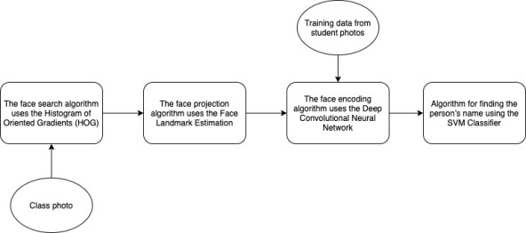

## Figure 3.1 Algorithm working process

**3.1 Face search algorithm by Histogram of Oriented Gradients (HOG) method**

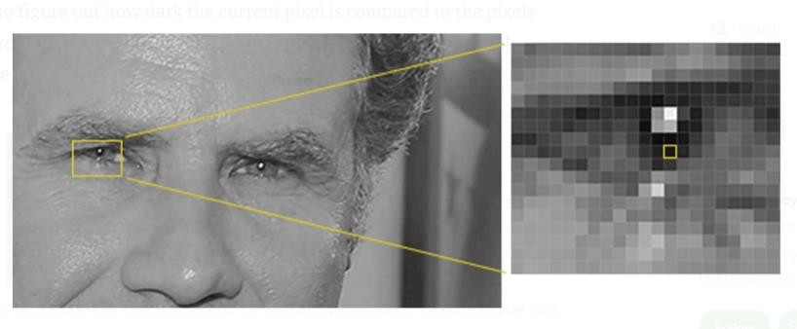

**Figure 3.2 finding every single pixel**

If you repeat that process for **every single pixel** in the image, you end up with every pixel being replaced by an arrow. These arrows are called *gradients*

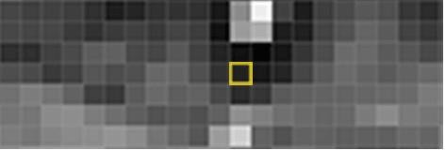

**Figure 3.3 Replacing pixel with gradients**

There’s a really good reason for replacing the pixels with gradients. If we analyse pixels directly, really dark images and really light images of the same person will have totally different pixel values. But by only considering the direction that brightness changes, both really dark images and really bright images will end up with the same exact representation. That makes the problem a lot easier to solve but saving the gradient for every single pixel gives us way too much detail

break up the image into small squares of 16x16 pixels each. In each square, we’ll count up how many gradients point in each major direction (how many point up, point up-right, point right, etc…). Then we’ll replace that square in the image with the arrow directions that were the strongest.

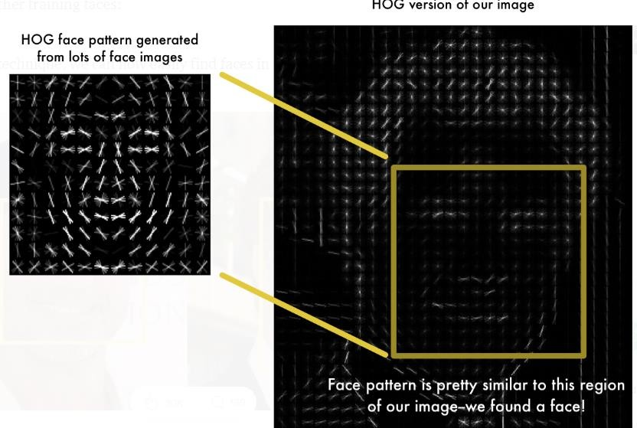

**Figure 3.4 HOG face pattern generator**

**3.1 POSING AND PROJECTING FACES**

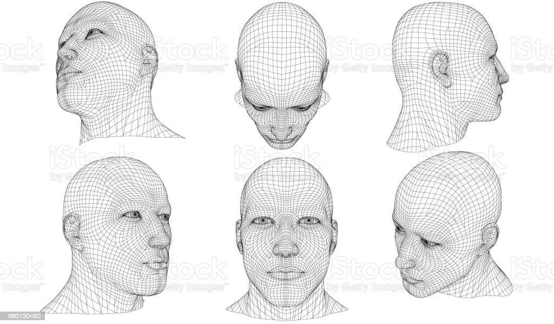

## Figure 3.5 Face posing and projecting

Face landmark estimation means identifying key points on a face, such as the tip of the nose and the centre of the eye.

There are different estimation models based on the number of face landmark points. The 5 points model is the simplest one which only detects the edges of each eye and the bottom of the nose.

Other models include 68 points face landmark model which detects 68 different points on the face including eyes, nose, lips and face shape.

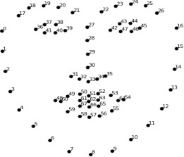

## Figure 3.6 face landmark

no matter how the face is turned, we are able to center the eyes and mouth are in roughly the same position in the image. This will make our next step a lot more accurate.

**3.1 ENCODING FACES**

Face encoding is an important step in face recognition. The measurements that seem obvious to us humans (like eye colour) don’t really make sense to a computer looking at individual pixels in an image. Researchers have discovered that the most accurate approach is to let the computer figure out the measurements to collect itself. Deep learning does a better job than humans at figuring out which parts of a face are important to measure.

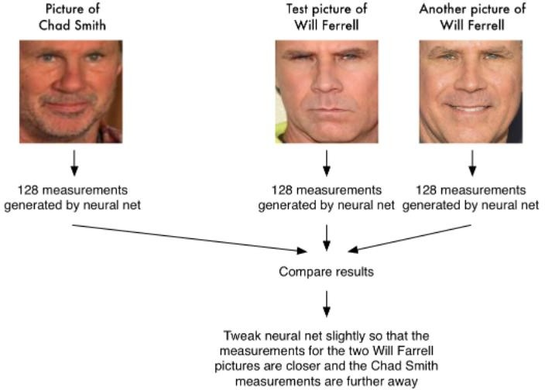

## Figure 3.7 face comparison

this step millions of times for millions of images of thousands of different people, the neural network learns to reliably generate 128 measurements for each person. Any ten different pictures of the same person should give roughly the same measurements.

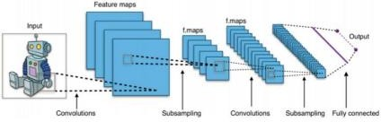

**Figure 3.8 layers of CNN**

* 1. **SUPPORT VECTOR MACHINE**

A support vector machine (SVM) is machine learning algorithm that analyzes data for classification and regression analysis. SVM is a supervised learning method that looks at data and sorts it into one of two categories. An SVM outputs a map of the sorted data with the margins between the two as far apart as possible. SVMs are used in text categorization, image classification, handwriting recognition and in the sciences.

A support vector machine is also known as a support vector network (SVN).

A support vector machine is a supervised learning algorithm that sorts data into two categories. It is trained with a series of data already classified into two categories, building the model as it is initially trained. The task of an SVM algorithm is to determine which category a new data point belongs in. This makes SVM a kind of non-binary linear classifier.

## CHAPTER 4

**METHODOLOGY AND SYSTEM DESIGN**

For implementing the smart attendance system using face recognition system, we have to follow the following steps in the same order. Those steps are as follows:

* + 1. Enrollment of students
    2. Train the system
    3. Face detection
    4. Face Alignment
    5. Face Encoding

## 1 Enrolment

The person will be enrolled to the database using their name and face images. The information will be stored in the folder with folder name as name of the person.

The process of enrolment includes:

* + Making a photo of person name as person name
  + Capture image from camera using opencv and python
  + Stored the images in the excel file

## Train the system

To train the system the uploaded image during enrolment is taken as input and the system is trained on those images. Steps for training the system is as follows:

* + - Face detect
    - Face alignment
    - Generate encoding using HOG algorithm
    - Train the SVM classifier

Image upload in the previous stage is taken as input in this stage. First, face detection is performed followed by face alignment and the aligned faces are cropped and stored. Second, the heart of the system Facene produce 128 dimension unique encoding per image. Finally, SVM classifier is trained on these 128 Dimension encoding

## FACE DETECTION

Many algorithms have been proposed for face detection., HOG face patterns detect the face by calculate the gradient of the image in both x and y direction and from that we finds the gradient vector of each pixel. Gradient vector include magnitude and angle of the vector. Both magnitude and angle are stored in a matrix form.

∇𝑔 = 𝑓𝑥 𝑓𝑦 = 𝜕𝑓 𝜕𝑥 𝜕𝑓 𝜕𝑦

Where ∇𝑔 is the gradient of the image and 𝑓𝑥 = 𝜕𝑓/𝜕𝑥 is the gradient of the image in x-direction and 𝑓𝑦 = 𝜕𝑓/𝜕𝑦 is the gradient of the image in y-direction.

𝜌 = 𝑓𝑥 2 + 𝑓𝑦

Magnitude of the gradient 𝜎 is calculated and it is stored in matrix form.

∅ = 𝑓𝑦 𝑓𝑥 (3)

Where ∅ is the angle of the gradient vector. The gradient vector is calculated for each pixel and stored in a matrix form

If you repeat that process for **every single pixel** in the image, you end up with every pixel being replaced by an arrow. These arrows are called *gradients*

## 4.4. FACE ALIGNMENT

Face alignment is an important step because if a person face is not aligned properly then computer will consider it as a different person. So, face alignment for our proposed system.so the Face estimation algorithm helps to detect every image in the previous stage 68 points are searched on the face and these points are called face estimation landmark and finding those 68 landmark points on the image, the image is scaled and rotated for alignment.

## FACE ENCODING

Face encoding is an important step in face recognition. the measurements that seem obvious to us humans (like eye color) don’t really make sense to a computer looking at individual pixels in an image. Researchers have discovered that the most accurate approach is to let the computer figure out the measurements to collect itself. Deep learning does a better job than humans at figuring out which parts of a face are important to measure.

## SYSTEM ARCHITECTURE

The system to be developed works in several stages, namely 1) Students enter the class to attend lectures; 2) Lecturers open a smart attendance system; 3) The lecturer chooses a class according to the schedule in the system; 4) The lecturer takes class photos from the attendance system; 5) The system works to analyse photos; 6) The system automatically detects the students' presence from the photo using facial recognition. In the form of a diagram, the system work process can be seen in Figure 1. Stage 1) flows from left to stage 2), 3), et cetera until stage 6) following the direction of the arrow.

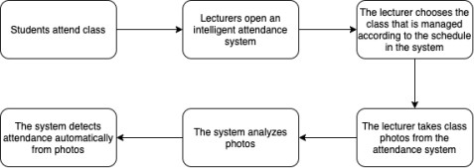

## Figure 4.1 Architecture image

The system to be developed is a web-based system consisting of several parts, namely front-end and back-end. The front-end is the view Graphical User Interface (GUI) is the front part of the system that directly interacts with the user. The front-end is developed with CSS, and HTML programming languages.

Meanwhile, the back-end is the primary system that carries out the system's functionality, runs algorithms, stores data, processes, and processes data displayed on the front-end. The back-end is developed with

Python programming languages. The back-end has several supports to run the system, namely, services, datasets, and algorithms. The parts of the system can be drawn on the diagram Figure 2

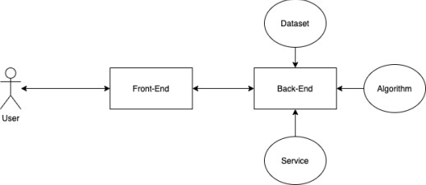

## Figure 4.2 Working layers

**CHAPTER 5**

## SYSTEM REQUIREMENTS

* 1. **HARDWARE REQUIREMENTS** PROCESSOR: LenovoE4115 HARD DISK DRIVE : 1TB RAM : 4 GB

## SOFTWARE REQUIREMENTS

OPERATING SYSTEM : Microsoft Windows 10PROGRAMMING LANGUAGES: Python 3

IDE : Jupyter Notebook

## DESCRIPTION OF THE TOOLS USED

used:

The project is mainly implemented in Python. The following are the tools

|  |  |  |
| --- | --- | --- |
|  | 5.3 | Python |
| 5.3 | Numpy |
| 5.3 | OpenCV |
|  | 5.3 | PIL |

## 5.3 Python

Python web server, or Jupyter document format depending on context. Python is an interpreted, high-level, general-purpose programming language. Python has a design philosophy that emphasizes code readability, notably using significant whitespace. It provides constructs that enable clear programming on both small and large scales.

Python is a multi-paradigm programming language. Object- oriented programming and structured programming are fully supported, and many of its features support functional programming and aspect- oriented programming (including by metaprogramming and metaobjects (magic methods). Many other paradigms are supported via extensions, including design by contract and logic programming.

Python uses dynamic typing and a combination of reference counting and a cycle-detecting garbage collector for memory management. It also features dynamic name resolution (late binding), which binds method and variable names during program execution. Python features a dynamic type system and automatic memory management. It supports multiple programming paradigms, including object-oriented, imperative, functional and procedural, it also has a comprehensivestandard library.

## 5.3 Numpy

NumPy stands for ‘Numerical Python’. It is an open-source Python library used to perform various mathematical and scientific tasks. It contains multi-dimensional arrays and matrices, along with many high-level mathematical functions. Many of its functions are very useful for performing any mathematical or scientific calculation. As it is known that mathematics is the foundation of machine learning, most of the mathematical tasks can be performed using Numpy.

## 5.3 OPENCV

OpenCV (Open Source Computer Vision Library) is a [library of](https://en.wikipedia.org/wiki/Library_(computing)) [programming functions](https://en.wikipedia.org/wiki/Library_(computing)) mainly aimed at real-time [computer vision](https://en.wikipedia.org/wiki/Computer_vision). The library is [cross-platform](https://en.wikipedia.org/wiki/Cross-platform) and free for use under the [open-source](https://en.wikipedia.org/wiki/Open-source_software) [Apache 2 License](https://en.wikipedia.org/wiki/Apache_License). Starting with 2011, OpenCV features GPU acceleration for real-time operations

OpenCV is a great tool for image processing and performing computer vision tasks. It is an open-source library that can be used to perform tasks like face detection, objection tracking, landmark detection, and much more. It supports multiple languages including python, java C++

* 1. **PIL**

Python Imaging Library is a free and open-source additional library for the Python programming language that adds support for opening, manipulating, and saving many different image file formats. It is available for Windows, Mac OS X and Linux. The latest version of PIL is 1.1.

## IMPLEMENTATION MODULES

* 1. **WEB APPLICATION DEVELOPMENT**

In this work, the web application is mainly developed using HTML, CSS, and PYTHON programming languages/ technologies.. HTML and CSS Bootstrap Framework are used to design the front end reliable web application. By using the CSS, all the front end design settings are stored in a single CSS file and whenever there is need to make any change we don’t need to change it at every page so we change only on value in the CSS file and this change is made in the whole website. python is used to create the application dynamic and interactive When the development is completed, all the features and content management system are strictly tested. When the initial testing is done, we then allow to the multi-browser check, where our website is checked over major browsers such as IE, Edge, Firefox, Google Chrome & Safari etc. and

finally we launch the website to the server which is available for every user

## LOGIN PAGE

Login Page For security purpose each type of users have to login by inputting email and password to access the system. Only authorized teachers, can enter into the web application and any visitor can only to view not to edit



## Figure 5.1 login page

**Home Page**

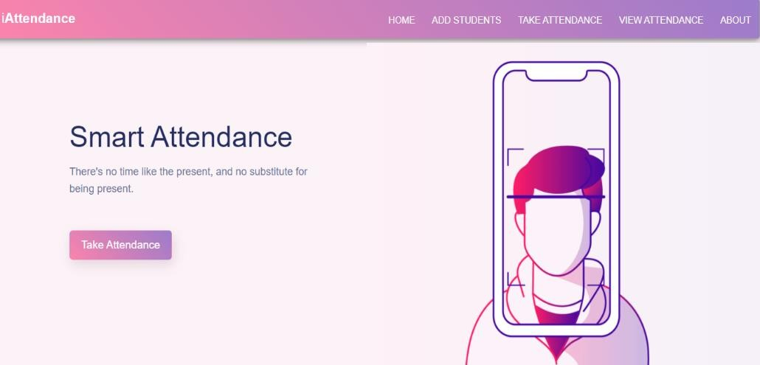

## Figure 5.2 Home page

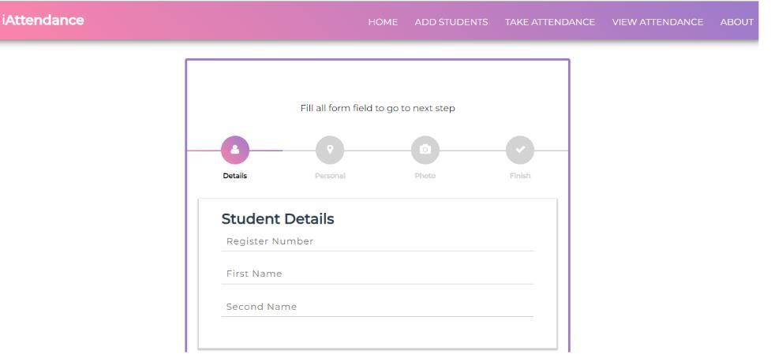

**Figure 5.3 Details page**



## Figure 5.4 Detected Image

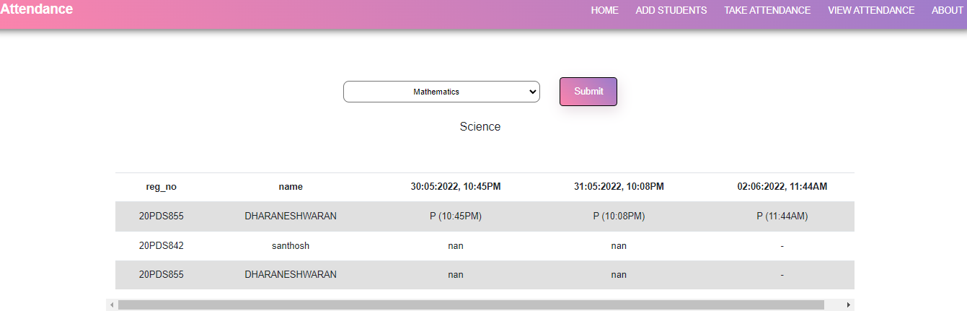

**Figure 5.5 Attendance marked**

## CHAPTER 6

**CONCLUSION**

The smart attendance system is proven to be an efficient system for classroom attendance. This system is non-intrusive and it reduces the chances of proxies and fake attendance. Many approaches for smart attendance system have been proposed but face recognition based approach is found to be the best method for smart attendance system. To take attendance a reliable system has to be made. We have implemented the same successfully in a classroom. Our system setup is very simple and easy to use, it requires a simple camera module and a pc to perform facial recognition. Also our system can be implemented on raspberry pi with internet enabled

## FUTURE WORK

The future work is to improve the recognition rate of my system when the faces of the students are half covered or when they are partially visible

## REFERENCE

1. Mohammad Ausaf Anwar, Durgaprasad Gangodkar, “Design and Implementation of Mobile Phones based Attendance Marking System”, Department of Computer Science Engineering, Graphic Era University, Dehradun, Uttarakhand, India, 2015.
2. Md. Milon Islam, Md. Kamrul Hasan, Md Masum Billah, Md. Manik Uddin, “Development of Smartphone-based Student Attendance System”, Department of Computer Science and Engineering Khulna University of Engineering & Technology, Khulna-9203, Bangladesh, 2017.
3. Jun Lio, “Attendance Management System using a Mobile Device and a Web Application”, Department of Socio-informatics, Faculty of Letters Chuo University 742-1 Higashinakano, Hachioji-shi, Tokyo 192-0393, Japan, 2016