**SLF4J LOGGING EXERCISES**

**Exercise 1: Logging Error Messages and Warning Levels**

**// pom.xml**

<!-- SLF4J API -->

<dependency>

<groupId>org.slf4j</groupId>

<artifactId>slf4j-api</artifactId>

<version>1.7.30</version>

</dependency>

<!-- Logback Classic (SLF4J backend) -->

<dependency>

<groupId>ch.qos.logback</groupId>

<artifactId>logback-classic</artifactId>

<version>1.2.3</version>

</dependency>

**// LoggingExample.java** (File: src/main/java/com/example/LoggingExample.java)

package org.example;

import org.slf4j.Logger;

import org.slf4j.LoggerFactory;

public class LoggingExample {

private static final Logger logger = LoggerFactory.getLogger(LoggingExample.class);

public static void main(String[] args) {

logger.error("This is an error message");

logger.warn("This is a warning message");

}

}

**Output:**

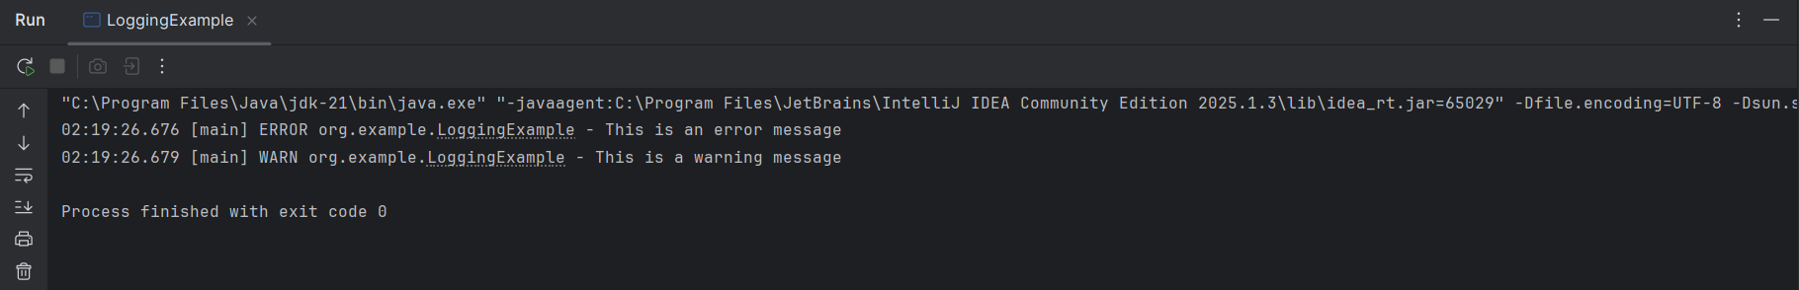

**Exercise 2: Parameterized Logging**

**// ParameterizedLoggingExample** (File: src/main/java/com/example/ParameterizedLoggingExample.java)

package org.example;

import org.slf4j.Logger;

import org.slf4j.LoggerFactory;

public class ParameterizedLoggingExample {

private static final Logger logger = LoggerFactory.getLogger(ParameterizedLoggingExample.class);

public static void main(String[] args) {

String username = "Dharaneeswari";

int loginAttempts = 3;

boolean accountLocked = true;

logger.info("User {} has logged in successfully.", username);

logger.warn("User {} has attempted to login {} times.", username, loginAttempts);

logger.error("Account locked status for user {}: {}", username, accountLocked);

}

}

**Output:**

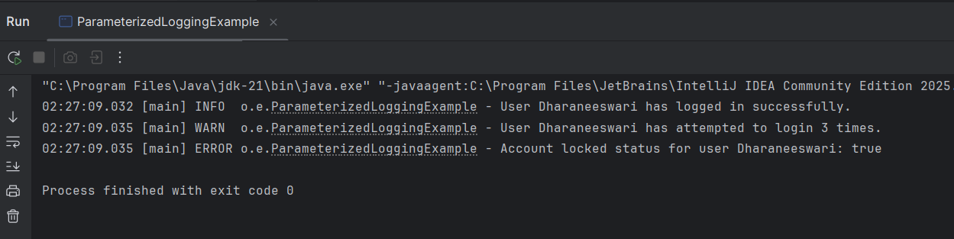

**Exercise 3: Using Different Appenders**

**// Logback.xml** (File: src/main/resources/logback.xml)

<configuration>

<!-- Console Appender -->

<appender name="console" class="ch.qos.logback.core.ConsoleAppender">

<encoder>

<pattern>%d{HH:mm:ss.SSS} [%thread] %-5level %logger{36} - %msg%n</pattern>

</encoder>

</appender>

<!-- File Appender -->

<appender name="file" class="ch.qos.logback.core.FileAppender">

<file>logs/app.log</file> <!-- Make sure the 'logs' folder exists or is created -->

<append>true</append>

<encoder>

<pattern>%d{HH:mm:ss.SSS} [%thread] %-5level %logger{36} - %msg%n</pattern>

</encoder>

</appender>

<!-- Root logger with both appenders -->

<root level="debug">

<appender-ref ref="console" />

<appender-ref ref="file" />

</root>

</configuration>

**// MultiAppenderExample** (File: src/main/java/com/example/MultiAppenderExample.java)

package org.example;

import org.slf4j.Logger;

import org.slf4j.LoggerFactory;

public class MultiAppenderExample {

private static final Logger logger = LoggerFactory.getLogger(MultiAppenderExample.class);

public static void main(String[] args) {

logger.info("This message will be logged to both console and file.");

logger.warn("This is a warning message.");

logger.error("This is an error message.");

}

}

**Output:**

