**Mockito - Mock Dependencies Exercises**

**Exercise 1: Mocking a Service Dependency in a Controller Test**

**// User.java**

package com.example.mockingrepo;

import jakarta.persistence.Entity;

import jakarta.persistence.Id;

@Entity

public class User {

@Id

private Long id;

private String name;

// Constructors

public User() {}

public User(Long id, String name) {

this.id = id;

this.name = name;

}

// Getters and Setters

public Long getId() {

return id;

}

public void setId(Long id) {

this.id = id;

}

public String getName() {

return name;

}

public void setName(String name) {

this.name = name;

}

}

**// UserService.java**

package com.example.mockingrepo;

import org.springframework.beans.factory.annotation.Autowired;

import org.springframework.stereotype.Service;

import java.util.Optional;

@Service

public class UserService {

@Autowired

private UserRepository userRepository;

public User getUserById(Long id) {

return userRepository.findById(id).orElse(null);

}

}

**// UserController.java**

package com.example.mockingrepo;

import org.springframework.beans.factory.annotation.Autowired;

import org.springframework.http.ResponseEntity;

import org.springframework.web.bind.annotation.*;

@RestController

@RequestMapping("/users")

public class UserController {

@Autowired

private UserService userService;

@GetMapping("/{id}")

public ResponseEntity<User> getUser(@PathVariable Long id) {

return ResponseEntity.ok(userService.getUserById(id));

}

}

**// UserControllerTest.java**

package com.example.mockingrepo;

import org.junit.jupiter.api.Test;

import org.mockito.Mockito;

import static org.mockito.Mockito.when;

import org.springframework.beans.factory.annotation.Autowired;

import org.springframework.boot.test.autoconfigure.web.servlet.WebMvcTest;

import org.springframework.boot.test.mock.mockito.MockBean;

import org.springframework.test.web.servlet.MockMvc;

import static org.springframework.test.web.servlet.request.MockMvcRequestBuilders.get;

import static org.springframework.test.web.servlet.result.MockMvcResultMatchers.*;

@WebMvcTest(UserController.class)

public class UserControllerTest {

@Autowired

private MockMvc mockMvc;

@MockBean

private UserService userService;

@Test

void testGetUser() throws Exception {

User mockUser = new User(1L, "John Doe");

// Mock the service

when(userService.getUserById(1L)).thenReturn(mockUser);

// Perform GET /users/1 and verify response

mockMvc.perform(get("/users/1"))

.andExpect(status().isOk())

.andExpect(jsonPath("$.id").value(1L))

.andExpect(jsonPath("$.name").value("John Doe"));

}

}

**Output:**

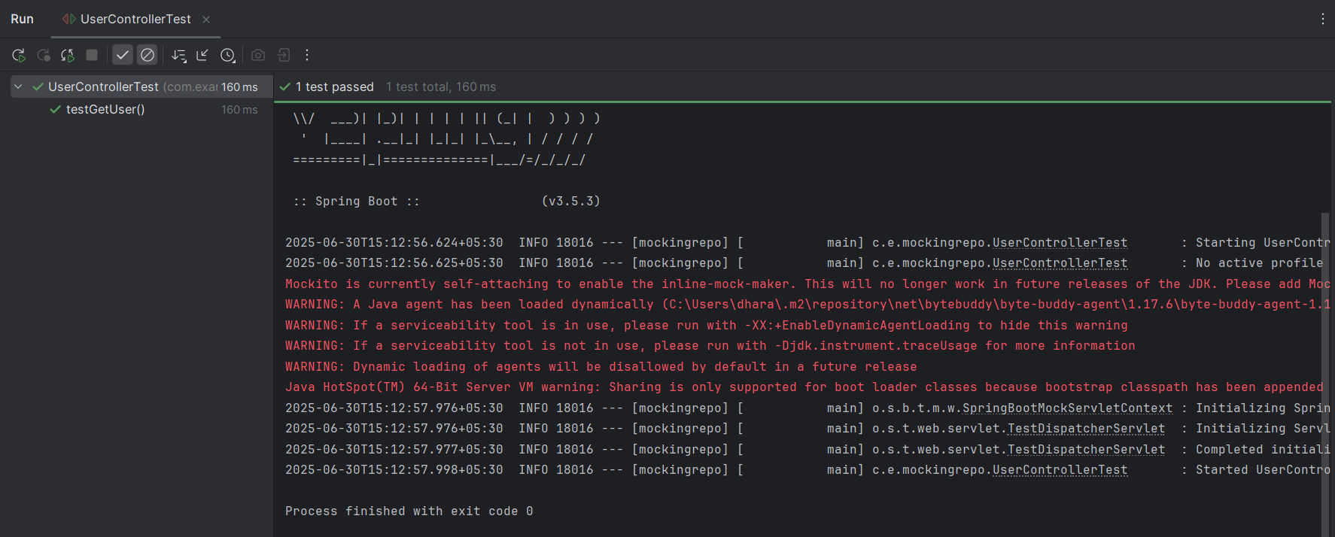

**Exercise 2: Mocking a Repository in a Service Test**

**// User.java**

package com.example.mockingrepo;

import jakarta.persistence.Entity;

import jakarta.persistence.Id;

@Entity

public class User {

@Id

private Long id;

private String name;

public User() {}

public User(Long id, String name) {

this.id = id;

this.name = name;

}

// Getters and setters

public Long getId() {

return id;

}

public void setId(Long id) {

this.id = id;

}

public String getName() {

return name;

}

public void setName(String name) {

this.name = name;

}

}

**// UserRepository.java**

package com.example.mockingrepo;

import org.springframework.data.jpa.repository.JpaRepository;

public interface UserRepository extends JpaRepository<User, Long> {

}

**// UserService.java**

package com.example.mockingrepo;

import org.springframework.beans.factory.annotation.Autowired;

import org.springframework.stereotype.Service;

@Service

public class UserService {

@Autowired

private UserRepository userRepository;

public User getUserById(Long id) {

return userRepository.findById(id).orElse(null);

}

}

**// UserServiceTest.java**

package com.example.mockingrepo;

import org.junit.jupiter.api.Test;

import org.mockito.InjectMocks;

import org.mockito.Mock;

import org.mockito.MockitoAnnotations;

import java.util.Optional;

import static org.junit.jupiter.api.Assertions.*;

import static org.mockito.Mockito.when;

public class UserServiceTest {

@Mock

private UserRepository userRepository;

@InjectMocks

private UserService userService;

public UserServiceTest() {

MockitoAnnotations.openMocks(this); // Initialize mocks

}

@Test

public void testGetUserById() {

// Arrange

User mockUser = new User(1L, "Alice");

when(userRepository.findById(1L)).thenReturn(Optional.of(mockUser));

// Act

User result = userService.getUserById(1L);

// Assert

assertNotNull(result);

assertEquals(1L, result.getId());

assertEquals("Alice", result.getName());

}

@Test

public void testGetUserById_NotFound() {

// Arrange

when(userRepository.findById(2L)).thenReturn(Optional.empty());

// Act

User result = userService.getUserById(2L);

// Assert

assertNull(result);

}

}

**Output:**

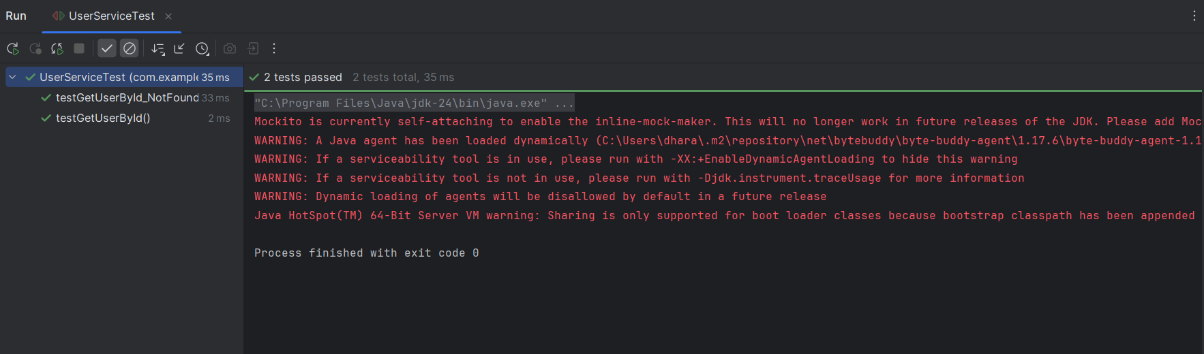

**Exercise 3: Mocking a Service Dependency in an Integration Test**

**// User.java**

package com.example.mockingrepo;

import jakarta.persistence.Entity;

import jakarta.persistence.Id;

@Entity

public class User {

@Id

private Long id;

private String name;

public User() {}

public User(Long id, String name) {

this.id = id;

this.name = name;

}

// Getters and setters

public Long getId() { return id; }

public void setId(Long id) { this.id = id; }

public String getName() { return name; }

public void setName(String name) { this.name = name; }

}

**// UserService.java**

package com.example.mockingrepo;

import org.springframework.beans.factory.annotation.Autowired;

import org.springframework.stereotype.Service;

@Service

public class UserService {

@Autowired

private UserRepository userRepository;

public User getUserById(Long id) {

return userRepository.findById(id).orElse(null);

}

}

**// UserController.java**

package com.example.mockingrepo;

import org.springframework.beans.factory.annotation.Autowired;

import org.springframework.http.ResponseEntity;

import org.springframework.web.bind.annotation.*;

@RestController

@RequestMapping("/users")

public class UserController {

@Autowired

private UserService userService;

@GetMapping("/{id}")

public ResponseEntity<User> getUser(@PathVariable Long id) {

User user = userService.getUserById(id);

return ResponseEntity.ok(user);

}

}

**// UserIntegrationTest.java**

package com.example.mockingrepo;

import org.junit.jupiter.api.Test;

import org.springframework.beans.factory.annotation.Autowired;

import org.springframework.boot.test.autoconfigure.web.servlet.AutoConfigureMockMvc;

import org.springframework.boot.test.context.SpringBootTest;

import org.springframework.boot.test.mock.mockito.MockBean;

import org.springframework.http.MediaType;

import org.springframework.test.web.servlet.MockMvc;

import static org.mockito.Mockito.when;

import static org.springframework.test.web.servlet.request.MockMvcRequestBuilders.get;

import static org.springframework.test.web.servlet.result.MockMvcResultMatchers.*;

@SpringBootTest

@AutoConfigureMockMvc

public class UserIntegrationTest {

@Autowired

private MockMvc mockMvc;

@MockBean

private UserService userService; // Mocked instead of real bean

@Test

public void testGetUserById() throws Exception {

User mockUser = new User(1L, "Alice");

when(userService.getUserById(1L)).thenReturn(mockUser);

mockMvc.perform(get("/users/1"))

.andExpect(status().isOk())

.andExpect(content().contentType(MediaType.APPLICATION_JSON))

.andExpect(jsonPath("$.id").value(1))

.andExpect(jsonPath("$.name").value("Alice"));

}

}

**Output:**

