**SPRING CORE AND MAVEN**

**Exercise 1: Configuring a Basic Spring Application**

**// pom.xml**

<project xmlns="http://maven.apache.org/POM/4.0.0"

xmlns:xsi="http://www.w3.org/2001/XMLSchema-instance"

xsi:schemaLocation="http://maven.apache.org/POM/4.0.0

http://maven.apache.org/xsd/maven-4.0.0.xsd">

<modelVersion>4.0.0</modelVersion>

<groupId>com.library</groupId>

<artifactId>LibraryManagement</artifactId>

<version>1.0-SNAPSHOT</version>

<dependencies>

<!-- Spring Core -->

<dependency>

<groupId>org.springframework</groupId>

<artifactId>spring-context</artifactId>

<version>5.3.34</version>

</dependency>

</dependencies>

</project>

**// applicationContext.xml**

<?xml version="1.0" encoding="UTF-8"?>

<beans xmlns="http://www.springframework.org/schema/beans"

xmlns:xsi="http://www.w3.org/2001/XMLSchema-instance"

xsi:schemaLocation="http://www.springframework.org/schema/beans

http://www.springframework.org/schema/beans/spring-beans.xsd">

<!-- Define BookRepository Bean -->

<bean id="bookRepository" class="com.library.repository.BookRepository" />

<!-- Define BookService Bean and inject BookRepository -->

<bean id="bookService" class="com.library.service.BookService">

<property name="bookRepository" ref="bookRepository" />

</bean>

</beans>

**// BookRepository.java**

package com.library.repository;

public class BookRepository {

public void saveBook(String title) {

System.out.println("Saving book: " + title);

}

}

**// BookService.java**

package com.library.service;

import com.library.repository.BookRepository;

public class BookService {

private BookRepository bookRepository;

// Setter for Dependency Injection

public void setBookRepository(BookRepository bookRepository) {

this.bookRepository = bookRepository;

}

public void addBook(String title) {

System.out.println("Adding book: " + title);

bookRepository.saveBook(title);

}

}

**// MainApp.java**

package com.library;

import org.springframework.context.ApplicationContext;

import org.springframework.context.support.ClassPathXmlApplicationContext;

import com.library.service.BookService;

public class MainApp {

public static void main(String[] args) {

// Load Spring Context

ApplicationContext context = new ClassPathXmlApplicationContext("applicationContext.xml");

// Get BookService bean

BookService bookService = (BookService) context.getBean("bookService");

// Use the service

bookService.addBook("Spring in Action");

}

}

**Output:**

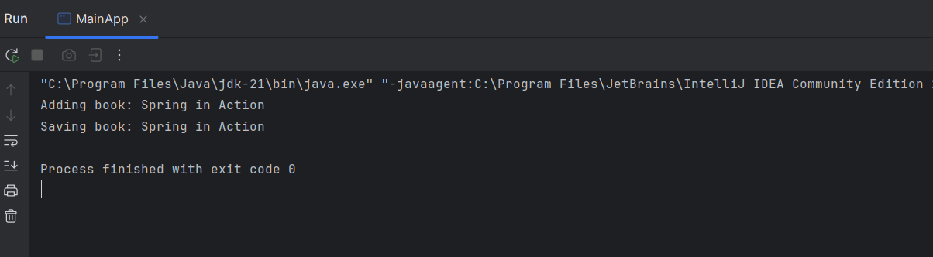

**Exercise 2: Implementing Dependency Injection**

**// applicationContext.xml**

<?xml version="1.0" encoding="UTF-8"?>

<beans xmlns="http://www.springframework.org/schema/beans"

xmlns:xsi="http://www.w3.org/2001/XMLSchema-instance"

xsi:schemaLocation="

http://www.springframework.org/schema/beans

http://www.springframework.org/schema/beans/spring-beans.xsd">

<!-- BookRepository Bean -->

<bean id="bookRepository" class="com.library.repository.BookRepository" />

<!-- BookService Bean with setter injection of BookRepository -->

<bean id="bookService" class="com.library.service.BookService">

<property name="bookRepository" ref="bookRepository" />

</bean>

</beans>

**// BookService.java**

package com.library.service;

import com.library.repository.BookRepository;

public class BookService {

private BookRepository bookRepository;

// Setter method for DI

public void setBookRepository(BookRepository bookRepository) {

this.bookRepository = bookRepository;

}

public void addBook(String title) {

System.out.println("Adding book: " + title);

bookRepository.saveBook(title);

}

}

**// MainApp.java**

package com.library;

import org.springframework.context.ApplicationContext;

import org.springframework.context.support.ClassPathXmlApplicationContext;

import com.library.service.BookService;

public class MainApp {

public static void main(String[] args) {

ApplicationContext context = new ClassPathXmlApplicationContext("applicationContext.xml");

// Get BookService bean

BookService bookService = (BookService) context.getBean("bookService");

// Call method to test DI

bookService.addBook("Clean Code");

}

}

**Output:**

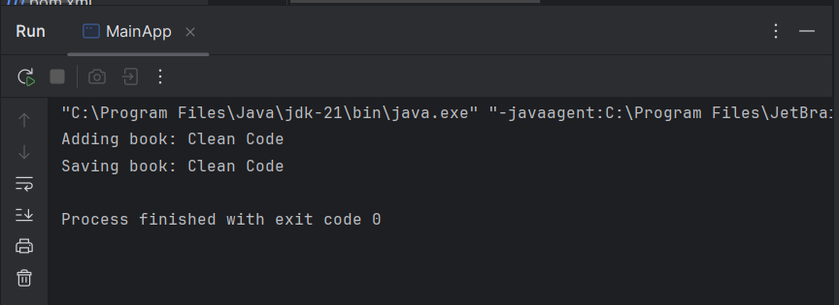

**Exercise 3: Implementing Logging with Spring AOP**

**// pom.xml**

<dependencies>

<!-- Spring Context (already present) -->

<dependency>

<groupId>org.springframework</groupId>

<artifactId>spring-context</artifactId>

<version>5.3.34</version>

</dependency>

<!-- Spring AOP -->

<dependency>

<groupId>org.springframework</groupId>

<artifactId>spring-aspects</artifactId>

<version>5.3.34</version>

</dependency>

<!-- AspectJ runtime -->

<dependency>

<groupId>org.aspectj</groupId>

<artifactId>aspectjweaver</artifactId>

<version>1.9.21</version>

</dependency>

</dependencies>

**// LoggingAspect.java**

package com.library.aspect;

import org.aspectj.lang.ProceedingJoinPoint;

import org.aspectj.lang.annotation.Around;

import org.aspectj.lang.annotation.Aspect;

@Aspect

public class LoggingAspect {

@Around("execution(* com.library.service.*.*(..))")

public Object logExecutionTime(ProceedingJoinPoint joinPoint) throws Throwable {

long start = System.currentTimeMillis();

Object result = joinPoint.proceed(); // Proceed with actual method

long duration = System.currentTimeMillis() - start;

System.out.println("Executed " + joinPoint.getSignature() + " in " + duration + "ms");

return result;

}

}

**// applicationContext.xml**

<?xml version="1.0" encoding="UTF-8"?>

<beans xmlns="http://www.springframework.org/schema/beans"

xmlns:xsi="http://www.w3.org/2001/XMLSchema-instance"

xmlns:aop="http://www.springframework.org/schema/aop"

xsi:schemaLocation="

http://www.springframework.org/schema/beans

http://www.springframework.org/schema/beans/spring-beans.xsd

http://www.springframework.org/schema/aop

http://www.springframework.org/schema/aop/spring-aop.xsd">

<!-- Enable AOP support -->

<aop:aspectj-autoproxy />

<!-- Define aspect bean -->

<bean id="loggingAspect" class="com.library.aspect.LoggingAspect" />

<!-- Define BookRepository -->

<bean id="bookRepository" class="com.library.repository.BookRepository" />

<!-- Define BookService and inject BookRepository -->

<bean id="bookService" class="com.library.service.BookService">

<property name="bookRepository" ref="bookRepository" />

</bean>

</beans>

**// MainApp.java**

package com.library;

import org.springframework.context.ApplicationContext;

import org.springframework.context.support.ClassPathXmlApplicationContext;

import com.library.service.BookService;

public class MainApp {

public static void main(String[] args) {

ApplicationContext context = new ClassPathXmlApplicationContext("applicationContext.xml");

BookService bookService = (BookService) context.getBean("bookService");

bookService.addBook("Effective Java");

}

}

**Output:**

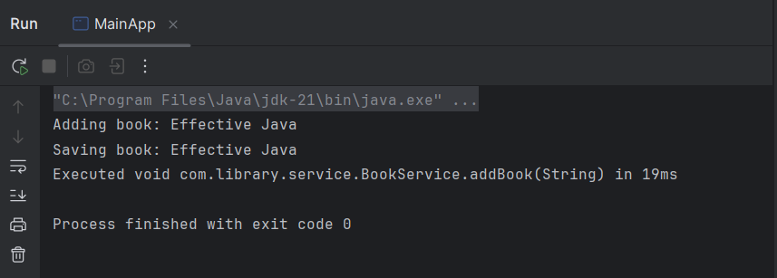

**Exercise 4: Creating and Configuring a Maven Project**

**// pom.xml**

<project xmlns="http://maven.apache.org/POM/4.0.0"

xmlns:xsi="http://www.w3.org/2001/XMLSchema-instance"

xsi:schemaLocation="http://maven.apache.org/POM/4.0.0

http://maven.apache.org/xsd/maven-4.0.0.xsd">

<modelVersion>4.0.0</modelVersion>

<groupId>com.library</groupId>

<artifactId>LibraryManagement</artifactId>

<version>1.0-SNAPSHOT</version>

<properties>

<maven.compiler.source>1.8</maven.compiler.source>

<maven.compiler.target>1.8</maven.compiler.target>

</properties>

<dependencies>

<!-- Spring Context (Core, Beans, Context) -->

<dependency>

<groupId>org.springframework</groupId>

<artifactId>spring-context</artifactId>

<version>5.3.34</version>

</dependency>

<!-- Spring AOP -->

<dependency>

<groupId>org.springframework</groupId>

<artifactId>spring-aspects</artifactId>

<version>5.3.34</version>

</dependency>

<!-- Spring WebMVC (for future web support) -->

<dependency>

<groupId>org.springframework</groupId>

<artifactId>spring-webmvc</artifactId>

<version>5.3.34</version>

</dependency>

<!-- AspectJ runtime -->

<dependency>

<groupId>org.aspectj</groupId>

<artifactId>aspectjweaver</artifactId>

<version>1.9.21</version>

</dependency>

</dependencies>

<build>

<plugins>

<!-- Maven Compiler Plugin for Java 1.8 -->

<plugin>

<groupId>org.apache.maven.plugins</groupId>

<artifactId>maven-compiler-plugin</artifactId>

<version>3.10.1</version>

<configuration>

<source>1.8</source>

<target>1.8</target>

</configuration>

</plugin>

</plugins>

</build>

</project>

**Exercise 5: Configuring the Spring IoC Container**

**// applicationContext.xml**

<?xml version="1.0" encoding="UTF-8"?>

<beans xmlns="http://www.springframework.org/schema/beans"

xmlns:xsi="http://www.w3.org/2001/XMLSchema-instance"

xsi:schemaLocation="

http://www.springframework.org/schema/beans

http://www.springframework.org/schema/beans/spring-beans.xsd">

<!-- Define BookRepository Bean -->

<bean id="bookRepository" class="com.library.repository.BookRepository" />

<!-- Define BookService Bean with setter injection -->

<bean id="bookService" class="com.library.service.BookService">

<property name="bookRepository" ref="bookRepository" />

</bean>

</beans>

**// BookService.java**

package com.library.service;

import com.library.repository.BookRepository;

public class BookService {

private BookRepository bookRepository;

// Setter for Dependency Injection

public void setBookRepository(BookRepository bookRepository) {

this.bookRepository = bookRepository;

}

public void addBook(String title) {

System.out.println("Adding book: " + title);

bookRepository.saveBook(title);

}

}

**// BookRepository.java**

package com.library.repository;

public class BookRepository {

public void saveBook(String title) {

System.out.println("Saving book: " + title);

}

}

**// MainApp.java**

package com.library;

import com.library.service.BookService;

import org.springframework.context.ApplicationContext;

import org.springframework.context.support.ClassPathXmlApplicationContext;

public class MainApp {

public static void main(String[] args) {

// Load Spring container using applicationContext.xml

ApplicationContext context = new ClassPathXmlApplicationContext("applicationContext.xml");

// Retrieve the bean and call its method

BookService bookService = (BookService) context.getBean("bookService");

bookService.addBook("The Pragmatic Programmer");

}

}

**Output:**

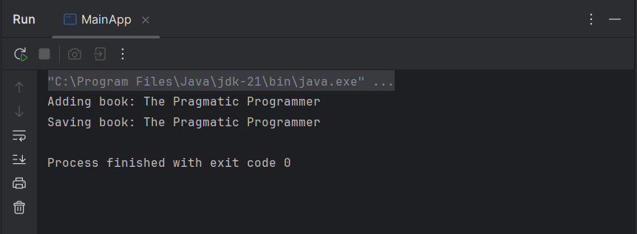

**Exercise 6: Configuring Beans with Annotations**

**// applicationContext.xml**

<?xml version="1.0" encoding="UTF-8"?>

<beans xmlns="http://www.springframework.org/schema/beans"

xmlns:context="http://www.springframework.org/schema/context"

xmlns:xsi="http://www.w3.org/2001/XMLSchema-instance"

xsi:schemaLocation="

http://www.springframework.org/schema/beans

http://www.springframework.org/schema/beans/spring-beans.xsd

http://www.springframework.org/schema/context

http://www.springframework.org/schema/context/spring-context.xsd">

<!-- Enable annotation-based configuration -->

<context:component-scan base-package="com.library" />

</beans>

**// BookRepository.java**

package com.library.repository;

import org.springframework.stereotype.Repository;

@Repository

public class BookRepository {

public void saveBook(String title) {

System.out.println("Saving book: " + title);

}

}

**// BookService.java**

package com.library.service;

import com.library.repository.BookRepository;

import org.springframework.beans.factory.annotation.Autowired;

import org.springframework.stereotype.Service;

@Service

public class BookService {

private BookRepository bookRepository;

@Autowired // Setter Injection (you can also use Constructor or Field)

public void setBookRepository(BookRepository bookRepository) {

this.bookRepository = bookRepository;

}

public void addBook(String title) {

System.out.println("Adding book: " + title);

bookRepository.saveBook(title);

}

}

**// MainApp.java**

package com.library;

import com.library.service.BookService;

import org.springframework.context.ApplicationContext;

import org.springframework.context.support.ClassPathXmlApplicationContext;

public class MainApp {

public static void main(String[] args) {

ApplicationContext context = new ClassPathXmlApplicationContext("applicationContext.xml");

BookService bookService = context.getBean(BookService.class);

bookService.addBook("Clean Architecture");

}

}

**Output:**

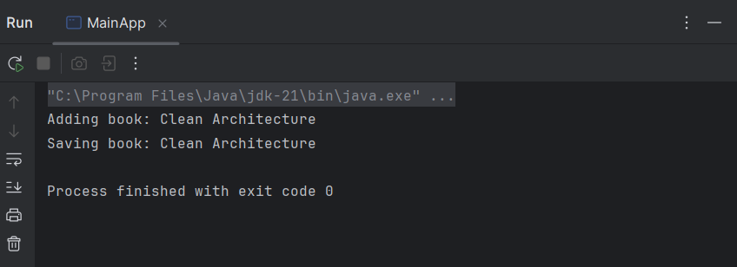

**Exercise 7: Implementing Constructor and Setter Injection**

**// applicationContext.xml**

<?xml version="1.0" encoding="UTF-8"?>

<beans xmlns="http://www.springframework.org/schema/beans"

xmlns:xsi="http://www.w3.org/2001/XMLSchema-instance"

xsi:schemaLocation="

http://www.springframework.org/schema/beans

http://www.springframework.org/schema/beans/spring-beans.xsd">

<!-- BookRepository Bean -->

<bean id="bookRepository" class="com.library.repository.BookRepository" />

<!-- BookService Bean with both constructor and setter injection -->

<bean id="bookService" class="com.library.service.BookService">

<!-- Constructor Injection -->

<constructor-arg value="Fiction" /> <!-- Injecting category -->

<!-- Setter Injection -->

<property name="bookRepository" ref="bookRepository" />

</bean>

</beans>

**// BookService.java**

package com.library.service;

import com.library.repository.BookRepository;

public class BookService {

private BookRepository bookRepository;

private String category; // This will be injected via constructor

// Constructor for injecting category (constructor injection)

public BookService(String category) {

this.category = category;

}

// Setter for injecting repository (setter injection)

public void setBookRepository(BookRepository bookRepository) {

this.bookRepository = bookRepository;

}

public void addBook(String title) {

System.out.println("Adding [" + category + "] book: " + title);

bookRepository.saveBook(title);

}

}

**// BookRepository.java**

package com.library.repository;

public class BookRepository {

public void saveBook(String title) {

System.out.println("Saving book: " + title);

}

}

**// MainApp.java**

package com.library;

import com.library.service.BookService;

import org.springframework.context.ApplicationContext;

import org.springframework.context.support.ClassPathXmlApplicationContext;

public class MainApp {

public static void main(String[] args) {

ApplicationContext context = new ClassPathXmlApplicationContext("applicationContext.xml");

BookService bookService = context.getBean(BookService.class);

bookService.addBook("The Hobbit");

}

}

**Output:**

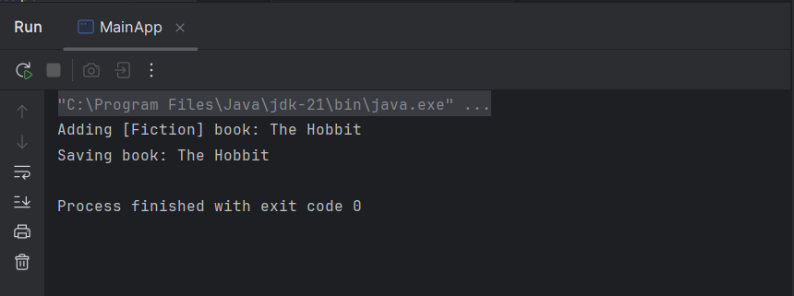

**Exercise 8: Implementing Basic AOP with Spring using Spring AOP and XML configuration**

**// LoggingAspect.java**

package com.library.aspect;

import org.aspectj.lang.JoinPoint;

import org.aspectj.lang.annotation.After;

import org.aspectj.lang.annotation.Aspect;

import org.aspectj.lang.annotation.Before;

@Aspect

public class LoggingAspect {

@Before("execution(* com.library.service.*.*(..))")

public void logBefore(JoinPoint joinPoint) {

System.out.println("Before: " + joinPoint.getSignature().getName() + " is about to execute");

}

@After("execution(* com.library.service.*.*(..))")

public void logAfter(JoinPoint joinPoint) {

System.out.println("After: " + joinPoint.getSignature().getName() + " has executed");

}

}

**// MainApp.java**

package com.library;

import com.library.service.BookService;

import org.springframework.context.ApplicationContext;

import org.springframework.context.support.ClassPathXmlApplicationContext;

public class MainApp {

public static void main(String[] args) {

ApplicationContext context = new ClassPathXmlApplicationContext("applicationContext.xml");

BookService bookService = context.getBean(BookService.class);

bookService.addBook("Refactoring");

}

}

**// pom.xml**

<dependencies>

<dependency>

<groupId>org.springframework</groupId>

<artifactId>spring-context</artifactId>

<version>5.3.34</version>

</dependency>

<dependency>

<groupId>org.springframework</groupId>

<artifactId>spring-aspects</artifactId>

<version>5.3.34</version>

</dependency>

<dependency>

<groupId>org.aspectj</groupId>

<artifactId>aspectjweaver</artifactId>

<version>1.9.21</version>

</dependency>

</dependencies>

**Output:**

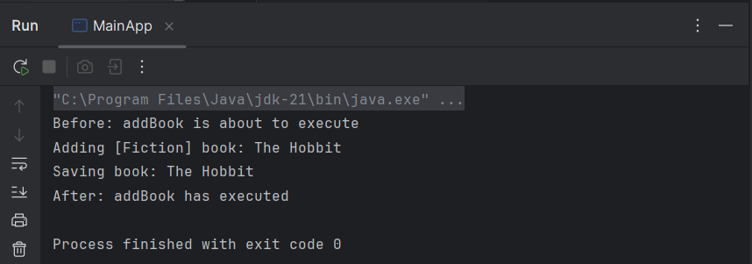

**Exercise 9: Creating a Spring Boot Application**

**// pom.xml**

<dependencies>

<dependency>

<groupId>org.springframework.boot</groupId>

<artifactId>spring-boot-starter-web</artifactId>

</dependency>

<dependency>

<groupId>org.springframework.boot</groupId>

<artifactId>spring-boot-starter-data-jpa</artifactId>

</dependency>

<dependency>

<groupId>com.h2database</groupId>

<artifactId>h2</artifactId>

<scope>runtime</scope>

</dependency>

</dependencies>

**// application.properties**

# H2 in-memory DB configuration

spring.datasource.url=jdbc:h2:mem:librarydb

spring.datasource.driverClassName=org.h2.Driver

spring.datasource.username=sa

spring.datasource.password=

# JPA & Hibernate

spring.jpa.database-platform=org.hibernate.dialect.H2Dialect

spring.jpa.hibernate.ddl-auto=update

spring.h2.console.enabled=true

**// Book.java**

package com.library.entity;

import jakarta.persistence.*;

@Entity

public class Book {

@Id

@GeneratedValue(strategy = GenerationType.IDENTITY)

private Long id;

private String title;

private String author;

// Constructors

public Book() {}

public Book(String title, String author) {

this.title = title;

this.author = author;

}

// Getters & Setters

public Long getId() { return id; }

public void setId(Long id) { this.id = id; }

public String getTitle() { return title; }

public void setTitle(String title) { this.title = title; }

public String getAuthor() { return author; }

public void setAuthor(String author) { this.author = author; }

}

**// BookRepository.java**

package com.library.repository;

import com.library.entity.Book;

import org.springframework.data.jpa.repository.JpaRepository;

public interface BookRepository extends JpaRepository<Book, Long> {

}

**// BookController.java**

package com.library.controller;

import com.library.entity.Book;

import com.library.repository.BookRepository;

import org.springframework.beans.factory.annotation.Autowired;

import org.springframework.web.bind.annotation.*;

import java.util.List;

@RestController

@RequestMapping("/api/books")

public class BookController {

@Autowired

private BookRepository bookRepository;

@GetMapping

public List<Book> getAllBooks() {

return bookRepository.findAll();

}

@PostMapping

public Book createBook(@RequestBody Book book) {

return bookRepository.save(book);

}

@GetMapping("/{id}")

public Book getBookById(@PathVariable Long id) {

return bookRepository.findById(id).orElseThrow(() -> new RuntimeException("Book not found"));

}

@PutMapping("/{id}")

public Book updateBook(@PathVariable Long id, @RequestBody Book updatedBook) {

Book book = bookRepository.findById(id).orElseThrow(() -> new RuntimeException("Book not found"));

book.setTitle(updatedBook.getTitle());

book.setAuthor(updatedBook.getAuthor());

return bookRepository.save(book);

}

@DeleteMapping("/{id}")

public void deleteBook(@PathVariable Long id) {

bookRepository.deleteById(id);

}

}

**// LibraryManagementApplication.java**

package com.library;

import org.springframework.boot.SpringApplication;

import org.springframework.boot.autoconfigure.SpringBootApplication;

@SpringBootApplication

public class LibraryManagementApplication {

public static void main(String[] args) {

SpringApplication.run(LibraryManagementApplication.class, args);

}

}

**Output:**

