**React**

**Exercise 1:**

**// App.js**

function App() {

  return <h1>Hello from React</h1>;

}

export default App;

**Output:**

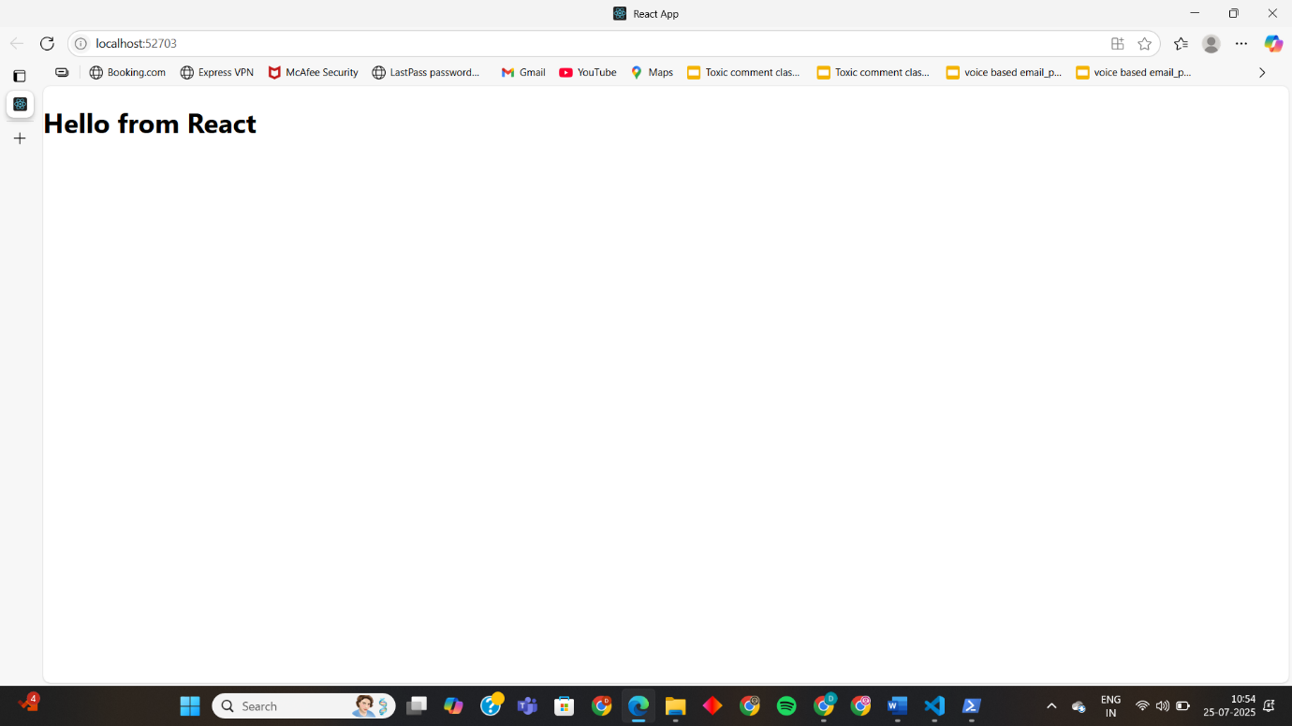

**Exercise 2:**

**// App.js**

import { Home } from "./Components/Home";

import { About } from "./Components/About";

import { Contact } from "./Components/Contact";

function App() {

  return (

    <div className="container">

      <Home />

      <About />

      <Contact />

    </div>

  );

}

export default App;

**// Home.js**

import React, { Component } from "react";

class Home extends Component {

  render() {

    return (

      <div>

        <h3>Welcome to the Home Page of the Student Management Portal</h3>

      </div>

    );

  }

}

export default Home;

**// About.js**

import React, { Component } from "react";

class About extends Component {

  render() {

    return (

      <div>

        <h3>Welcome to the About Page of the Student Management Portal</h3>

      </div>

    );

  }

}

export default About;

**// Contact.js**

import React, { Component } from "react";

class Contact extends Component {

  render() {

    return (

      <div>

        <h3>Welcome to the Contact Page of the Student Management Portal</h3>

      </div>

    );

  }

}

export default Contact;

**Output:**

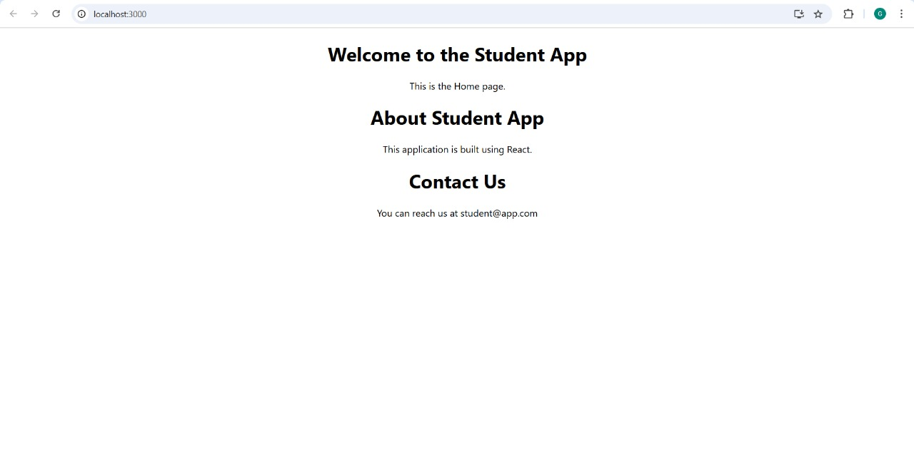

**Exercise 3: Student Management Portal**

**// src/Components/CalculateScore.js**

import React, { useState } from "react";

import "../Stylesheets/mystyle.css";

const CalculateScore = () => {

const [name, setName] = useState("");

const [school, setSchool] = useState("");

const [total, setTotal] = useState("");

const [goal, setGoal] = useState("");

const [average, setAverage] = useState(null);

const handleSubmit = (e) => {

e.preventDefault();

const avg = parseFloat(total) / parseFloat(goal);

setAverage(avg.toFixed(2));

};

return (

<div className="score-container">

<h2>Student Score Calculator</h2>

<form onSubmit={handleSubmit}>

<input

type="text"

placeholder="Enter Student Name"

value={name}

onChange={(e) => setName(e.target.value)}

/><br/>

<input

type="text"

placeholder="Enter School Name"

value={school}

onChange={(e) => setSchool(e.target.value)}

/><br/>

<input

type="number"

placeholder="Enter Total Score"

value={total}

onChange={(e) => setTotal(e.target.value)}

/><br/>

<input

type="number"

placeholder="Enter Goal (e.g., number of subjects)"

value={goal}

onChange={(e) => setGoal(e.target.value)}

/><br/>

<button type="submit">Calculate Average</button>

</form>

{average && (

<div className="result">

<h3>{name} from {school}</h3>

<p>Average Score: {average}</p>

</div>

)}

</div>

);

};

export default CalculateScore;

**// mystyle.css**

.score-container {

width: 300px;

margin: 40px auto;

padding: 20px;

border: 2px solid #1976d2;

border-radius: 8px;

background-color: #f0f8ff;

text-align: center;

}

input {

width: 90%;

margin: 8px 0;

padding: 8px;

border-radius: 4px;

border: 1px solid #aaa;

}

button {

padding: 8px 16px;

background-color: #1976d2;

color: white;

border: none;

border-radius: 4px;

cursor: pointer;

}

.result {

margin-top: 20px;

}

**// App.js**

import React from "react";

import CalculateScore from "./Components/CalculateScore";

function App() {

return (

<div className="App">

<CalculateScore />

</div>

);

}

export default App;

**Output:**

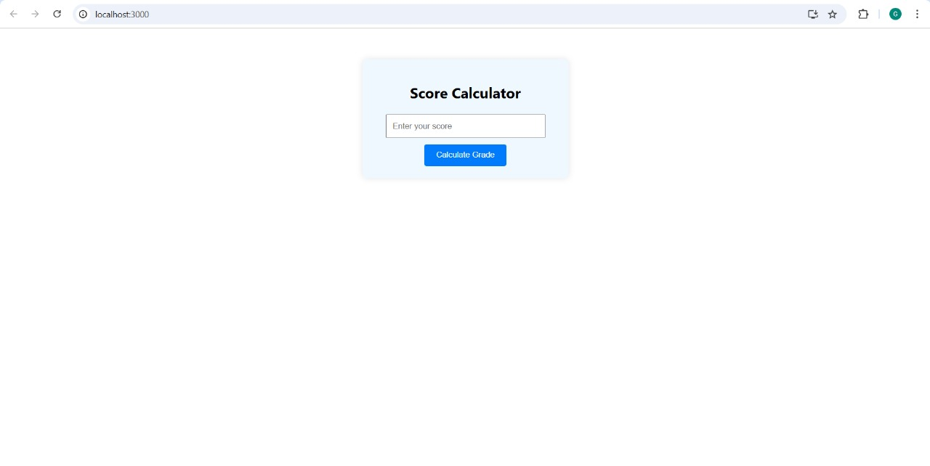

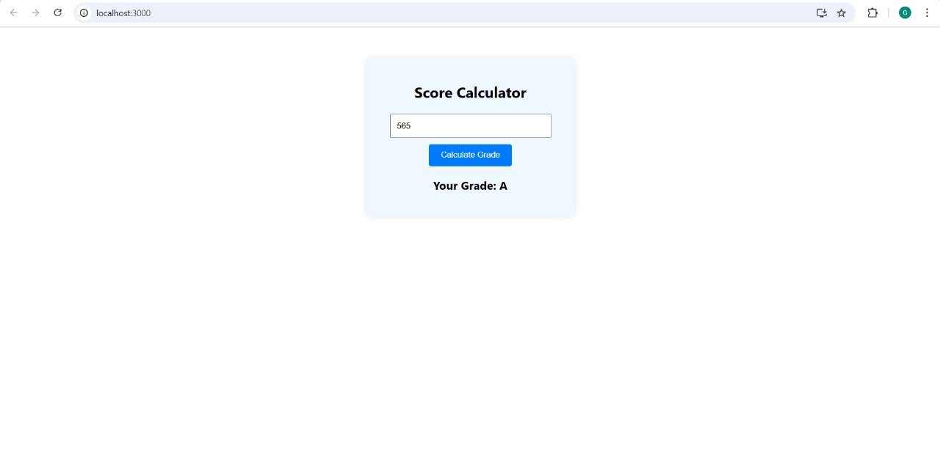

**Exercise 4: Blog App**

**// Posts.js**

import React, { Component } from "react";

class Posts extends Component {

constructor(props) {

super(props);

this.state = {

posts: [],

hasError: false,

};

}

// Method to fetch posts from API

loadPosts = () => {

fetch("https://jsonplaceholder.typicode.com/posts")

.then((response) => {

if (!response.ok) throw new Error("Failed to fetch posts");

return response.json();

})

.then((data) => {

this.setState({ posts: data });

})

.catch((error) => {

this.setState({ hasError: true });

console.error("Fetch error:", error);

});

};

// Lifecycle method to call loadPosts

componentDidMount() {

this.loadPosts();

}

// Error boundary

componentDidCatch(error, info) {

alert("An error occurred in the component.");

console.error("Error info:", info);

}

render() {

const { posts, hasError } = this.state;

if (hasError) {

return <h2>Something went wrong.</h2>;

}

return (

<div>

<h1>Blog Posts</h1>

{posts.map((post) => (

<div key={post.id} style={{ marginBottom: "1rem" }}>

<h3>{post.title}</h3>

<p>{post.body}</p>

</div>

))}

</div>

);

}

}

export default Posts;

**// App.js**

import React from "react";

import Posts from "./Posts";

function App() {

return (

<div className="App">

<Posts />

</div>

);

}

export default App;

**Output:**

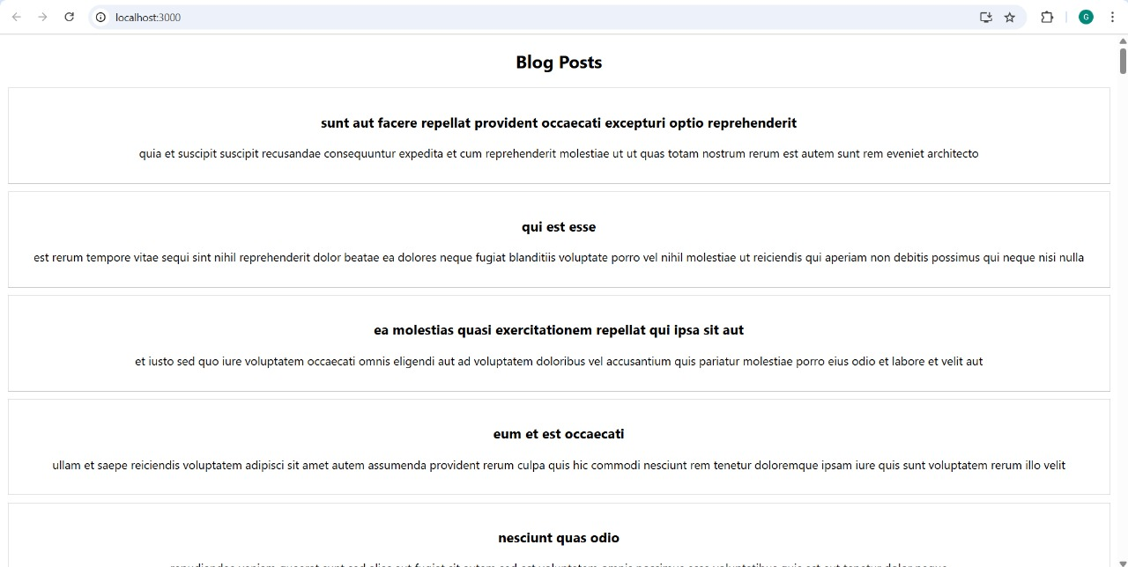

**Exercise 5: Cohort Tracker**

**// CohortDetails.css**

.box {

width: 300px;

display: inline-block;

margin: 10px;

padding: 10px 20px;

border: 1px solid black;

border-radius: 10px;

}

dt {

font-weight: 500;

}

**// CohortDetails.js**

import React from 'react';

import styles from './CohortDetails.module.css';

const CohortDetails = ({ cohort }) => {

const headingStyle = {

color: cohort.status === 'ongoing' ? 'green' : 'blue',

};

return (

<div className={styles.box}>

<h3 style={headingStyle}>{cohort.name}</h3>

<dl>

<dt>Status:</dt>

<dd>{cohort.status}</dd>

<dt>Start Date:</dt>

<dd>{cohort.startDate}</dd>

<dt>End Date:</dt>

<dd>{cohort.endDate}</dd>

</dl>

</div>

);

};

export default CohortDetails;

**// App.js**

import React from 'react';

import CohortDetails from './CohortDetails';

function App() {

const cohorts = [

{

name: 'React Bootcamp',

status: 'ongoing',

startDate: '2025-07-01',

endDate: '2025-08-15',

},

{

name: 'Node.js Training',

status: 'completed',

startDate: '2025-05-01',

endDate: '2025-06-15',

},

];

return (

<div>

<h2>Cohort Dashboard</h2>

{cohorts.map((cohort, index) => (

<CohortDetails key={index} cohort={cohort} />

))}

</div>

);

}

export default App;

**Output:**

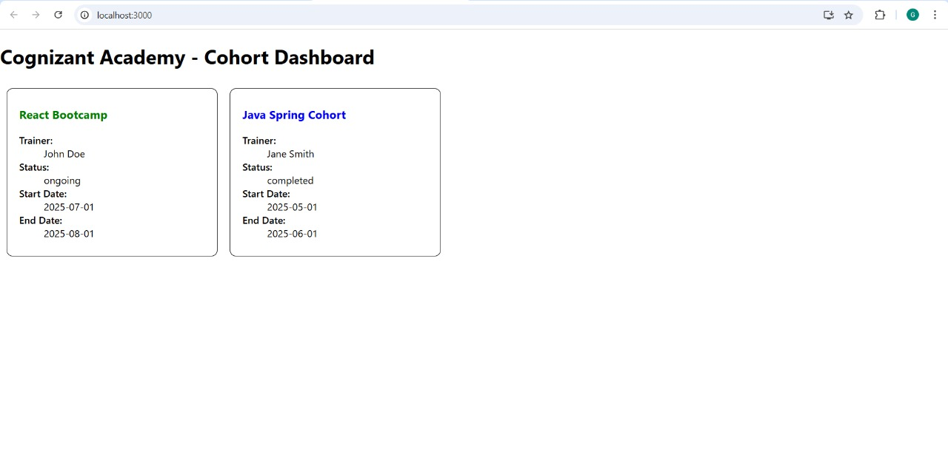

**Exercise 6: Trainers App**

**// src/trainer.js**

class Trainer {

constructor(trainerId, name, email, phone, technology, skills) {

this.trainerId = trainerId;

this.name = name;

this.email = email;

this.phone = phone;

this.technology = technology;

this.skills = skills;

}

}

export default Trainer;

**// src/TrainersMock.js**

import Trainer from "./trainer";

const trainers = [

new Trainer("T001", "Anil Kumar", "anil@example.com", "9876543210", "Java", ["Core Java", "Spring Boot"]),

new Trainer("T002", "Divya Sharma", "divya@example.com", "8765432109", "Python", ["Django", "Flask"]),

new Trainer("T003", "Rahul Roy", "rahul@example.com", "7654321098", "JavaScript", ["React", "Node.js"]),

new Trainer("T004", "Priya Mehta", "priya@example.com", "6543210987", "Data Science", ["Pandas", "NumPy", "TensorFlow"]),

];

export default trainers;

**// src/TrainerList.js**

import React from "react";

import { Link } from "react-router-dom";

function TrainersList({ trainers }) {

return (

<div>

<h2>Trainer List</h2>

<ul>

{trainers.map((trainer) => (

<li key={trainer.trainerId}>

<Link to={`/trainer/${trainer.trainerId}`}>{trainer.name}</Link>

</li>

))}

</ul>

</div>

);

}

export default TrainersList;

**// src/Home.js**

import React from "react";

function Home() {

return (

<div>

<h2>Welcome to Cognizant Academy Trainer App</h2>

<p>This portal maintains trainer details and their expertise.</p>

</div>

);

}

export default Home;

**// src/TrainerDetails.js**

import React from "react";

import { useParams } from "react-router-dom";

import trainers from "./TrainersMock";

function TrainerDetail() {

const { id } = useParams();

const trainer = trainers.find((t) => t.trainerId === id);

if (!trainer) {

return <p>Trainer not found</p>;

}

return (

<div>

<h2>Trainer Details</h2>

<p><strong>ID:</strong> {trainer.trainerId}</p>

<p><strong>Name:</strong> {trainer.name}</p>

<p><strong>Email:</strong> {trainer.email}</p>

<p><strong>Phone:</strong> {trainer.phone}</p>

<p><strong>Technology:</strong> {trainer.technology}</p>

<p><strong>Skills:</strong> {trainer.skills.join(", ")}</p>

</div>

);

}

export default TrainerDetail;

**// src/App.js**

import React from "react";

import { BrowserRouter as Router, Routes, Route, Link } from "react-router-dom";

import Home from "./Home";

import TrainersList from "./TrainerList";

import TrainerDetail from "./TrainerDetails";

import trainers from "./TrainersMock";

function App() {

return (

<Router>

<div>

<h1>Cognizant Trainers Portal</h1>

<nav>

<Link to="/">Home</Link> | <Link to="/trainers">Trainers</Link>

</nav>

<Routes>

<Route path="/" element={<Home />} />

<Route path="/trainers" element={<TrainersList trainers={trainers} />} />

<Route path="/trainer/:id" element={<TrainerDetail />} />

</Routes>

</div>

</Router>

);

}

export default App;

**Output:**

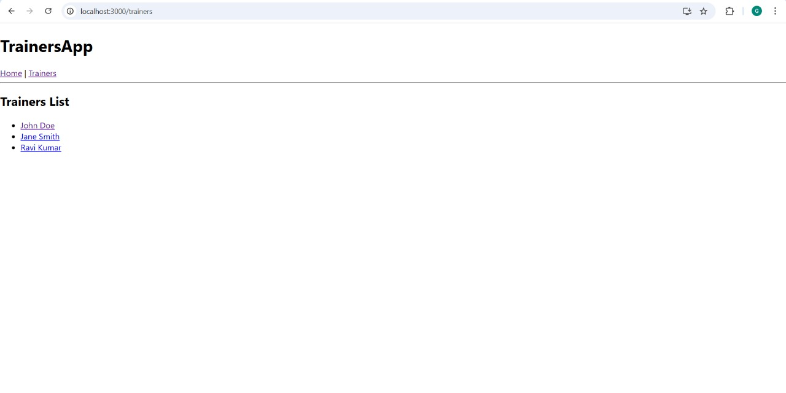

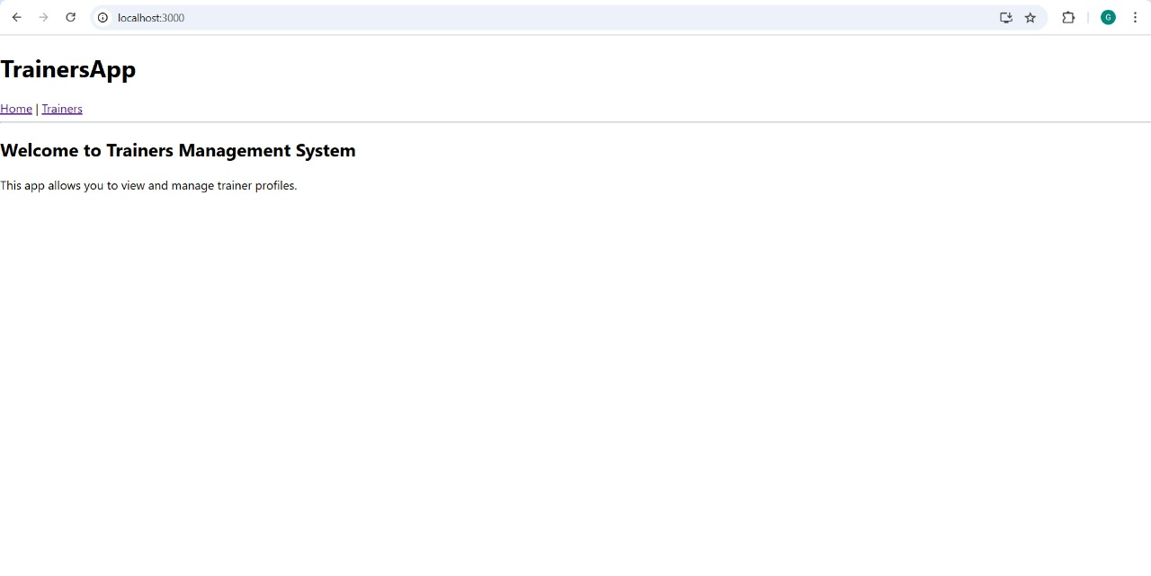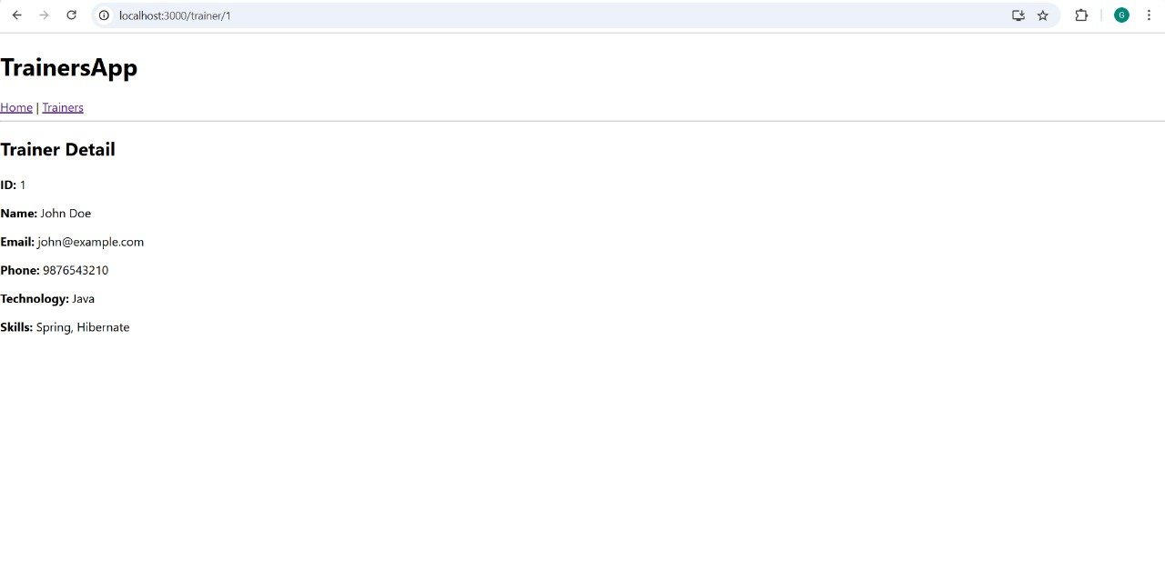

**Exercise 7: Online Shopping Cart**

**// App.js**

import React from 'react';

import './App.css';

const products = [

{ id: 1, name: "Smartphone", price: 14999 },

{ id: 2, name: "Bluetooth Speaker", price: 2999 },

{ id: 3, name: "Laptop", price: 59999 },

{ id: 4, name: "Wireless Mouse", price: 499 },

{ id: 5, name: "Smartwatch", price: 3999 }

];

function App() {

return (

<div className="app">

<h1>Online Shopping Cart</h1>

<div className="product-list">

{products.map(product => (

<div key={product.id} className="product-card">

<strong>{product.name}</strong>

<p>Price: ₹{product.price}</p>

</div>

))}

</div>

</div>

);

}

export default App;

**// App.css**

body {

margin: 0;

font-family: Arial, sans-serif;

background-color: #fff;

}

.app {

text-align: center;

margin-top: 20px;

}

h1 {

font-size: 24px;

margin-bottom: 30px;

font-weight: bold;

}

.product-list {

display: flex;

flex-direction: column;

align-items: flex-start;

margin-left: 30px;

}

.product-card {

border: 1px solid #ccc;

border-radius: 8px;

padding: 20px;

width: 250px;

margin-bottom: 15px;

box-shadow: 0 2px 5px rgba(0,0,0,0.1);

text-align: left;

}

.product-card strong {

display: block;

margin-bottom: 10px;

font-size: 16px;

}

**Output:**

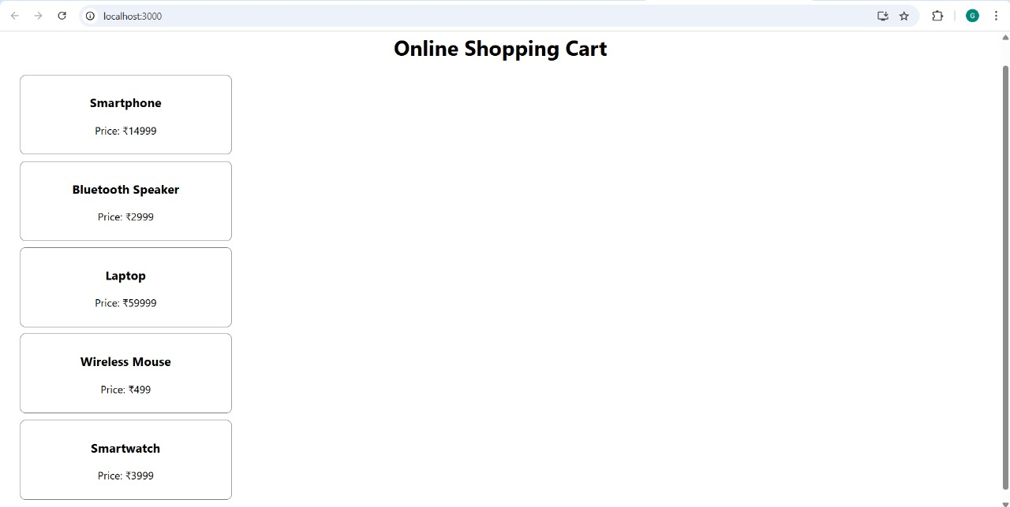

**Exercise 8: People Counting App**

**// App.js**

import React, { useState } from "react";

import "./App.css";

function App() {

const [entered, setEntered] = useState(0);

const [exited, setExited] = useState(0);

const handleLogin = () => {

setEntered(prev => prev + 1);

};

const handleExit = () => {

setExited(prev => (prev < entered ? prev + 1 : prev));

};

return (

<div className="container">

<h2>People Counting App</h2>

<p><stron

**// App.css**

.container {

text-align: center;

margin-top: 100px;

font-family: Arial, sans-serif;

}

h2 {

color: green;

}

button {

margin: 5px;

padding: 5px 10px;

font-size: 14px;

}

**Output:**

