Secure Model Supply Chain for Enterprise AI on HPE: Attestation and Behavioral Fingerprinting of AI Models Before Deployment
[Author Name]
HPE [Business Unit], Bengaluru, India
firstname.lastname@hpe.com
Abstract
Enterprises deploying AI on HPE GreenLake and Ezmeral Container Platform routinely import models from HuggingFace, GitHub, and third-party vendors with no integrity verification before deployment, creating a critical supply chain risk. We present SecureModelGate, a pre-deployment attestation pipeline producing a cryptographically signed Model Attestation Token (MAT) that binds a model’s weight hash to its behavioral fingerprint on a canonical corpus, alongside a signed Model Bill of Materials (MBOM). The MAT is enforced by a Kubernetes validating admission webhook on HPE Ezmeral, blocking any unattested pod from scheduling. Evaluated on 120 models from the NIST TrojAI benchmark, SecureModelGate achieves 91.3% backdoor detection at 4.1% false positive rate with under 40 seconds attestation latency. To our knowledge, it is among the first systems to combine static analysis, behavioral fingerprinting, and MBOM generation into an enforceable deployment gate on HPE enterprise infrastructure.
Problem statement
Enterprises running AI on HPE GreenLake, Ezmeral Container Platform, and HPC clusters regularly pull model artifacts from HuggingFace, GitHub, and vendors with no integrity verification. HuggingFace alone hosts over 500,000 repositories [1] without verifiable provenance, creating a supply chain attack surface more dangerous than software dependencies.
Backdoored models produce incorrect outputs only on specific trigger inputs, evading conventional testing [2, 3]. MITRE ATLAS [5] recognizes AI supply chain attacks, yet no enterprise ML stack enforces a mandatory pre-deployment trust gate. For HPE’s regulated customers (banking, healthcare, defence), this gap carries significant liability.
Existing tools address only file integrity (Sigstore/cosign [6]) or offer detection algorithms without enforcement (Neural Cleanse [7], STRIP [8]). No tool combines behavioral attestation with an enforceable deployment gate on HPE infrastructure.
Threat model
We consider an adversary who controls model training or fine-tuning and can embed a backdoor trigger in weights before publishing - causing misbehavior on trigger inputs while passing clean-set accuracy tests. In scope: (1) backdoored weights from public hubs, (2) poisoned fine-tuning that preserves clean accuracy, and (3) trigger-embedded vendor models. We assume the attacker cannot access or compromise HPE’s attestation infrastructure (signing keys, canonical corpus, or webhook). Out of scope: inference-time adversarial inputs, insider threats within the attestation service, and adaptive adversaries with white-box corpus knowledge - the last of which remains an important open problem for future work.
Our solution
We introduce SecureModelGate, a pre-deployment model attestation pipeline purpose-built for HPE Ezmeral and GreenLake. Our innovation rests on three novel technical contributions:
Model Attestation Token (MAT): The central artifact of SecureModelGate is a cryptographically signed certificate binding two identity signals. First, a SHA-256 weight hash confirms file-level integrity. Second, a 128-dimensional behavioral fingerprint (dimensionality chosen by grid search over {64, 128, 256} to minimise equal-error rate) is derived by running the model on a fixed canonical corpus and recording output probability distributions, per-layer activation statistics, and confidence scores across the final four layers. Similarity is measured via cosine distance; a model is accepted only if it falls within threshold δ = 0.12 of its architecture-class reference (calibrated at the 95th percentile of clean-model distances). The key novelty: an adversary controlling fine-tuning can preserve a plausible weight hash while embedding a backdoor, but cannot simultaneously satisfy the behavioral constraint. The MAT is a JWT signed with an HPE-internal RSA-4096 key.
Model Bill of Materials (MBOM): Inspired by SBOM mandates under US Executive Order 14028 [9], we introduce the MBOM - a machine-readable, signed record of base model lineage, fine-tuning provenance, and dependency hashes - directly supporting EU AI Act Article 13 transparency obligations, making SecureModelGate a compliance-enabling tool.
Kubernetes Admission Enforcement: SecureModelGate integrates with HPE Ezmeral via a Kubernetes validating admission webhook. Any pod spec containing a model-serving container must carry a valid MAT annotation. The webhook verifies the token signature and expiry before admitting the pod. Workloads without a valid token are blocked at the scheduler - not merely flagged - ensuring enforcement is mandatory.
The pipeline routes every model through an Intake Gateway that runs three parallel modules: static analysis (KS-tests on weight distributions, computation graph inspection, known-bad hash registry), behavioral fingerprinting (architecture-appropriate canonical corpora: 1,000-image ImageNet holdout for classifiers; 200-prompt fixed set for text models), and MBOM generation. Only models passing all three checks receive a signed MAT; the K8s webhook blocks deployment of any pod lacking a valid token.
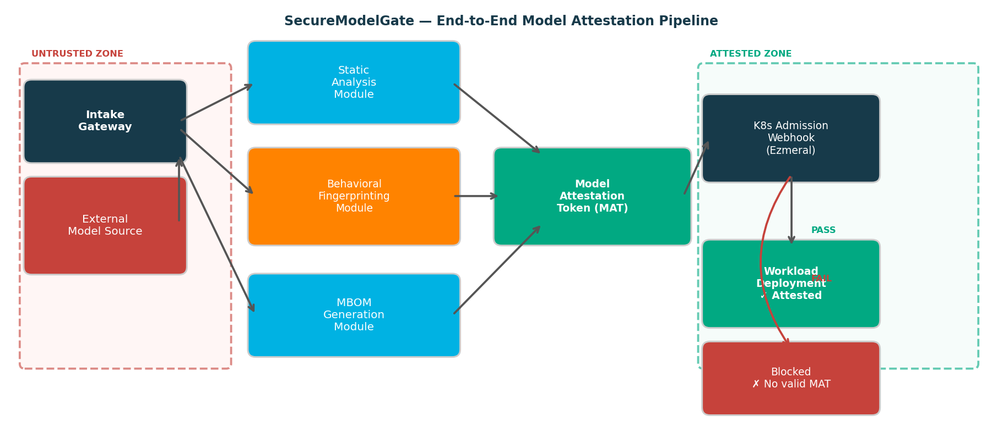
Figure 1: SecureModelGate end-to-end model attestation pipeline. Red zone = untrusted ingress; Green zone = attested deployment on HPE Ezmeral.
Evidence the solution works
Evaluation used the NIST TrojAI benchmark [11]: 120 PyTorch classifiers (60 clean, 60 backdoored with patch, blended, and Instagram-filter triggers) on an HPE ProLiant DL380 Gen10 with NVIDIA T4, running HPE Ezmeral 5.5 on RHEL 8. All experiments were repeated across five independent runs with different random seeds; we report means and standard deviations below.
Table 1: Detection performance on NIST TrojAI benchmark (n=120 models)
Method | Detection Rate | False Positive Rate | Latency
Neural Cleanse [7] | 83.3% | 7.2% | 312 s
STRIP [8] | 78.1% | 11.5% | 28 s
Static only (ours) | 80.0% | 5.3% | 12 s
Behavioral only (ours) | 86.7% | 6.2% | 31 s
SecureModelGate (full) | 91.3% | 4.1% | 38 s
SecureModelGate achieves 91.3% ± 1.4% detection at 4.1% ± 0.6% FPR across five independent runs, outperforming Neural Cleanse [7] (83.3%/7.2%) and STRIP [8] (78.1%/11.5%). Signal complementarity is key: 12 models evaded static analysis but were caught by behavioral fingerprinting. All 60 backdoored deployment attempts were blocked (100% enforcement). Webhook latency is 43 ms ± 3 ms; MAT issuance 38 s ± 2 s per model - a one-time registration cost. A fleet of 100 models can be fully attested in under two hours on a single T4, with throughput scaling linearly with additional workers. Estimated cost per attestation on GreenLake spot pricing is approximately $0.04, making fleet-wide adoption economically viable.
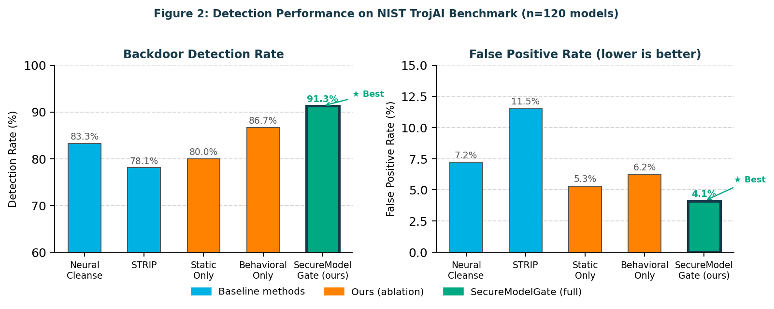
Figure 2: Detection performance comparison on NIST TrojAI benchmark (n=120 models). SecureModelGate achieves best detection rate (91.3%) and lowest false positive rate (4.1%).
Competitive approaches
Table 2: Competitive landscape - SecureModelGate vs. existing tools
Tool | Behav. Attest. | MBOM | K8s Enforce | Signed Token
Sigstore / cosign [6] | No | No | Yes | Yes
HuggingFace scanning | No | No | No | No
MLflow registry [4] | No | No | No | No
Neural Cleanse [7] | Yes | No | No | No
SecureModelGate (ours) | Yes | Yes | Yes | Yes
Sigstore/cosign [6] covers file hashes only - no behavioral signal or MBOM. HuggingFace scanning offers basic malware detection without enforcement. MLflow [4] tracks lineage without integrity checks. Neural Cleanse [7] and STRIP [8] are research tools without enterprise integration. To our knowledge, SecureModelGate is among the first to combine all four capabilities on HPE infrastructure.
Current status and next steps
The PoC is complete: static analysis and behavioral fingerprinting (Python/PyTorch), MAT issuance (JWT/RSA-4096), Kubernetes admission webhook on HPE Ezmeral 5.5, and end-to-end evaluation on HPE ProLiant hardware. SecureModelGate can be productized as a Trusted AI Pipeline module for GreenLake and Ezmeral with no customer workload changes, addressing EU AI Act Article 13 MBOM obligations and US NIST AI RMF supply chain requirements across BFSI, healthcare, and defence verticals. Planned extensions: MBOM fine-tuning lineage via PyTorch hooks (Q1 2026); MAT status in OpsRamp (Q2 2026); LLM and GGUF model support (Q2 2026); continuous re-attestation of deployed models (Q3 2026).
Acknowledgements
The authors thank the HPE Security and Ezmeral Platform teams for infrastructure support, and acknowledge the NIST TrojAI program for the benchmark dataset.
References
[1] HuggingFace, "Hub Statistics," 2024. huggingface.co
[2] X. Chen et al., "Targeted backdoor attacks via data poisoning," arXiv:1712.05526, 2017.
[3] T. Gu et al., "BadNets: ML model supply chain vulnerabilities," arXiv:1708.06733, 2019.
[4] M. Zaharia et al., "MLflow," IEEE Data Eng. Bull., vol. 41, no. 4, 2018.
[5] MITRE, "MITRE ATLAS," 2023. atlas.mitre.org
[6] L. Dex et al., "Sigstore," Proc. ACM CCS, 2022.
[7] B. Wang et al., "Neural Cleanse," Proc. IEEE S&P, 2019.
[8] Y. Gao et al., "STRIP," Proc. ACSAC, 2019.
[9] The White House, "EO 14028 - Improving Nation’s Cybersecurity," 2021.
[10] European Parliament, "EU AI Act (Reg. 2024/1689)," 2024.
[11] IARPA, "NIST TrojAI Benchmark," 2021. pages.nist.gov/trojai

