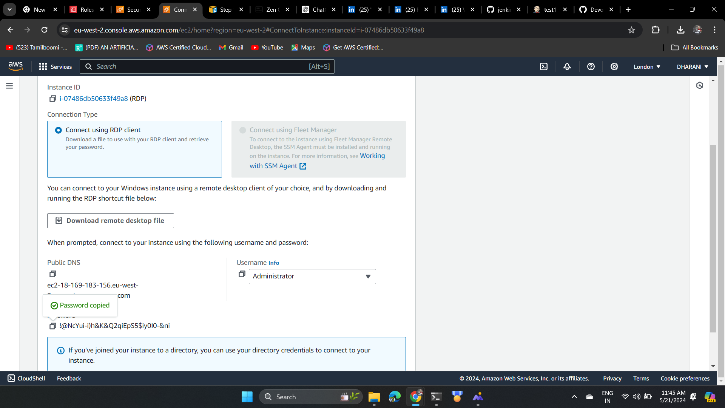

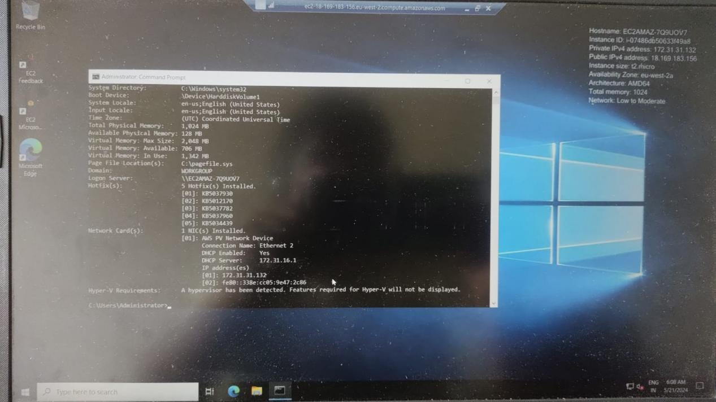

The above image is the result of the rdp client connection as like mention the systeminfo of the rdp is shown in the above image