EXERCISE 1 : Create and Read a File

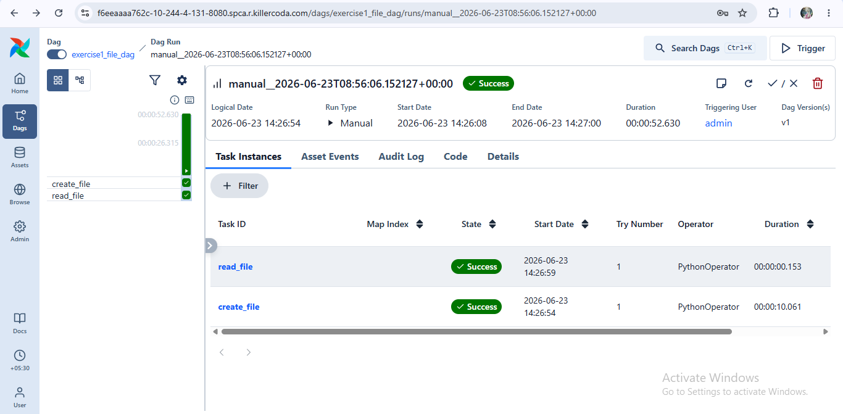

Exercise 2 : Employee Salary Report

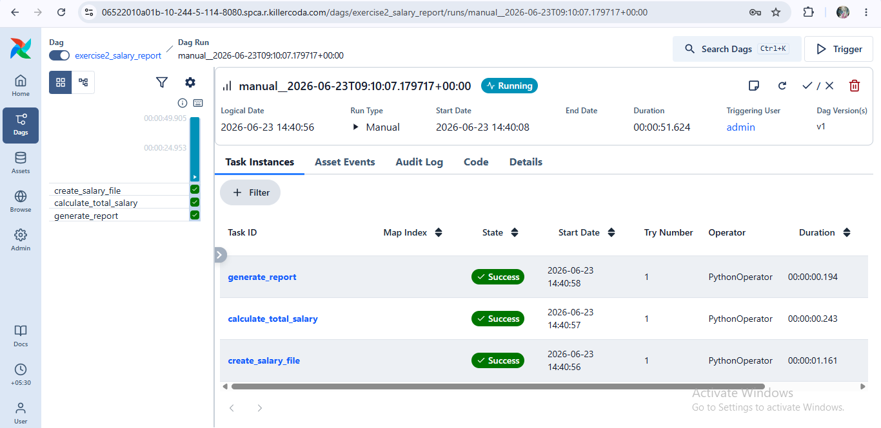

Exercise 3 : Student Marks Processing

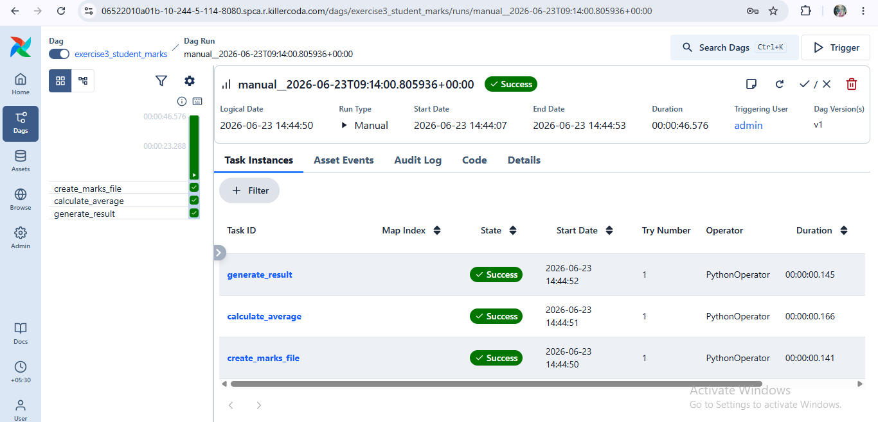

Exercise 4: Product Stock Alert

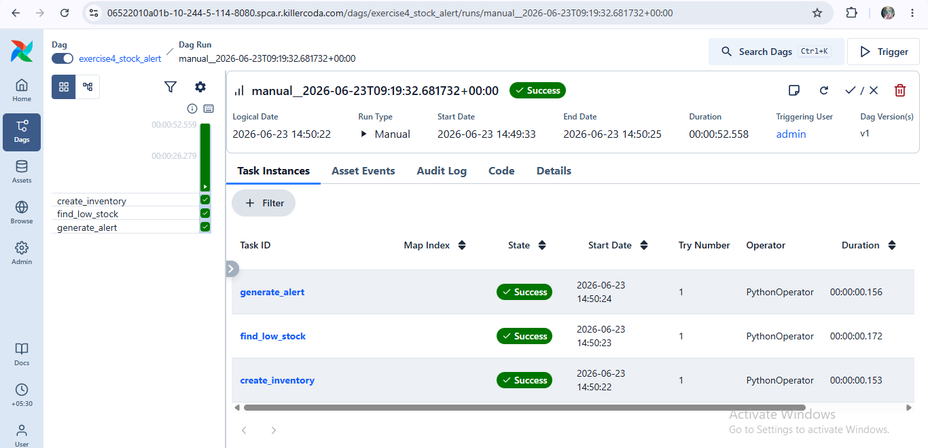

Exercise 5: Attendance Report

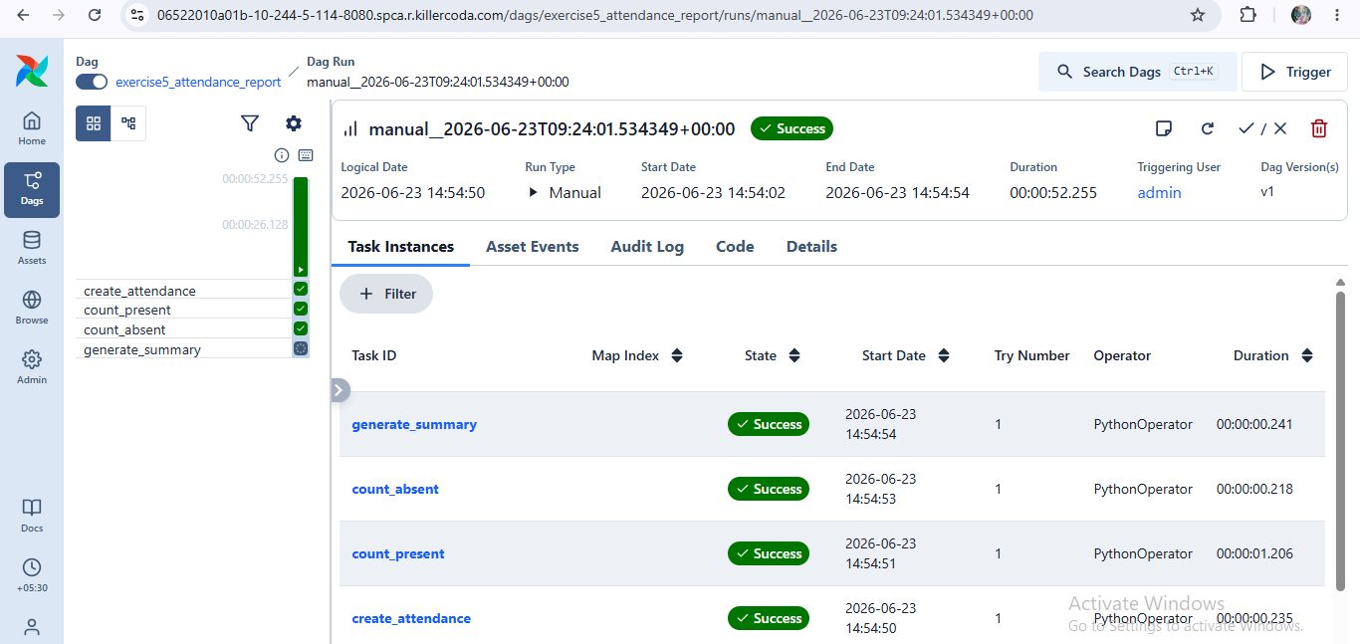

Exercise 6: CSV Processing

