What is Big Data?
Big Data refers to extremely large volumes of data that cannot be efficiently processed using traditional tools like Excel or standard databases.
Examples:
- Social media posts from millions of users
- Online shopping transactions
- Banking records
- Sensor and IoT data
- Video streaming data
The 5 V's of Big Data
- Volume – Huge amount of data (TBs, PBs, etc.)
- Velocity – Data is generated very quickly.
- Variety – Different types of data (text, images, videos, logs).
- Veracity – Data quality and accuracy.
- Value – Useful insights obtained from data.
Example
Imagine an e-commerce company:
- Millions of customers visit daily.
- Thousands of orders are placed every minute.
- Product reviews, clicks, and searches generate massive amounts of data.
Traditional tools struggle to handle this efficiently, so Big Data technologies are used.

What is PySpark?
PySpark is the Python API for Apache Spark.
It allows you to use Python to process and analyze Big Data across multiple machines.
Simple Definition
PySpark is a framework that helps process large datasets quickly using Python.

Why PySpark?
Suppose you have:
- Excel → 10,000 rows → Easy
- Pandas → 1 million rows → Usually manageable
- 100 million+ rows → PySpark becomes useful
PySpark distributes the work across multiple computers (or cores) and processes data in parallel.

PySpark vs Pandas
Feature | Pandas | PySpark
Data Size | Small to Medium | Very Large
Runs On | Single Machine | Cluster / Distributed System
Speed | Good | Excellent for Big Data
Memory | Limited by one machine | Distributed
Use Case | Analysis, Reporting | Big Data Processing

Common PySpark Operations
Create DataFrame
df = spark.createDataFrame(data, columns)
Select Columns
df.select("name", "salary").show()
Filter Rows
df.filter(df.salary > 70000).show()
Sort Data
df.orderBy("salary").show()
Group By
df.groupBy("department").count().show()
Add Column
df.withColumn("bonus", df.salary * 0.10).show()

Real-World Uses of PySpark
- Banking fraud detection
- Customer analytics
- Recommendation systems
- Log analysis
- Data engineering pipelines
- Real-time analytics
- Machine learning on large datasets
Many companies such as Netflix, Uber, Amazon, and Airbnb use Spark-based technologies to process large-scale data.

Apache Spark Basic Architecture:

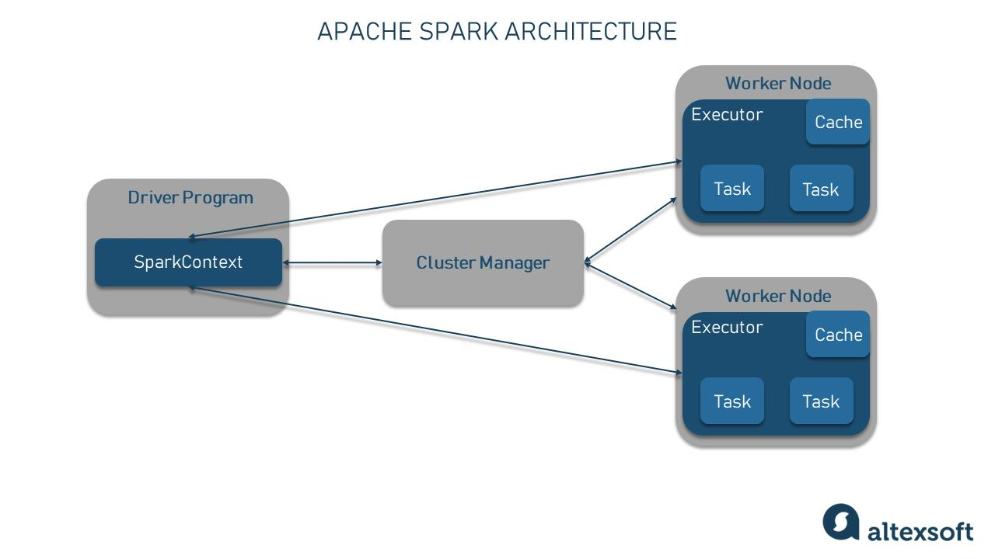

Main Components
1. Driver Program
The Driver is the main application that:
- Creates the Spark Session
- Converts your code into tasks
- Schedules and coordinates execution
- Collects results from workers

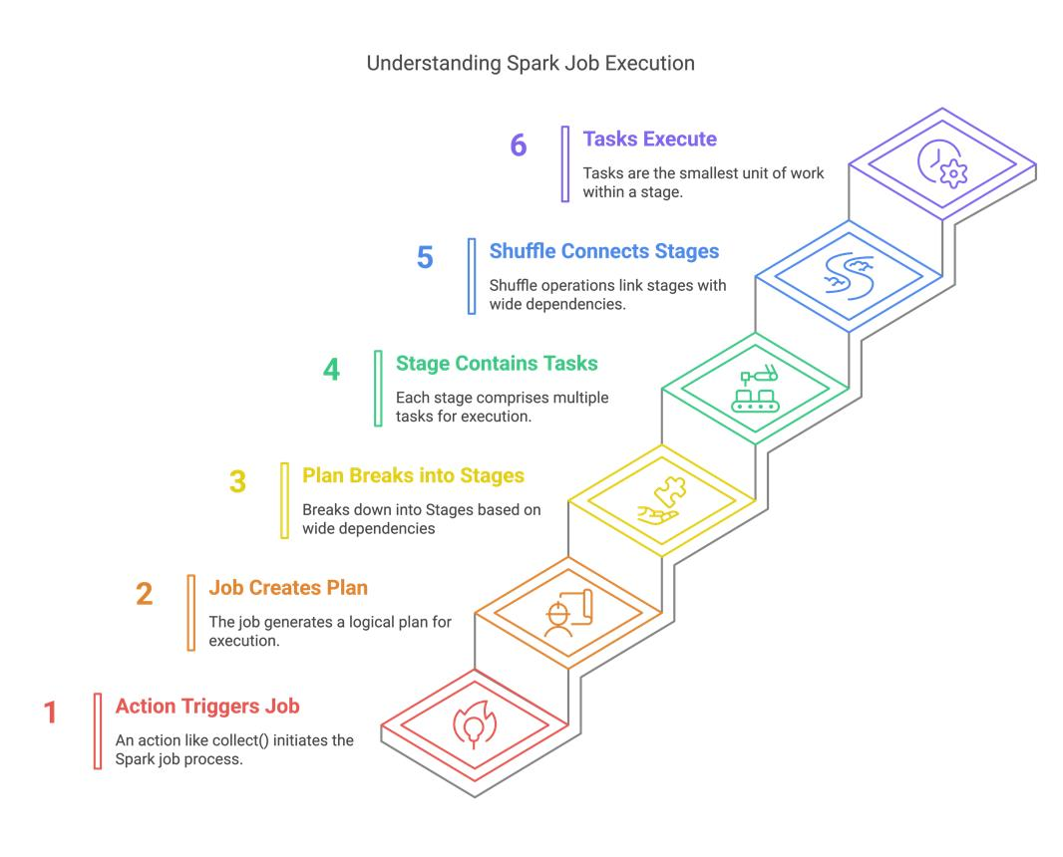

Example:
from pyspark.sql import SparkSession
spark = SparkSession.builder.appName("EmployeeData").getOrCreate()

2. Cluster Manager
The Cluster Manager allocates resources to Spark applications.
Common cluster managers:
- Standalone Cluster Manager
- Apache Hadoop YARN
- Kubernetes
Its job is to decide where Spark jobs will run.

3. Worker Nodes
Worker nodes are machines that perform the actual computation.
Each worker can run multiple executors.
Responsibilities:
- Store data partitions
- Execute tasks
- Return results

4. Executors
Executors are processes running on worker nodes.
They:
- Execute tasks assigned by the Driver
- Store data in memory
- Return results to the Driver
A Spark application may have many executors running simultaneously.

Execution Flow
User Program
│
▼
Driver Program
│
▼
Cluster Manager
│
▼
Worker Nodes
│
▼
Executors
│
▼
Task Execution

Example Flow
Suppose you run:
df.groupBy("department").count().show()

1. Spark Session
Spark Session is the entry point to work with Spark.
Whenever you start a PySpark application, you create a Spark Session first.
from pyspark.sql import SparkSession
spark = SparkSession.builder \
.appName("EmployeeData") \
.getOrCreate()
Responsibilities:
- Creates DataFrames
- Reads files (CSV, JSON, Parquet, etc.)
- Executes SQL queries
- Manages Spark applications
Think of it as the main door to Spark.
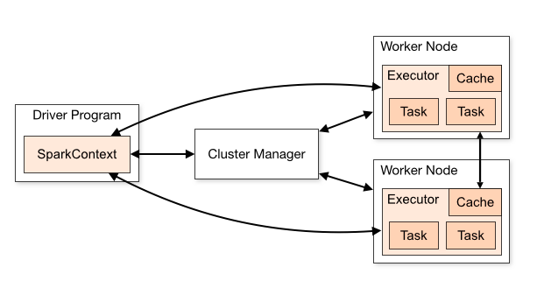
2. Spark Context
Spark Context (sc) is the core engine that connects your application to the Spark cluster.
You can access it through the Spark Session:
sc = spark.sparkContext
Responsibilities:
- Connects to the cluster
- Distributes tasks
- Manages executors
- Controls job execution
Think of Spark Context as the brain that communicates with the cluster.

3. Driver Node
The Driver Node is the machine where your Spark application starts.
It contains:
- Spark Session
- Spark Context
- Application logic
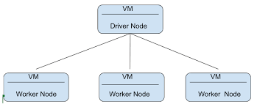

Example:
df.filter(df.salary > 70000).show()
The Driver:
- Receives this command.
- Creates an execution plan.
- Sends tasks to workers.
- Collects results.
Responsibilities:
- Creates jobs
- Schedules tasks
- Coordinates execution
- Returns results
Think of the Driver as the project manager.

4. Worker Node
Worker Nodes are machines that perform the actual computation.
A Spark cluster may contain many worker nodes.
Responsibilities:
- Execute tasks
- Store partitions of data
- Run executors
Think of workers as the employees doing the work.

5. Cluster Manager
The Cluster Manager manages the resources of the entire cluster.
Popular cluster managers include:
- Apache Hadoop YARN
- Kubernetes
- Standalone Cluster Manager
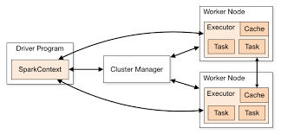

Responsibilities:
- Allocates CPU and memory
- Starts executors on worker nodes
- Monitors resources
Think of the Cluster Manager as the HR department assigning workers to projects.

Client Mode vs Cluster Mode in Spark
When you submit a Spark application, the Driver Program can run in two different places:
- Client Mode
- Cluster Mode

1. Client Mode
In Client Mode, the Driver runs on the machine from which you submit the application.
Architecture
Your Laptop
(Driver Program)
│
▼
Cluster Manager
│
▼
Worker Nodes + Executors
How it works
- You submit the Spark job.
- Driver starts on your local machine.
- Cluster Manager allocates resources.
- Executors run on worker nodes.
- Results are sent back to the Driver on your machine.
Example
spark-submit --deploy-mode client app.py
Advantages
- Easy to debug
- Driver logs appear directly on your machine
- Good for development and testing
Disadvantages
- If your laptop disconnects, the job may fail
- Not ideal for long-running production jobs

Cluster Mode
In Cluster Mode, the Driver runs inside the cluster itself.
Architecture
Your Laptop
│
▼
Cluster Manager
│
▼
Driver Node (inside cluster)
│
▼
Worker Nodes + Executors
How it works
- You submit the job.
- Cluster Manager launches the Driver in the cluster.
- Driver creates tasks.
- Executors execute tasks on worker nodes.
- Processing continues even if you disconnect.
Example
spark-submit --deploy-mode cluster app.py
Advantages
- Better for production
- More reliable
- Continues running after you log out
- Driver has direct access to cluster resources
Disadvantages
- Harder to debug
- Driver logs must be viewed through cluster tools

Comparison
Feature | Client Mode | Cluster Mode
Driver Location | Local Machine | Inside Cluster
Debugging | Easy | More Difficult
Development | Best Choice | Less Common
Production | Not Recommended | Recommended
Disconnect User | Job may fail | Job continues
Driver Logs | Local Machine | Cluster Logs

Example Scenario
Suppose you're running a PySpark application that processes 500 GB of employee and sales data.
Client Mode
Laptop (Driver)
↓
Executors in Cluster
If your laptop shuts down or loses connection, the Driver is gone.
Cluster Mode
Cluster Driver
↓
Executors
The job keeps running because both Driver and Executors are inside the cluster.

