what is databricks delta lake give a detailed explanation?
What is Delta Lake?
Delta Lake is an open-source storage layer developed by Databricks that brings reliability, performance, and advanced database features to data lakes.
It sits on top of existing cloud storage (such as Azure Data Lake Storage, Amazon S3, or Google Cloud Storage) and stores data in Parquet format while maintaining a transaction log that tracks every change.
In simple words:
Delta Lake = Data Lake + Database Features
It combines the scalability of a data lake with the reliability of a traditional database.
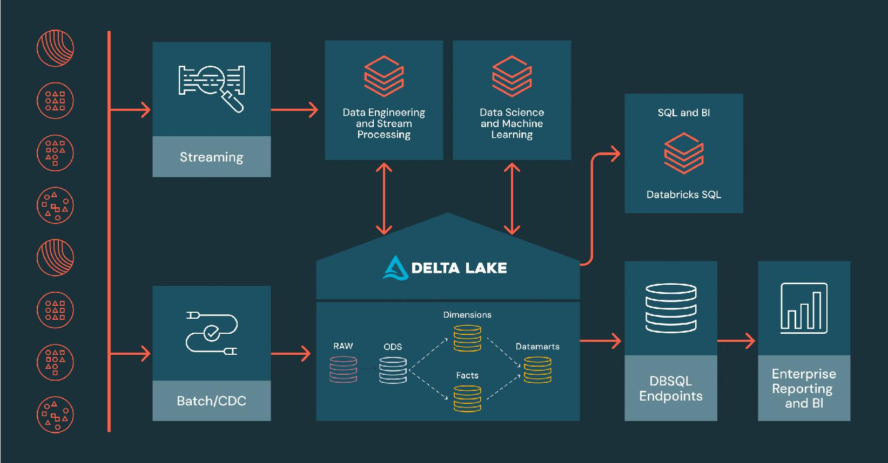

Traditional data lakes have several problems:
- No ACID transactions
- Data corruption when multiple users write simultaneously
- Difficult to update or delete records
- No version history
- Slow queries on large datasets
Delta Lake solves all of these issues.
A Delta table consists of:
- Data files (Parquet files)
- _delta_log folder
- Transaction log (JSON + Checkpoint files)
The _delta_log folder stores every operation performed on the table.

Example:
sales_table/
├── part-0000.parquet
├── part-0001.parquet
└── _delta_log/
├── 00000000000000000000.json
├── 00000000000000000001.json
├── 00000000000000000002.json
└── checkpoint.parquet

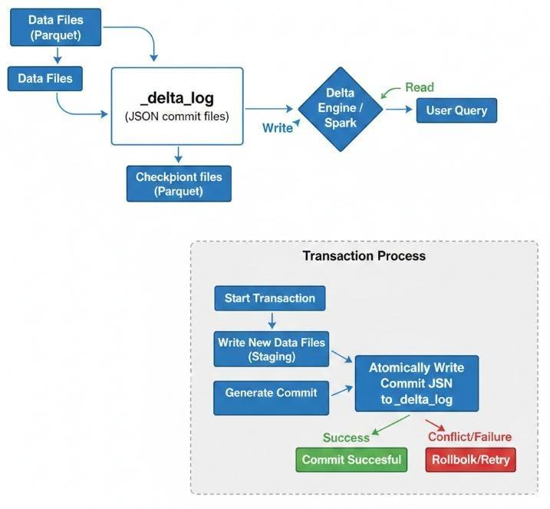

Features of Delta Lake
1. ACID Transactions
Delta Lake supports:
- Atomicity
- Consistency
- Isolation
- Durability
If two users write at the same time, data remains consistent.
Example:
User A → Insert data
User B → Update data
Delta Lake handles both safely.
2. Schema Enforcement
Wrong data types are rejected.
Example:
Table:
id INT
name STRING
salary DOUBLE
Trying to insert:
("ABC", "Rahul", "50000")
will fail because id must be integer.
This prevents bad data.

3. Schema Evolution
Delta Lake can automatically add new columns.
Example:
Old table:
id
name
salary
New data:
id
name
salary
city
Using merge schema:
df.write \
.mode("append") \
.option("mergeSchema","true") \
.format("delta") \
.save("/mnt/data/employees")
The new column gets added automatically.

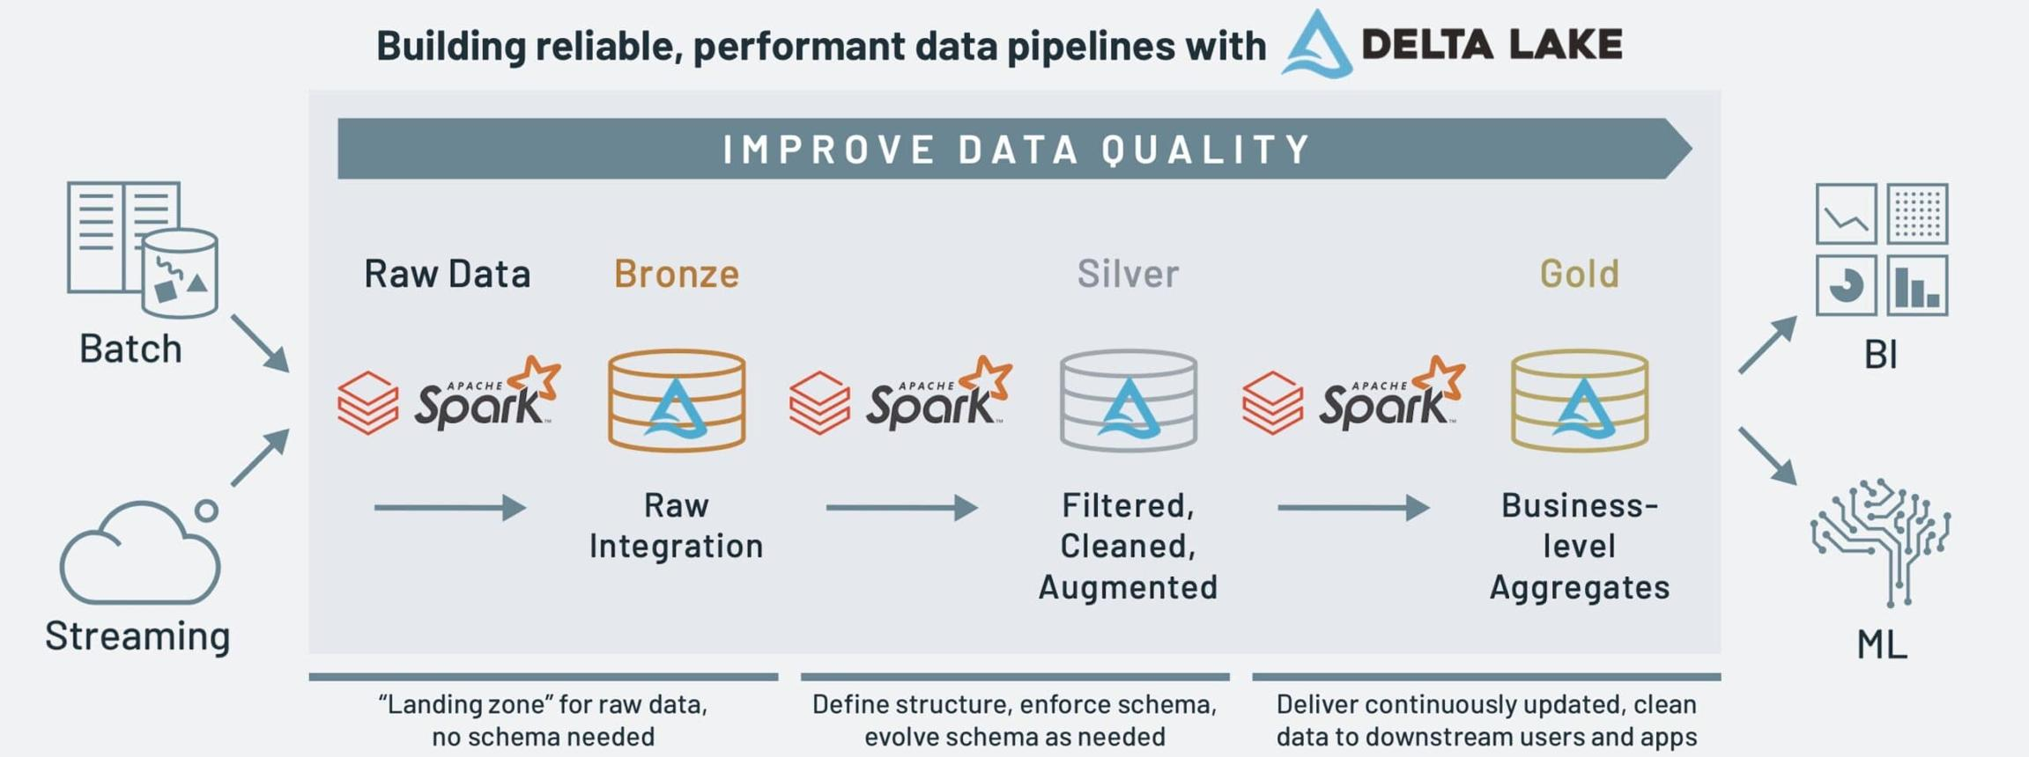

4. Time Travel
One of the most popular features.
You can read previous versions of a table.
Example:
Version 0
↓
Version 1
↓
Version 2
↓
Version 3

5. Upsert (MERGE)
Delta Lake supports update + insert together.
Example:
MERGE INTO customers c
USING updates u
ON c.id=u.id
WHEN MATCHED THEN
UPDATE SET *
WHEN NOT MATCHED THEN
INSERT *
Optimized Performance
Delta Lake uses:
- File statistics
- Data skipping
- Partition pruning
- Z-order indexing (Databricks)
This speeds up queries significantly.
Real-world Example
Imagine an e-commerce company:
- New orders arrive every minute.
- Some orders are cancelled.
- Some orders are updated.
- Daily reports need accurate data.
With normal Parquet files, updates and deletes are difficult.

database vs datawarehouse vs data lake vs delta lake

1. Database
A database stores day-to-day operational data.
Examples:
- Banking system
- College management
- Hospital management
- E-commerce website
Example
Customer Table
Customer_ID Name City
101 Rahul Chennai
102 Priya Bangalore
103 Anil Delhi
A database is optimized for:
- Fast inserts
- Fast updates
- Fast deletes
- Transaction processing
Examples
- MySQL
- PostgreSQL
- Oracle
- SQL Server

2. Data Warehouse
A Data Warehouse stores historical data collected from multiple databases for reporting and business intelligence.
Example:
Sales Database
│
HR Database
│
Inventory Database
│
Customer Database
│
▼
Data Warehouse
│
▼
Power BI / Tableau Reports
Instead of daily transactions, it stores years of historical data.
Example
Sales Report
Year Revenue
2023 50 Cr
2024 65 Cr
2025 82 Cr
Used for:
- Dashboards
- Reports
- Business decisions
- Analytics
Examples:
- Snowflake
- Amazon Redshift
- Azure Synapse
- Google BigQuery
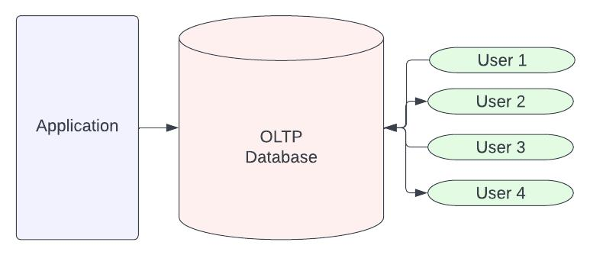
3. Data Lake
A Data Lake stores raw data in its original format.
It can store:
- CSV
- JSON
- XML
- Images
- Videos
- Audio
- Logs
- Parquet files
Example:
Azure Data Lake
sales.csv
employees.json
video.mp4
image.jpg
sensor_logs.txt
transactions.parquet
Nothing needs to be cleaned before storing.
It supports:
- Structured data
- Semi-structured data
- Unstructured data
Advantages
- Cheap storage
- Huge scalability
- Stores any type of data
Disadvantages
- No ACID transactions
- Difficult updates
- No version control
- Possible data inconsistency
Examples:
- Azure Data Lake Storage
- Amazon S3
- Google Cloud Storage

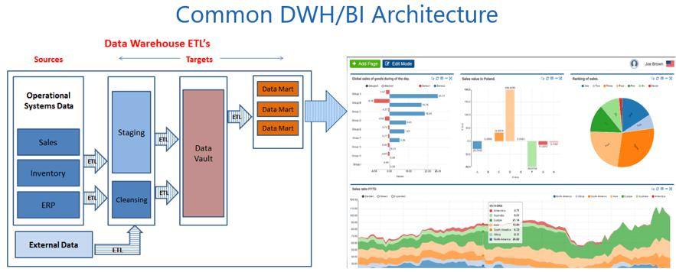

4. Delta Lake
A Delta Lake is a Data Lake with database capabilities.
Think of it like this:
Data Lake
+
Transaction Log
+
ACID Transactions
+
Time Travel
+
Update/Delete
+
Schema Enforcement
=
Delta Lake
Delta Lake stores data as Parquet files but maintains a transaction log (_delta_log) to track every change.
Example:
sales/
part-0001.parquet
part-0002.parquet
_delta_log/
000000.json
000001.json
checkpoint.parquet
- Database → Run the business (transactions)
- Data Warehouse → Analyze the business (reports and BI)
- Data Lake → Store all raw data (any format)
- Delta Lake → A smarter data lake with database features (ACID, updates, time travel, and high-performance analytics)
A simple memory trick is:
Database → Operations → Data Warehouse → Analytics → Data Lake → Raw Storage → Delta Lake → Reliable Big Data Storage + Analytics

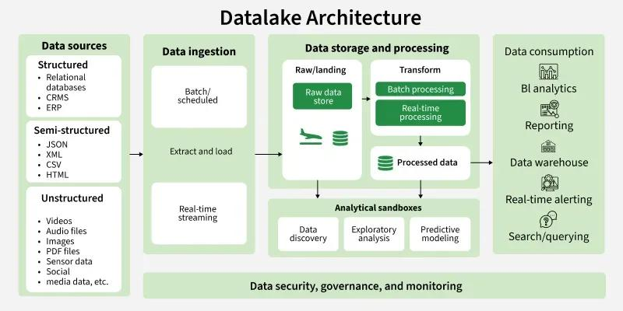

Feature | Database | Data Warehouse | Data Lake | Delta Lake
Purpose | Store operational data | Business analytics | Store all types of data | Reliable data lake with advanced features
Data Type | Structured | Structured | Structured, Semi-structured, Unstructured | Structured, Semi-structured, Unstructured
Examples | MySQL, PostgreSQL | Snowflake, Redshift | Azure Data Lake, Amazon S3 | Databricks Delta Lake
Schema | Fixed | Fixed | Schema-on-read | Schema enforcement + evolution
ACID Transactions | Done | Done | ❌ | Done
Update/Delete | Done | Limited | ❌ | Done
Time Travel | ❌ | ❌ | ❌ | Done
Best For | Daily applications | Reporting & BI | Big Data storage | Big Data analytics & ETL

