Exercise 7 – Department Salary Report

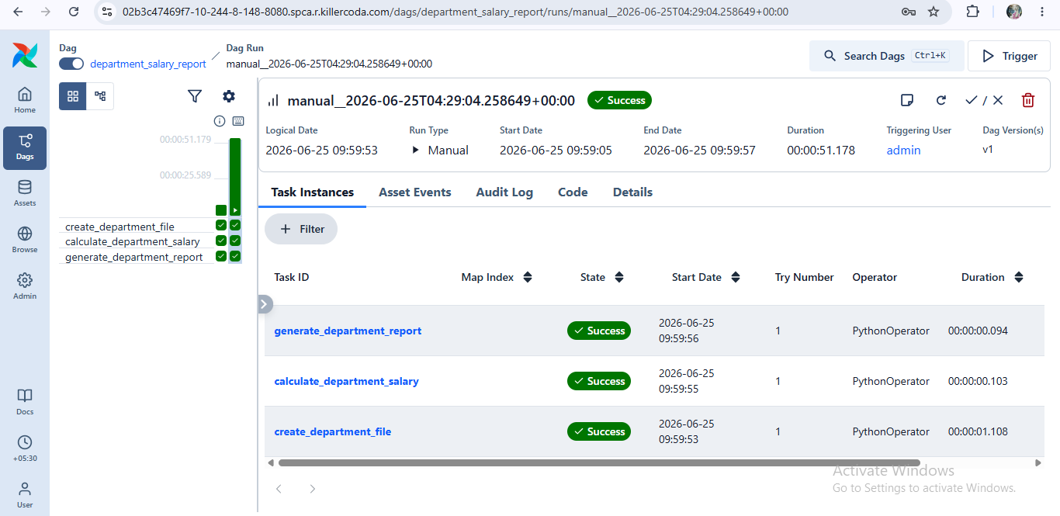

Exercise 8 – Electricity Bill Summary

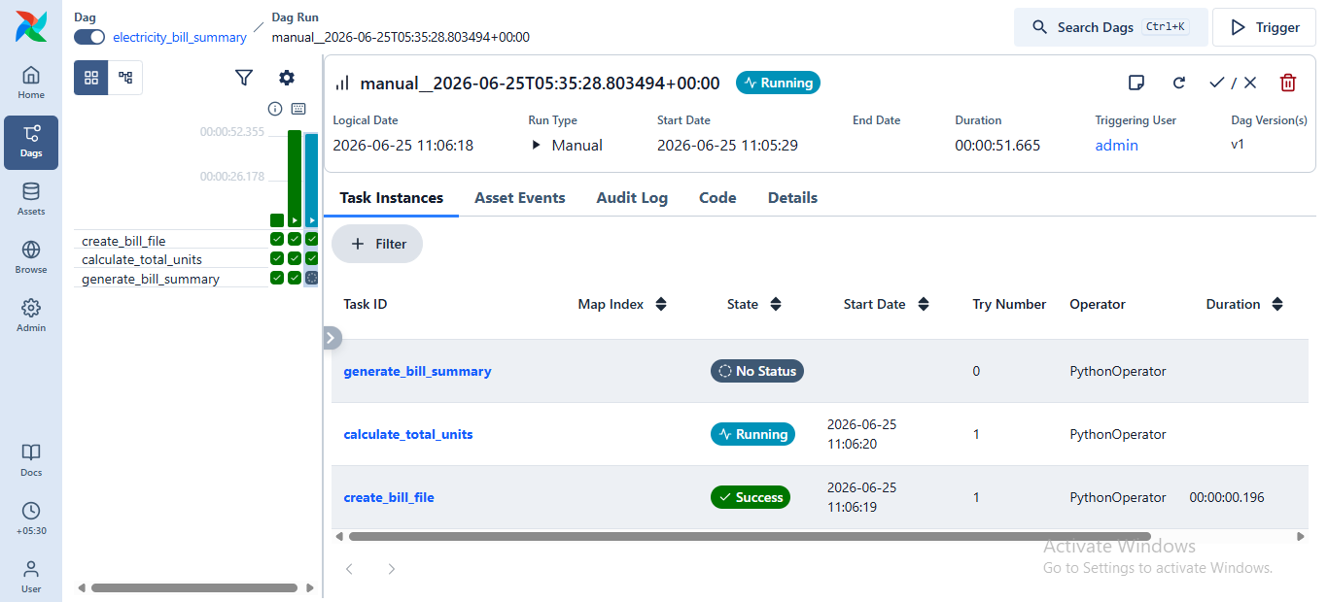

Exercise 9 – Exam Result Report

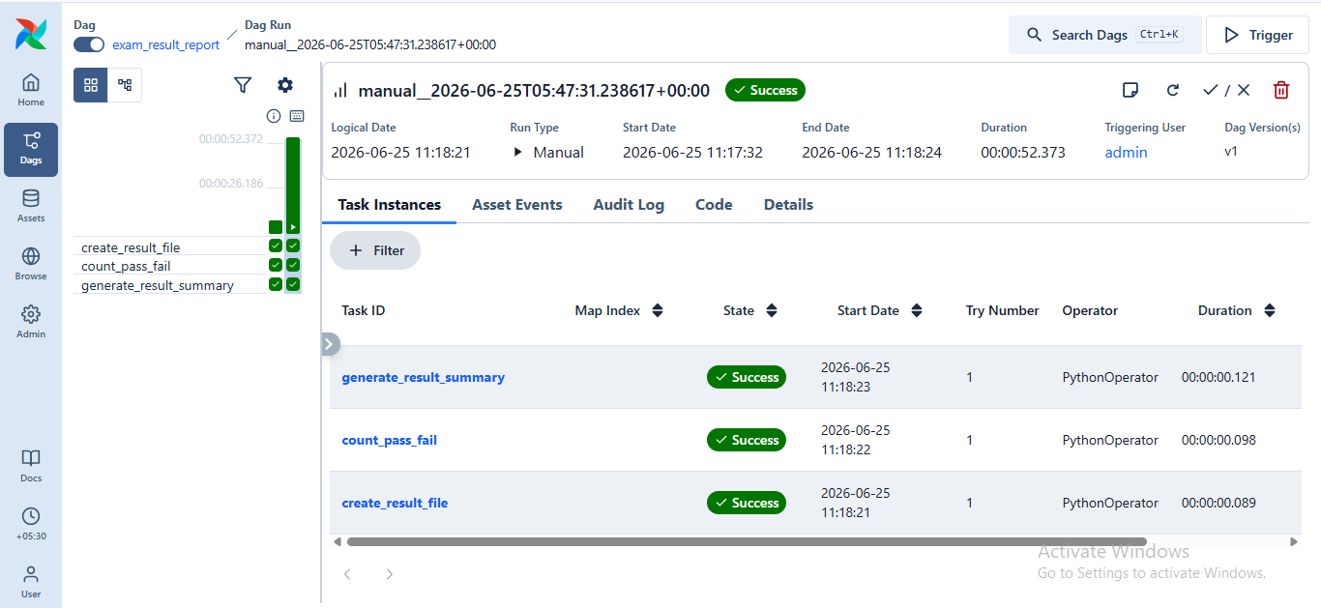

Exercise 10 – Online Orders

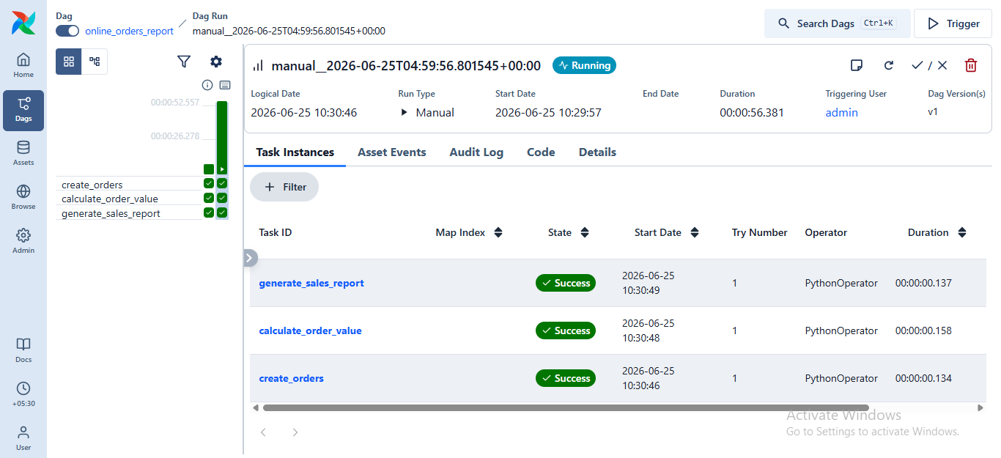

Exercise 11 – Temperature Analysis

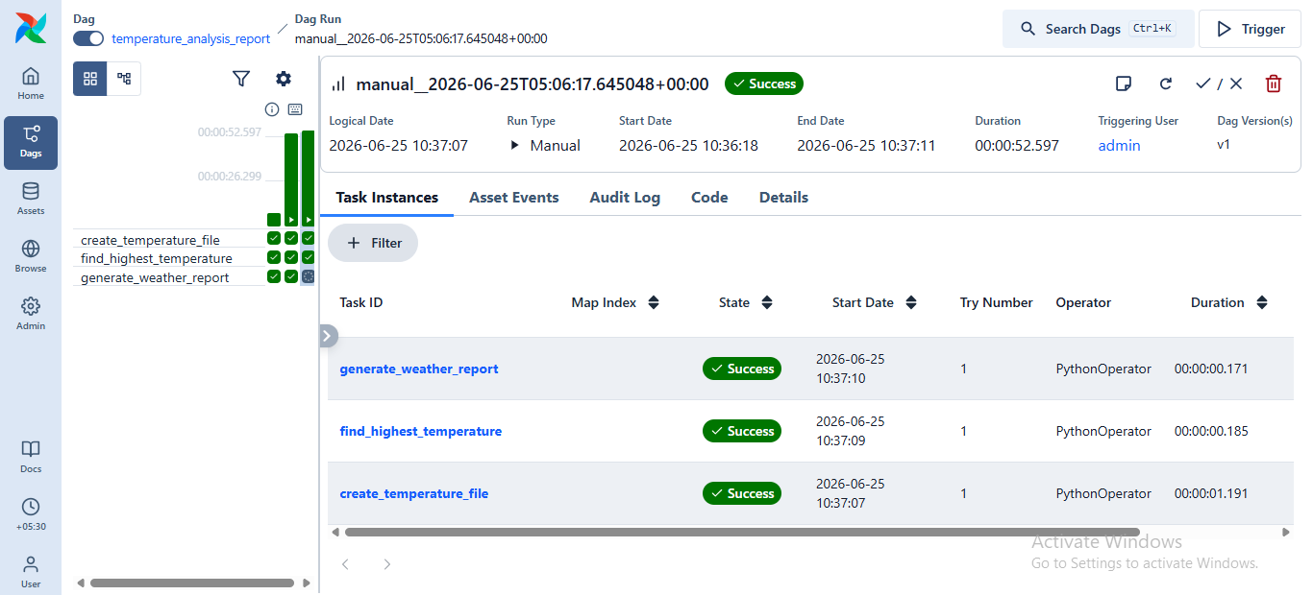

Exercise 12 – Bank Transaction Summary

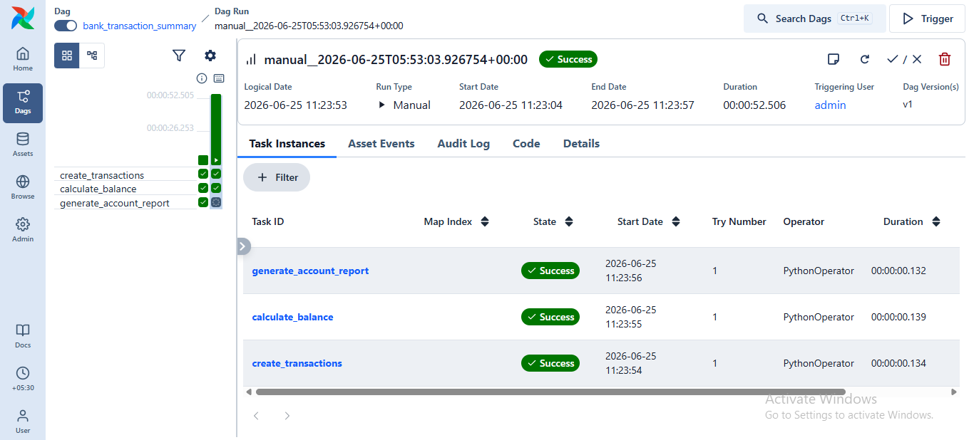

Exercise 13 – Employee Age Report

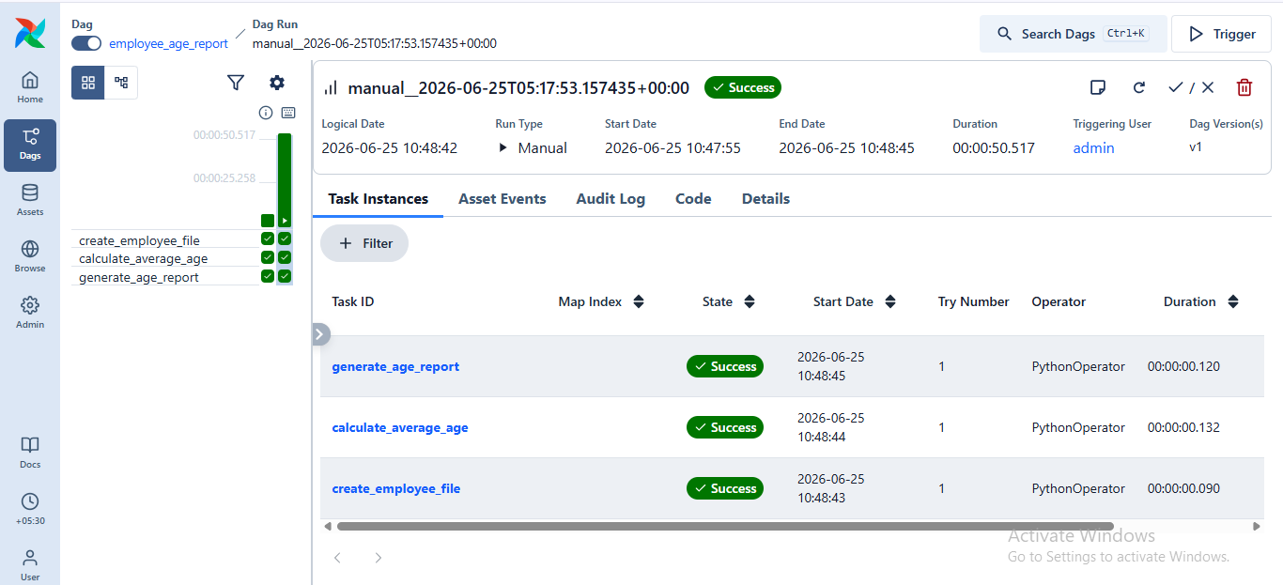

Exercise 14 – Course Enrollment Report

