EXP NO 7: DEMONSTRATE VIRTUALIZATION BY INSTALLING TYPE-2 HYPERVISOR IN YOUR DEVICE, CREATE AND CONFIGURE VM IMAGE WITH A HOST OPERATING SYSTEM (EITHER WINDOWS/LINUX).
DATE: 18/11/2025
AIM: To demonstrate virtualization by installing type-2 hypervisor in your device, create and configure VM image with a host operating system (either windows/linux).
PROCEDURE:
STEP 1: Dowload VMware workstation and installed as type 2 hypervisor.
STEP2: Dowload ubuntu or tiny OS as iso image file.
STEP 3: In VMware workstation->create new VM.
STEP 4: Do the basic configuration settings.
STEP 5: Created tiny OS virtual machine.
STEP 6: Launch the VM.
Output:
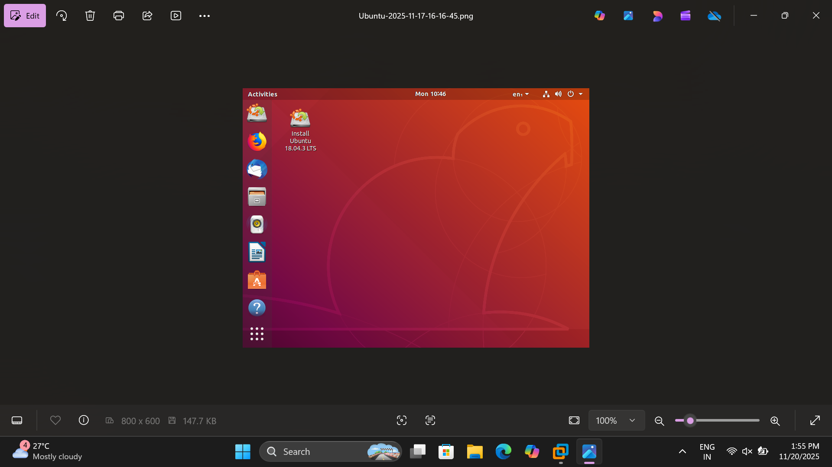
EXPNO 8: CREATE A VIRTUAL MACHINE WITH 1 CPU, 2GB RAM AND 15GB STORAGE DISK USING A TYPE 2 VIRTUALIZATION SOFTWARE.
DATE: 18/11/2025
AIM: To create a virtual machine with 1 cpu, 2gb ram and 15gb storage disk using a type 2 virtualization software.
PROCEDURE:
STEP 1:Dowload VMware workstation and installed as type 2 hypervisor.
STEP2:Dowload ubuntu or tiny OS as iso image file.
STEP 3: In VMware workstation->create new VM.
STEP 4: Do the basic configuration settings.
STEP 5: Created tiny OS virtual machine.
STEP 6: Launch the VM.
OUTPUT:
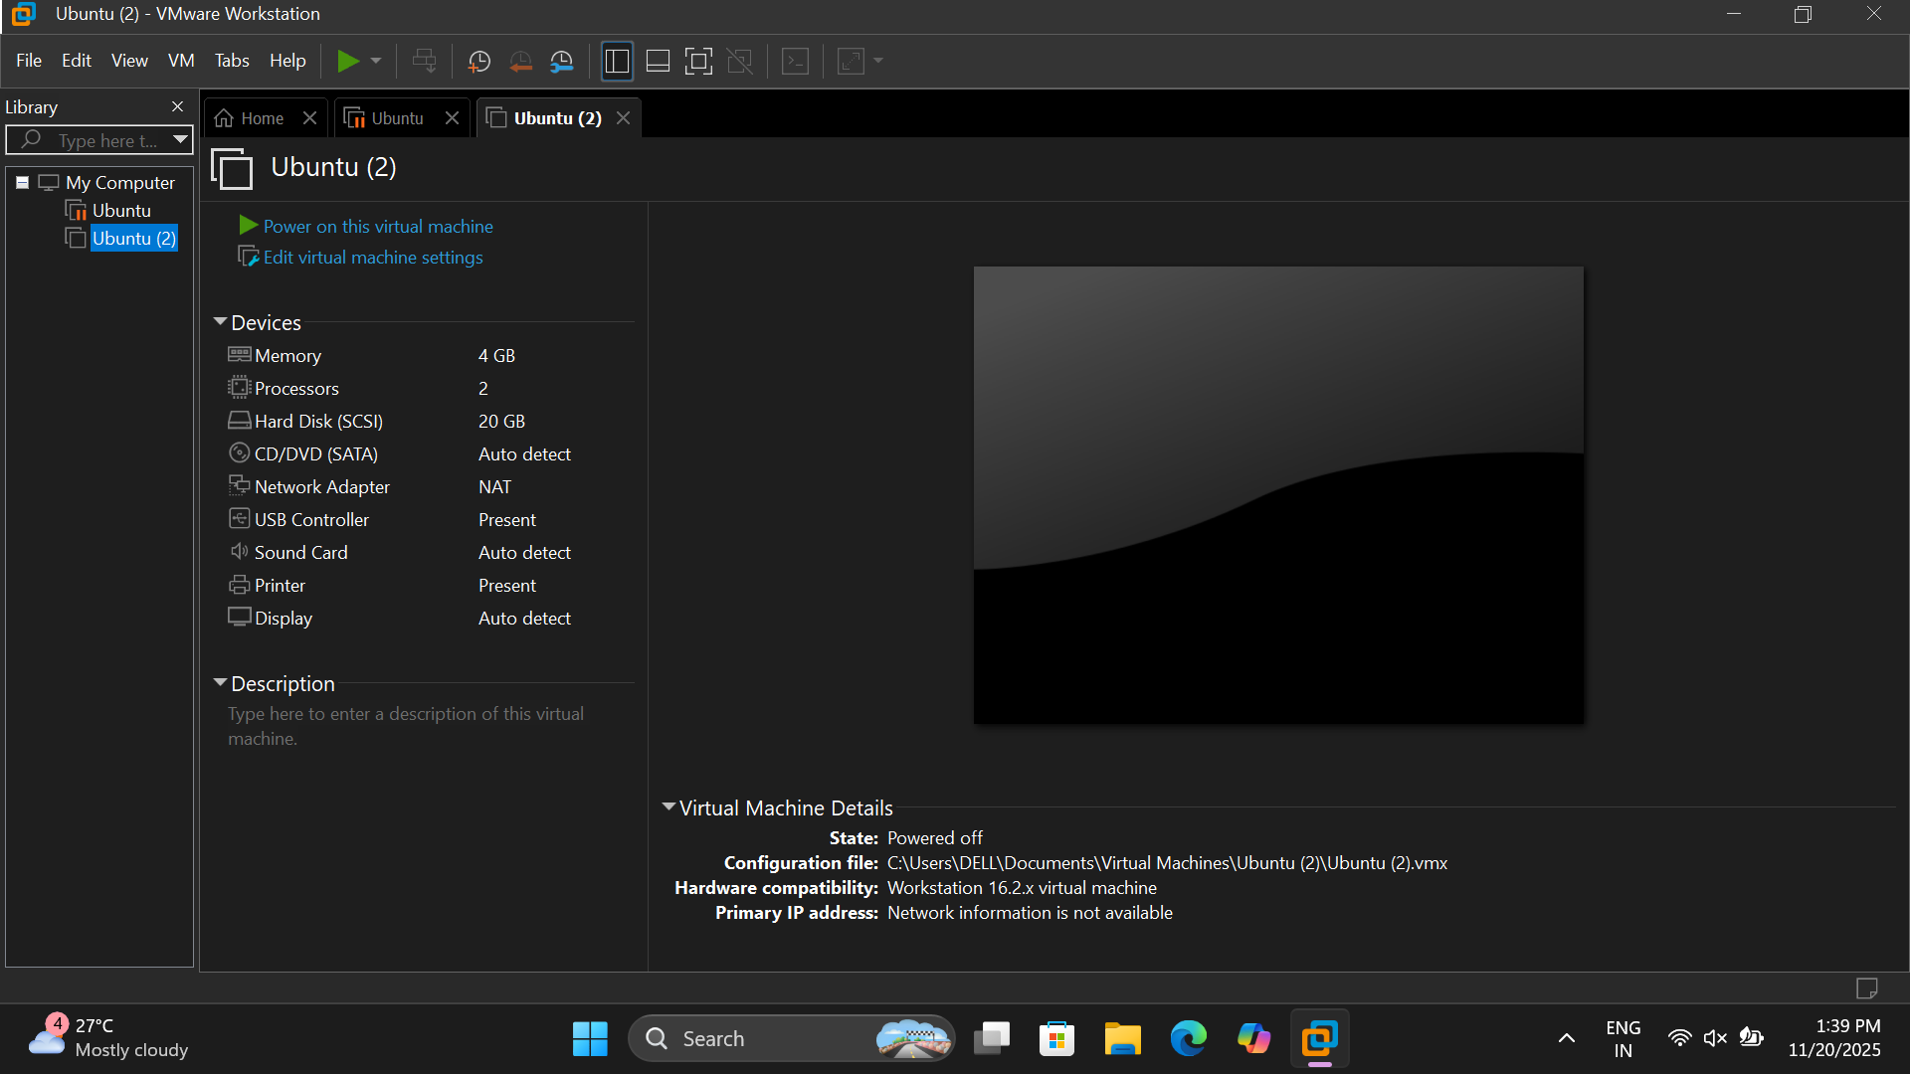

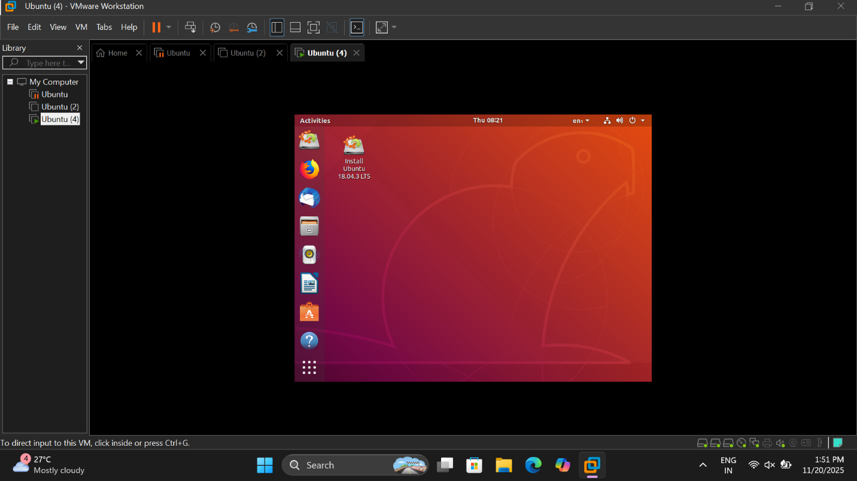

EXP 9: CREATE A VIRTUAL HARD DISK AND ALLOCATE THE STORAGE USING VM WARE WORKSTATION.
DATE: 18/11/2025
AIM: To create a virtual hard disk and allocate the storage using vm ware workstation
PROCEDURE:
STEP 1:GOTO VM WARE WORKSTATION.
STEP2: RIGHT CLICK THE VM AND GOTO THE SETTINGS.
STEP 3: ADD HARDWARE WIZARD AND SELECT SCSI AND CLICK NEXT.
STEP 4: CREATE NEW VIRTUAL DISK.
STEP 5: SELCT THE DISK SIZE AS 2.0. AND SELCT SPLIT VIRTUAL DISK INTO MULTIFILES.
STEP 6: GIVE NAME AND CLICK THE FINISH.
OUTPUT:
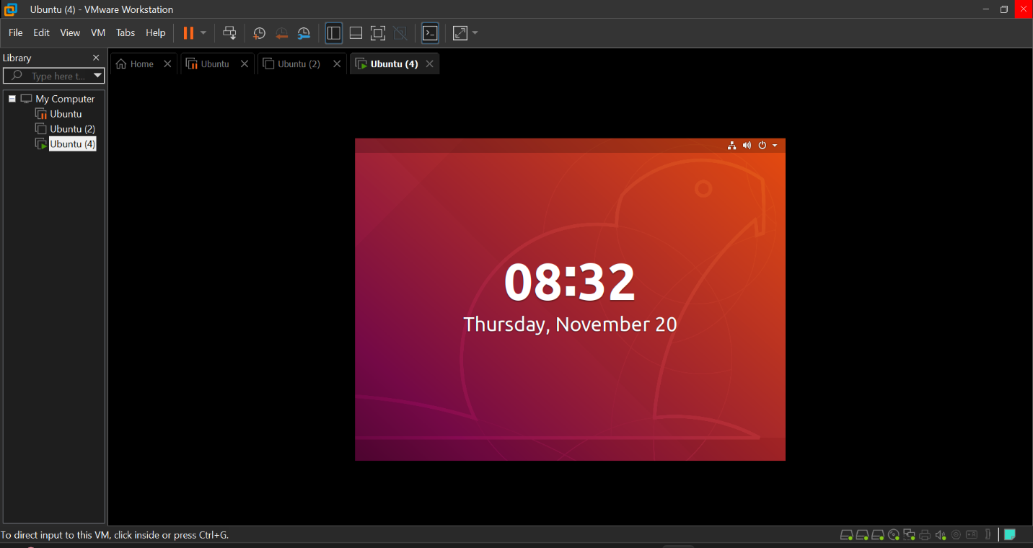

EXPNO 10: CREATE A SNAPSHOT OF A VM AND TEST IT BY LOADING THE PREVIOUS VERSION/CLONED VM
DATE:
AIM: To create a snapshot of a vm and test it by loading the previous version/cloned vm
PROCEDURE:
STEP 1: GOTO VMWARE WORKSTATION.
STEP 2: CREATE FILES ON DESKTOP.
STEP 3: CLICK ON VM AND SELECTS SNAPSHOT-> TAKE SNAPSHOT.
STEP 4: SNAPSHOT IS BEING DONE
OUTPUT:

EXPNO 11: CREATE A CLONING OF A VM AND TEST IT BY LOADING THE PREVIOUS VERSION/CLONED VM.
DATE:
AIM: To create a cloning of a vm and test it by loading the previous version/cloned vm.
PROCEDURE:
STEP 1: GO TO VM AND GOTO MANAGE AND CLICK CLONE
STEP 2: CLICK CLONE
STEP 3: SELECT THE FULL CLONE
STEP 4: AFTER CLONE AGAIN OR VM IS OPENED.
OUTPUT:
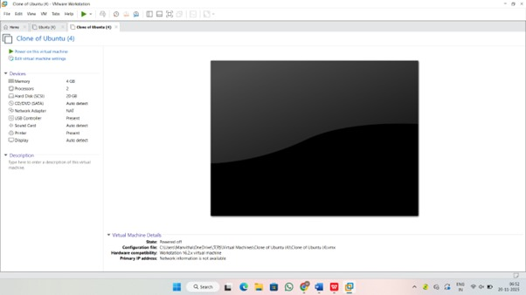

EXP 12: CHANGE HARDWARE COMPATIBILITY OF A VM (EITHER BY CLONE/CREATE NEW ONE) WHICH IS ALREADY CREATED AND CONFIGURED.
DATE: 19/11/2025
AIM: To Change Hardware compatibility of a VM (Either by clone/create new one) which is already created and configured.
PROCEDURE:
STEP 1:GOTO VM WARE WORKSTATION.
STEP2: RIGHT CLICK THE VM AND GOTO THE SETTINGS.
STEP 3: ADD HARDWARE WIZARD AND SELECT SCSI AND CLICK NEXT.
STEP 4: CREATE NEW VIRTUAL DISK.
STEP 5: SELCT THE DISK SIZE AS 2.0. AND SELCT SPLIT VIRTUAL DISK INTO MULTIFILES.
STEP 6: GIVE NAME AND CLICK THE FINISH.
OUTPUT:
