Co-CHESS
I have started working on a game – CHESS, today (25.01.2026) I have completed the chess board, make a move, switch the board for opposite player, capturing, no rule.
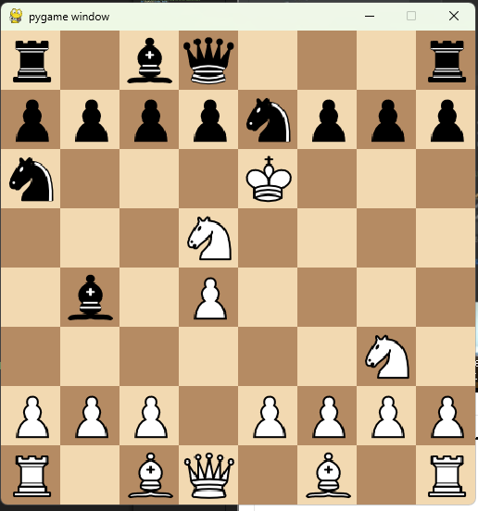
This the image of the chess board, I have created watching YouTube video by Eddie Sharick (Eddie).
These are the logs:
d2d4
e7d5
e1a5
b8a6
b1c3
g1g3
a5d5
e8e6
d5e6
f8b4
c3d5
g8e7

Now completed unique ID for each valid move and overriding function in python to handle some problem (still trying to figure out) TIME - 17:15

