|  |
| --- |
| **PPS LAB-MINI PROJECT**  **ROCK PAPER SCISSOR**  **21CSS101J – PROGRAMMING FOR PROBLEM SOLVING**  **Mini Project Report**  *Submitted by*  **Sivasubramaniyan E.S. [Reg. No.: RA2211047010034]**  **Artificial Intelligence (Batch 1)**  **Dharanya C [Reg. No.: RA2211047010025]**  **Artificial Intelligence (Batch 1)**  SRMIST-01.jpg  **SCHOOL OF COMPUTING**  **COLLEGE OF ENGINEERING AND TECHNOLOGY**  **SRM INSTITUTE OF SCIENCE AND TECHNOLOGY**  **(Under Section 3 of UGC Act, 1956)**  S.R.M. NAGAR, KATTANKULATHUR – 603 203  KANCHEEPURAM DISTRICT |

**TABLE OF CONTENTS**

|  |  |  |
| --- | --- | --- |
| **Chapter No.** | **Title** | **Page No.** |
| 1 | Problem Statement | 1 |
| 2 | Methodology / Procedure | 2 |
| 3 | Coding (C or Python) | 3 |
| 4 | Results | 5 |
| 5 | Conclusion | 6 |

PROBLEM STATEMENT

This mini project aims at creating a small game which is rock paper scissors and running it efficiently and getting a desired output wherein the game page is shown separately and the scores of computer and the

player who is playing against it is calculated.

METHODOLOGY/PROCEDURE

Step1: We use pycharm as the compiler for the program through which we first import random and tkinter modules. If they are not downloaded we download it through python packages.

Step2: We assign two variables comp_score and player_score and their values as 0.

Step3: We create a nested dictionary schema where the first key value is the player choice for which the value is another dictionary where the corresponding points for the computer response is stored.

Step4: A function outcome_handler is created where comp_score and player_score are defined as global variables. A list named outcomes is created which holds rock paper and scissors and has an index 0,1,2. A random number is chose from the three numbers using randit function. This output is stored as the computer choice and the result is calculated by comparing user and computer choice.

Step5: If result is 2 then the player wins and the player score gets incremented. If the result is 1 then it’s a draw and both the scores get incremented. If it is 0 then the computer wins and the computer score gets incremented.

Step6: A tkinter page is created to show the game which has 3 buttons for the options and also showcases the scores.

CODING(PYTHON)

import random  
from tkinter import *  
comp_score=0  
player_score=0  
schema={  
 "rock":{"rock":1,"paper":0,"scissors":2},  
 "paper":{"rock":2,"paper":1,"scissors":0},  
 "scissors":{"rock":0,"paper":2,"scissors":1}  
}  
  
#functions  
def outcome_handler(user_choice):  
 global comp_score  
 global player_score  
 outcomes= ["rock","paper","scissors"]  
 random_number= random.randint(0,2)  
 computer_choice =outcomes[random_number]  
 result =schema[user_choice][computer_choice]  
  
 player_choice_label.config(fg="red",text="Player Choice :"+str(user_choice))  
 computer_choice_label.config(fg="green",text="Computer Choice :"+str(computer_choice))  
  
 if result ==2:  
 player_score=player_score+2  
 player_score_label.config(text="player: "+str(player_score))  
 outcome_label.config(fg="blue",text="Outcome: Player won")  
  
 elif result==1:  
 player_score=player_score+1  
 comp_score=comp_score+1  
 player_score_label.config(text="player :"+str(player_score))  
 computer_score_label.config(text="computer: "+str(comp_score))  
 outcome_label.config(fg="blue",text="outcome : draw")  
  
 elif result==0:  
 comp_score=comp_score+2  
 computer_score_label.config(text="computer: "+str(comp_score))  
 outcome_label.config(fg="blue",text="outcome: computer won")  
master=Tk()  
master.title("proj")  
Label(master,text="Rock, Paper, Scissors",font=("Calibre",14)).grid(row=0,sticky=N,pady=10,padx=200)  
Label(master,text="Please select an option",font=("Calibre",12)).grid(row=1,sticky=N)  
player_score_label= Label(master,text="Player :0",font=("Calibre",12))  
player_score_label.grid(row=2,sticky=W)  
computer_score_label=Label(master,text="computer :0",font=("Calibre",12))  
computer_score_label.grid(row=2,sticky=E)  
player_choice_label=Label(master,font=("Calibre",12))  
player_choice_label.grid(row=3,sticky=W)  
computer_choice_label=Label(master,font=("Calibre",12))  
computer_choice_label.grid(row=3,sticky=E)  
outcome_label=Label(master,font=("Calibre",12))  
outcome_label.grid(row=3,sticky=N)  
Button(master,text="rock",width=15,command=lambda: outcome_handler("rock")).grid(row=4,sticky=W,padx=5,pady=5)  
Button(master,text="paper",width=15,command=lambda: outcome_handler("paper")).grid(row=4,sticky=N,padx=5,pady=5)  
Button(master,text="scissors",width=15,command=lambda: outcome_handler("scissors")).grid(row=4,sticky=E,padx=5,pady=5)  
#dummy label  
Label(master).grid(row=5)  
master.mainloop()

RESULTS

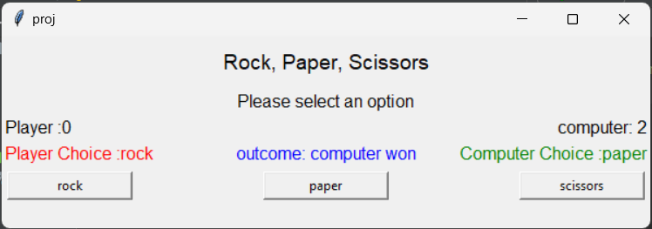

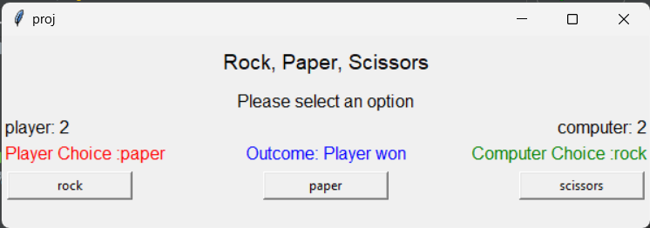

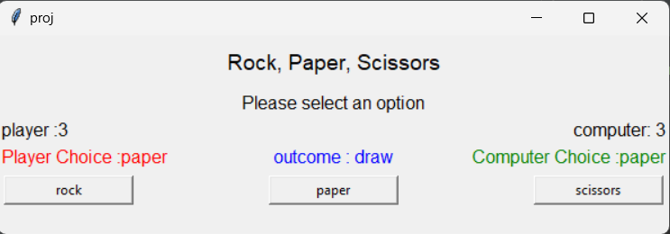

CONCLUSION

The following game was coded and was executed successfully by getting the desired output screen. This shows the game in a separate tkinter page and the scores of the player and computer.