MINI PROJECT REPORT

ON

MAZE SOLVER USING
BACKTRACKING IN HASKELL

Submitted by
R.Dharini
NC.SC.U4CSE24151

Submitted to
Mrs Supriya C M
AP/CSE

For
23CSE212- Principles of functional Language
IV Semester
B.Tech. CSE

School of Computing
Amrita Vishwa Vidyapeetham, Nagercoil
Index

Sl.No. | Chapter Name | Page No.
 | Abstract | 3
 | Introduction | 3
 | Literature Review / Background Study | 3
 | Problem Statement | 3
 | System Requirements | 4
 | System Design | 4
 | Implementation | 4-6
 | Results and Output | 6,7
 | Discussion and Analysis | 7
 | Applications and Future Scope | 7
 | Conclusion | 7,8
 | References | 8
 | GitHub link of the project | 8

1. ABSTRACT
This project implements a maze solver in Haskell using recursion and backtracking. The maze is represented as a grid of numbers, where 0 denotes an open path and 1 denotes a wall. The program accepts maze size and grid input at runtime, then attempts to find a path from the start (0,0) to the end (n-1, n-1). If a valid path exists, it prints the sequence of coordinates; otherwise, it reports “No path found.” This project demonstrates functional programming concepts such as immutability, recursion, and pattern matching.

2. INTRODUCTION
Maze solving is a classical computer science problem that demonstrates pathfinding and search algorithms. In this project, the maze is represented as a two-dimensional list. The solver uses recursion to explore possible moves and backtracking to undo invalid paths. Implementing this in Haskell highlights the strengths of functional programming in handling recursive algorithms and immutable data structures.

3. LITERATURE REVIEW / BACKGROUND STUDY
Maze solving algorithms such as Depth-First Search (DFS), Breadth-First Search (BFS), and backtracking are widely studied in artificial intelligence. Backtracking is particularly suited for functional languages like Haskell, as it naturally fits recursive problem solving. Previous studies show that maze solvers are effective demonstrations of search algorithms and functional programming paradigms.

4. PROBLEM STATEMENT
The challenge is to design a program that can represent a maze, accept user input, validate moves, and determine whether a path exists from the start to the exit. The solution must be interactive, efficient, and implemented using functional programming principles in Haskell.

5. SYSTEM REQUIREMENTS
- Software: GHC (Glasgow Haskell Compiler), GHCi interactive environment
- Hardware: Standard PC/Laptop with keyboard input
- OS: Ubuntu/Linux or Windows

6. SYSTEM DESIGN
- Maze Representation: List of lists ([[Int]])
- Player Position: Tuple (x,y) coordinates
- Functions:
  - valid → checks if a move is inside the maze and not a wall
  - solve → recursive backtracking function to find path
  - readRow → reads one row of maze input
  - readMaze → reads full maze from user
- Algorithm Flow:
  - Read maze size and grid input.
  - Start at (0,0).
  - Try moves in four directions (up, down, left, right).
  - If move is valid → recurse.
  - If dead end → backtrack.
  - If exit reached → print path.

7. IMPLEMENTATION
Code File: mazesolverbacktrack.hs
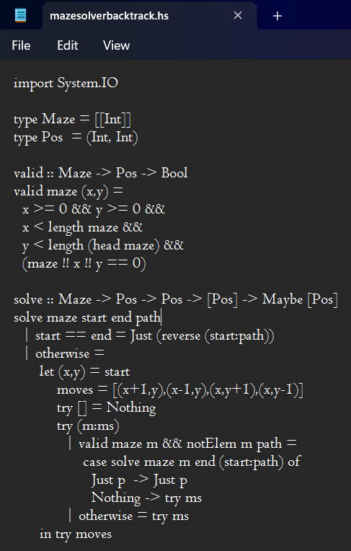

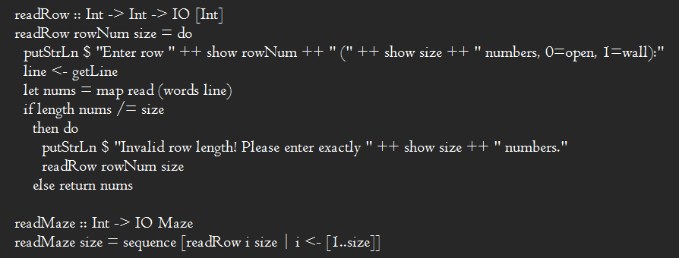
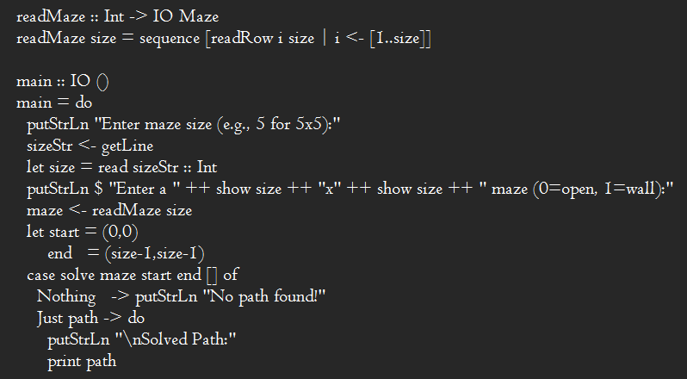

8. RESULTS & OUTPUT
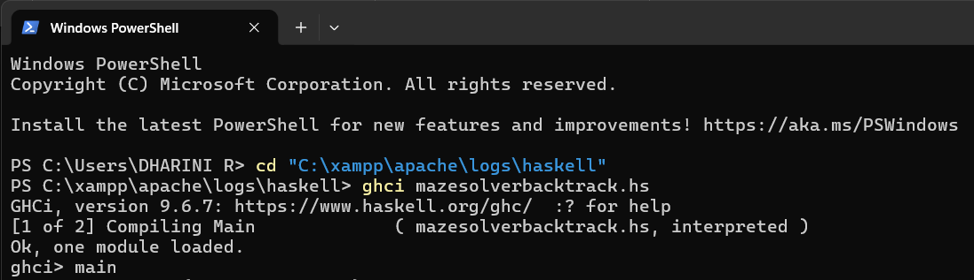
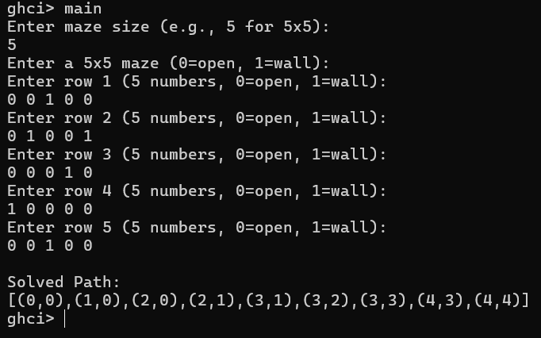

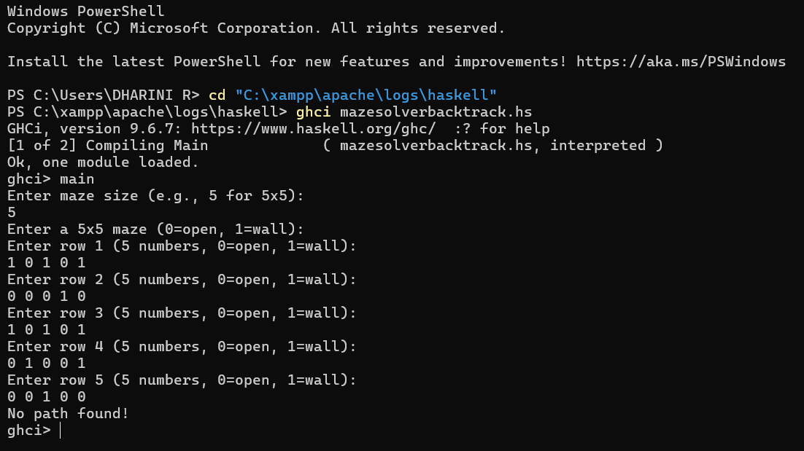

9. DISCUSSION & ANALYSIS
The project successfully demonstrates recursion and backtracking in Haskell. The interactive design allows flexible maze input, and the solver correctly identifies whether a path exists. Limitations include fixed start (0,0) and end (n-1,n-1) positions. Future improvements could include user-defined start/end points, larger maze sizes, or automatic path visualization.

10. APPLICATIONS & FUTURE SCOPE
- Teaching recursion and backtracking concepts
- Demonstrating functional programming in Haskell
- Extending to AI pathfinding algorithms (DFS, BFS, A*)
- Maze-based games or puzzle applications

11. CONCLUSION
The Maze Solver project in Haskell demonstrates how recursion and backtracking can be applied to solve classical pathfinding problems. It highlights functional programming strengths such as immutability, recursion, and pattern matching, while providing an interactive learning experience.

12. REFERENCES
- Graham Hutton, Programming in Haskell, Cambridge University Press, 2nd Edition, 2016.
- Bryan O’Sullivan, John Goerzen, Don Stewart, Real World Haskell, O’Reilly Media, 2008.
- Haskell Documentation – https://www.haskell.org/documentation
- GeeksforGeeks, “Backtracking Algorithm in Maze Solving,” https://www.geeksforgeeks.org

13. GITHUB LINK
https://github.com/DHARINIRAJSEKAR/Pfl-maze-solver.git

