Final Project Report
TITLE
1. INTRODUCTION
A cataract is a chronic eye disease that results in a gradually clouding lens, causing vision to become fuzzy, particularly for distant objects and at night. If left untreated, it can lead to complete blindness. Although surgery is an effective treatment, timely and accurate diagnosis remains a challenge in many parts of the world, especially in rural and underserved areas where access to ophthalmic care is limited.
One of the major breakthroughs in medical imaging has been the use of artificial intelligence (AI) and deep learning. This technology is already being applied successfully in screening retinal scans for diseases such as diabetic retinopathy and glaucoma [1][2]. The same approach is now being explored for cataract detection, offering the possibility of automated diagnosis even in the absence of ophthalmologists [3][4].
The focus of this study is to develop an automatic cataract detection system using deep learning techniques applied to ophthalmic images. The objective is to classify each image into one of two categories: “normal” or “cataract-affected.” The process involves image preprocessing, data augmentation, model training, and performance evaluation.
We began by developing a custom Convolutional Neural Network (CNN) trained on contrast-enhanced grayscale images, which served as the baseline model. We then applied transfer learning using three powerful pre-trained models: ResNet50, EfficientNetB0, and DenseNet121 fine-tuning them on the same dataset. Their performances were evaluated based on accuracy, precision, recall, and AUC to allow direct comparison [1][4][5].
Given the global rise in preventable blindness, the need for reliable and accessible AI-based screening tools is more urgent than ever. An automated system that can accurately detect cataracts has the potential to significantly improve early diagnosis, particularly in areas lacking specialized medical personnel.
2. METHODOLOGY
2.1. Dataset Preparation
The dataset used for this study was obtained from [Kaggle Cataract Dataset]. It consisted of two balanced classes: images of normal eyes and cataract-affected eyes. The dataset was pre-organized into folders based on labels, allowing for direct use in supervised learning tasks.
For training and evaluation, the dataset was split into three subsets:
- 75% for training,
- 15% for validation,
- 10% for testing.
The training and validation sets were created using a stratified random split to preserve class balance. The test set was manually separated before training began and remained untouched throughout the development process to ensure an unbiased final evaluation.
Each image was labeled according to its class; either normal or cataract. These labels were used to train supervised classification models. The dataset was designed to be balanced between the two categories to prevent bias during training.
2.2. Image Preprocessing
To prepare the images for model input, several preprocessing steps were applied:
- Resizing: All images were resized to a fixed resolution of 224×224 pixels to ensure uniformity across the dataset and compatibility with deep learning models.
- Grayscale Conversion: For the baseline custom model, images were converted to grayscale. This reduced computational complexity and allowed the model to focus on structural patterns within the eye.
- Contrast Enhancement: Histogram equalization was applied to the grayscale images. This technique improves image contrast, helping highlight key features such as lens opacity that are indicative of cataracts.
- Normalization: Pixel values were scaled to a range between 0 and 1. This normalization process stabilized training and improved convergence by preventing extremely high or low values from skewing the learning process.
- RGB Conversion for Pretrained Models: For models that were pre-trained on natural RGB images (such as ResNet, EfficientNet, and DenseNet), the grayscale images were adapted to RGB format to meet input requirements. This involved duplicating the grayscale channel across the red, green, and blue channels.
2.3. Data Augmentation
To improve generalization and prevent overfitting, the training data was artificially expanded through augmentation. Each image underwent multiple random transformations, including:
- Rotations
- Horizontal flips
- Scaling (zoom in/out)
- Shearing (diagonal distortion)
- Translations (shifts in position)

These transformations simulated real-world variability in image capture such as eye angle, lighting differences, and positioning enabling the models to learn more robust features.
Each original training image was used to generate four additional augmented images. This significantly increased the dataset size and diversity, improving the model's ability to perform well on previously unseen data.
2.4. Image Counts (After Augmentation):
After augmentation, the final image counts were as follows:
- Training set: 1,571 images
- Validation set: 393 images
- Test set: 121 images

Data augmentation was applied only to the training set, expanding each image through random transformations (rotation, flipping, scaling, etc.). This increased dataset diversity and helped improve model generalization without affecting evaluation fairness.

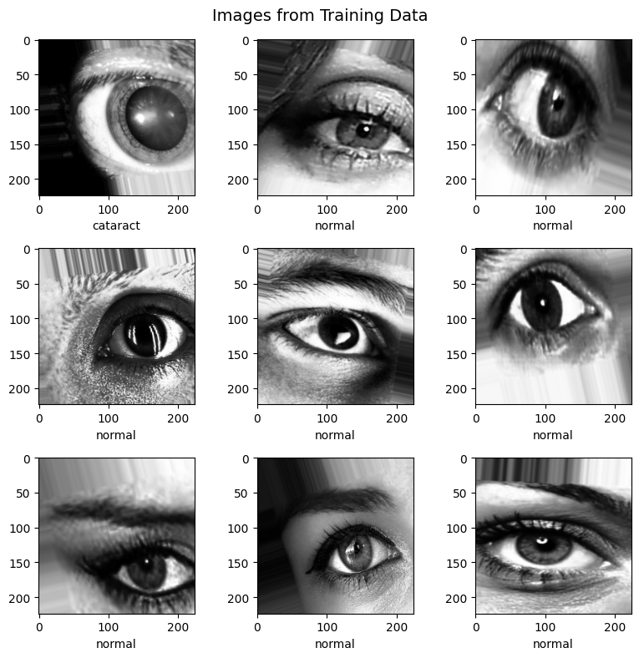
Figure 1. Sample Images for Cataract Detection after Image Augmentation
2.5. Model Development
To evaluate different modeling approaches for cataract detection, four deep learning architectures were developed and trained in this study. These included a custom-built Convolutional Neural Network (CNN) and three transfer learning models—ResNet50, EfficientNetB0, and DenseNet121. Each model was designed to classify eye images as either normal or cataract-affected, with performance evaluated using standardized metrics.
2.5.1. Custom Convolutional Neural Network (CNN)
A custom Convolutional Neural Network (CNN) was built from scratch to serve as a baseline model. The architecture consisted of three convolutional blocks, each containing a Conv2D layer followed by batch normalization, ReLU activation, and max pooling. The number of filters increased from 32 → 64 → 128 across the blocks, using 3×3 kernels with 'same' padding. After the final pooling layer, the feature maps were flattened and passed through a fully connected dense layer with 128 units and ReLU activation, followed by a dropout layer (rate: 0.5) to prevent overfitting. The output layer was a single sigmoid-activated neuron for binary classification.
The model was trained on contrast-enhanced grayscale images and benefited from reduced computational load compared to the RGB models. Despite its simplicity, it achieved competitive results, validating the importance of effective preprocessing and lightweight design in medical imaging applications [1].
2.5.2. ResNet50
ResNet50 is a deep convolutional neural network consisting of 50 layers. It uses a technique called skip connections, where outputs from earlier layers are directly added to outputs of deeper layers. This design allows the model to learn residuals and improves the flow of gradients during training, making it easier to train very deep networks without performance degradation [2].
For this study, a ResNet50 model pre-trained on the ImageNet dataset was used. During the first phase of training, the base convolutional layers were frozen, and new classification layers were added on top. These included a global average pooling layer, a dropout layer with a dropout rate of 50 percent, and a dense output layer with sigmoid activation for binary classification. In the second phase, the entire network was unfrozen and fine-tuned using a lower learning rate to better adapt the model to the cataract detection task.
The model was trained on RGB versions of the eye images, which were converted from grayscale to match ResNet50's input requirements. Although ResNet50 is a widely used and powerful architecture, its performance in this study was lower than expected, indicating the importance of task-specific fine-tuning and hyperparameter optimization in transfer learning applications [3].
2.5.3. EfficientNetB0
EfficientNetB0 is a highly efficient convolutional neural network that uses a compound scaling method to simultaneously scale the model's depth, width, and resolution in a balanced way. It achieves high performance with significantly fewer parameters compared to traditional models [4].
A pre-trained EfficientNetB0 model (ImageNet weights) was used and adapted using a two-phase training approach. Initially, the base layers were frozen while new classification layers: Global Average Pooling 2D, dropout (0.5), and a sigmoid-activated dense layer were trained. Later, the entire model was fine-tuned to adapt its representations to cataract features.
The model was trained on RGB-transformed versions of the dataset. EfficientNetB0 was especially appealing due to its low memory footprint, fast training time, and high performance, making it suitable for deployment in real-time or mobile settings without significant sacrifice in accuracy [4].
2.5.4. DenseNet121
DenseNet121 is a deep convolutional network that introduces dense connectivity, where each layer receives input from all preceding layers. This improves gradient flow, encourages feature reuse, and reduces the total number of parameters required [5].
A pre-trained DenseNet121 model (with ImageNet weights) was used and adapted through the same two-stage training strategy: freezing the base layers initially and then fine-tuning the entire model after training the added classification head. The classification head included a Global Average Pooling 2D layer, dropout (0.5), and a sigmoid-activated output layer for binary prediction.
RGB versions of the eye images were used as input to match the pre-trained network’s expected format. DenseNet121 delivered the highest performance among all models in this study, demonstrating strong generalization capability and superior feature extraction in the context of medical image classification [5].
2.6. Training and Evaluation
All models were trained using supervised learning on the augmented training dataset. For the transfer learning models (ResNet50, EfficientNetB0, DenseNet121), training was conducted in two phases:
- Feature Extraction Phase: The base layers of the pre-trained models were frozen, and only the top classification layers were trained.
- Fine-Tuning Phase: The entire model was unfrozen and trained at a reduced learning rate for better adaptation to the cataract detection task.
All models used binary cross-entropy loss, the Adam optimizer, and early stopping (with patience set to 5 epochs), and were trained for up to 25 epochs.
Model performance was evaluated using a hold-out test set. Evaluation metrics included:
- Accuracy – the proportion of correct predictions.
- AUC (Area Under the Curve) – how well the model separates classes regardless of threshold.
- Precision – the percentage of positive predictions that are positive.
- Recall – the percentage of actual positives correctly predicted.
- F1-score – harmonic mean of precision and recall.
- Loss – a measure of the model’s confidence in predictions.
- Confusion Matrix – a tabular view of correct and incorrect predictions.
2.7. Cataract Detection Pipeline

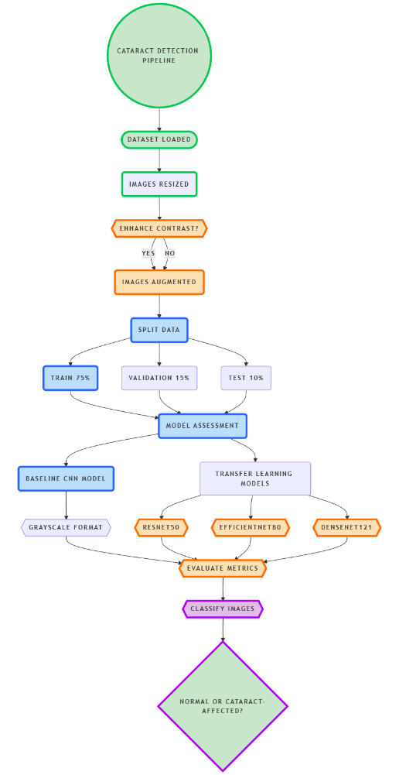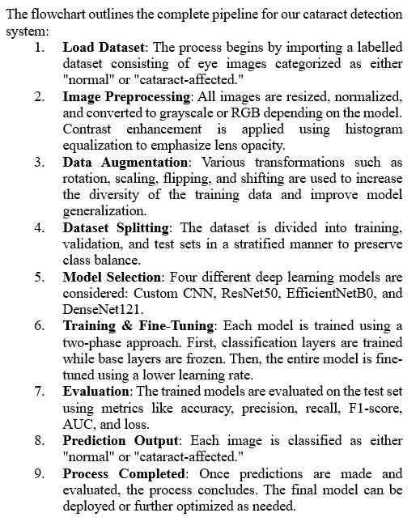
Figure 2. Flow Diagram of Cataract Detection Pipeline
3. MODEL ARCHITECTURES
In this project, four different model architectures were implemented and evaluated for cataract detection. The models vary in complexity and design philosophy from a lightweight custom-built CNN to deep and densely connected transfer learning models. This section explains the structure, design intent, and functionality of each model.
3.1. Custom Convolutional Neural Network (CNN)
This baseline model was designed from scratch and trained on pre-processed grayscale images. Its architecture is relatively shallow compared to the transfer learning models but is optimized for efficient feature extraction and classification.
Input shape: (7224, 224, 1) grayscale image
Architecture Overview:
Layer Type | Parameters | Purpose
Input Layer | (224, 224, 1) | Accepts pre-processed grayscale image
Conv2D | 32 filters, 3×3 kernel, ReLU, padding='same' | Extracts low-level features like edges and textures
Batch Normalization | - | Stabilizes and accelerates training
Max Pooling 2D | Pool size: 2×2 | Reduces spatial dimensions
Conv2D | 64 filters, 3×3 kernel, ReLU, padding='same' | Extracts mid-level patterns
Batch Normalization | - | Improves convergence and generalization
Max Pooling 2D | Pool size: 2×2 | Further reduces dimensionality
Conv2D | 128 filters, 3×3 kernel, ReLU, padding='same' | Captures high-level semantic features
Batch Normalization | - | Mitigates internal covariate shift
Max Pooling 2D | Pool size: 2×2 | Final spatial reduction before classification
Flatten | - | Converts 2D feature maps to 1D feature vector
Dense Layer | 128 units, ReLU activation | Learns high-level, abstract patterns
Dropout | 50% dropout rate | Prevents overfitting by randomly disabling neurons
Output Layer (Dense) | 1 unit, Sigmoid activation | Outputs probability of cataract
Table 1. Custom Convolutional Neural Network Model Architecture
Why this architecture?
This architecture was chosen because it is simple and efficient, making it well-suited for small-scale medical datasets where overfitting can be a concern. It serves as an effective baseline for evaluating the performance of more complex models, helping to establish a point of reference. Additionally, it performs well with contrast-enhanced grayscale images, which are commonly used in medical imaging tasks, making it a practical and reliable starting point for this study.
3.2. ResNet50 (Transfer Learning)
ResNet50 is a 50-layer deep convolutional neural network with residual connections. These skip connections solve the vanishing gradient problem and allow the training of very deep networks.
Input shape: (224, 224, 3) RGB image
Architecture Overview (Top Layers Only):
Layer Type | Description
Base Model (ResNet50) | Pretrained on ImageNet; convolutional body frozen during initial training
Global Average Pooling 2D | Reduces 7×7×2048 feature maps to 2048-dim vector
Dropout | 50% dropout to reduce overfitting
Dense Layer (Output) | 1 unit, Sigmoid activation
Table 2. ResNet50 Model Architecture
Training Strategy:
- First phase: Only train the top layers, keeping the ResNet base frozen
- Second phase: Unfreeze and fine-tune the entire model at a lower learning rate
Why ResNet50?
ResNet50 was selected for its deep architecture, which enables the model to capture complex and abstract features essential for accurate image classification. The use of residual connections addresses the vanishing gradient problem, allowing for faster convergence and improved generalization, especially in deep networks. Moreover, ResNet50 has demonstrated strong and consistent performance in various medical image analysis tasks, making it a reliable choice for this application.
3.3. EfficientNetB0 (Transfer Learning)
EfficientNetB0 is a modern, lightweight CNN architecture that scales depth, width, and resolution using a compound coefficient. It achieves excellent performance with fewer parameters compared to traditional networks.
Input shape: (224, 224, 3)
Architecture Overview (Top Layers Only):
Layer Type | Description
Base Model (EfficientNetB0) | Pretrained on ImageNet; frozen initially
Global Average Pooling 2D | Compresses feature maps into a single vector
Dropout | 50% dropout rate
Dense Layer (Output) | 1 unit, Sigmoid activation
Table 3. EfficientNetB0 Model Architecture
Training Strategy:
- Initial training with frozen layers
- Followed by full fine-tuning to adapt the entire model to cataract-specific patterns
Why EfficientNetB0?
EfficientNetB0 was chosen for its excellent performance-to-size ratio, making it highly efficient without compromising accuracy. Its lightweight architecture is ideal for real-time and embedded applications, such as deployment on mobile or edge devices. Despite its compact size, EfficientNetB0 consistently delivers high AUC and accuracy, while requiring relatively low training time, making it a strong candidate for medical imaging tasks where computational resources and time may be limited.
3.4. DenseNet121 (Transfer Learning)
DenseNet121 introduces dense connectivity where each layer receives input from all previous layers. This design improves feature propagation and reduces the number of parameters.
Input shape: (224, 224, 3)
Architecture Overview (Top Layers Only):
Layer Type | Description
Base Model (DenseNet121) | Pretrained convolutional body, initially frozen
Global Average Pooling 2D | Converts feature maps to a flat vector
Dropout | 50% dropout for regularization
Dense Layer (Output) | 1 unit, Sigmoid activation
Table 4. DenseNet121 Model Architecture
Training Strategy:
- Followed same two-phase fine-tuning approach
- Slightly heavier than EfficientNetB0 but achieved high accuracy
Why DenseNet121?
DenseNet121 was selected for its ability to promote feature reuse through dense connections, leading to a more compact and efficient model. Its excellent depth-to-parameter efficiency allows it to achieve strong performance without an excessive number of parameters. This architecture also demonstrates robust generalization on medical imagery, making it well-suited for tasks like disease detection where subtle patterns must be accurately identified.
📊 Model Comparison Summary
Model | Input Type | # Trainable Parameters | Strengths
Custom CNN | Grayscale | ~1 million | Simple, interpretable, fast to train
ResNet50 | RGB | ~25 million | Deep, strong baseline, robust performance
EfficientNetB0 | RGB | ~5 million | Efficient, top accuracy, mobile-ready
DenseNet121 | RGB | ~8 million | Compact, powerful, high generalization
Table 5. Cataract Detection Model Architecture Comparison
Each model was trained using binary cross-entropy loss and evaluated with metrics such as accuracy, precision, recall, F1-score, and AUC to ensure fair and reliable comparison.
4. EXPERIMENT AND EVALUATION
4.1. Custom CNN (Baseline – Grayscale)
Experiment Setup
  - Input: Grayscale eye images (224×224×1)
  - Architecture: Three convolutional blocks with batch normalization and max pooling, followed by a fully connected layer with dropout and a final sigmoid output.
  - Data: Augmented training data (4x expansion), stratified validation split
  - Training: 25 epochs with early stopping

Evaluation Results
- Accuracy: 85.95%
- AUC: 0.9287
- Loss: 0.4836
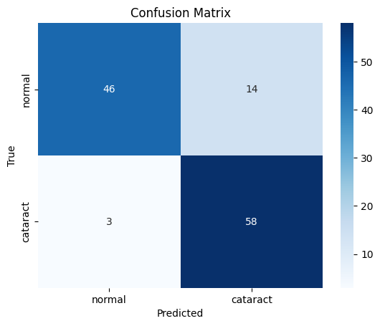
Figure 3. Confusion Matrix of Custom Convolutional Neural Network Model
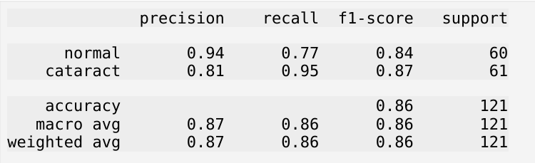
Figure 4. Classification Report of Custom Convolutional Neural Network Model
Insights
The custom CNN achieved a solid baseline with an accuracy of 85.95%, an AUC of 0.9287, and a moderate loss of 0.4836, indicating reliable class separation but some uncertainty in predictions. The confusion matrix showed that the model had higher recall for cataract (0.95) than normal cases (0.77), making it valuable for minimizing false negatives in screening. However, precision for cataract (0.81) was lower than for normal images (0.94), reflecting some misclassification of healthy eyes as cataract-affected.
The F1-scores were balanced: 0.84 for normal and 0.87 for cataract, confirming the model's consistent performance. The grayscale-based preprocessing with contrast enhancement allowed the network to detect structural features like lens opacity effectively. Overall, the custom CNN demonstrated that even a lightweight model can be viable for medical screening in low-resource environments, especially when early detection is a priority.
4.2. ResNet50 (Transfer Learning)
Experiment Setup
- Input: RGB images (converted from grayscale)
- Architecture: Pretrained ResNet50 (frozen base), followed by global average pooling, dropout, and a sigmoid classification head
- Fine-tuning: Top layers trained first, then base model unfrozen with lower learning rate
Evaluation Results
- Accuracy: 83.47%
- AUC: 0.8984
- Loss: 0.4365
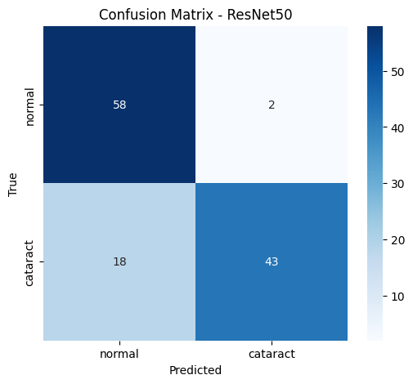
Figure 5. Confusion Matrix of ResNet50 Model
Insights
ResNet50 reached an accuracy of 83.47%, AUC of 0.8984, and loss of 0.4365, making it the lowest-performing model overall. The confusion matrix suggested the model struggled more with correctly identifying cataract cases, showing a high number of false negatives. Although it performed reasonably well on normal images, its generalization was limited.
Despite being a deep architecture with residual connections, its transfer from ImageNet did not translate effectively to cataract detection, likely due to the domain shift from natural RGB images to medical grayscale images adapted into RGB. ResNet50 would benefit from further tuning and domain-specific augmentation. Its performance underlines that deeper is not always better—especially without fine-tuning for medical context.
4.3. EfficientNetB0 (Transfer Learning)
Experiment Setup
- Input: RGB images (repeated channels)
- Architecture: EfficientNetB0 pretrained on ImageNet, followed by pooling, dropout, and a sigmoid classifier
- Training: Same two-phase strategy as ResNet50
Evaluation Results
- Accuracy: 95.04%
- AUC: 0.9919
- Loss: 0.1416
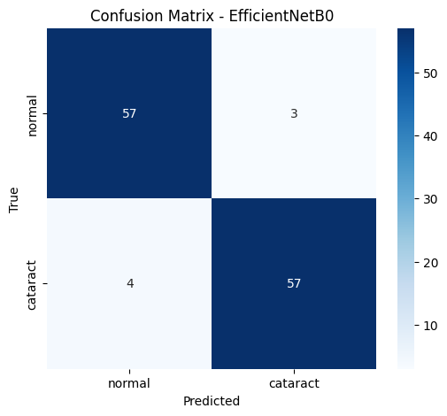
Figure 6. Confusion Matrix of EfficientNetB0 Model
Insights
EfficientNetB0 demonstrated strong and consistent performance, with an accuracy of 95.04%, an AUC of 0.9919, and a low loss of 0.1416. The confusion matrix confirmed that the model balanced prediction between both classes with minimal errors, showing nearly equal counts of true positives and true negatives.
Its compact architecture and efficient scaling allowed it to generalize well with fewer parameters and less training time. The model’s reliability, speed, and compatibility with mobile deployment make it a strong candidate for real-world applications. EfficientNetB0 is particularly suited for portable screening tools in under-resourced clinical settings.

4.4. DenseNet121 (Transfer Learning)
Experiment Setup
- Input: RGB images (converted from grayscale)
- Architecture: DenseNet121 with dense block connectivity, followed by pooling, dropout, and sigmoid output
- Training: Two-stage training with early stopping
Evaluation Results
- Accuracy: 97.52%
- AUC: 0.9981
- Loss: 0.0557
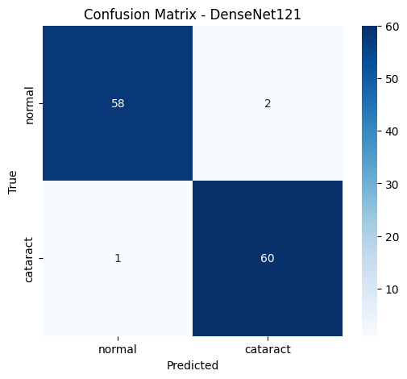
Figure 7. Confusion Matrix of DenseNet121 Model
Insights
DenseNet121 was the top-performing model, achieving an accuracy of 97.52%, an AUC of 0.9981, and an impressively low loss of 0.0557. The confusion matrix showed almost perfect classification, with very few false positives or false negatives across both classes.
The dense connectivity structure enabled superior feature reuse and stable gradient flow, making this model highly reliable in detecting even subtle signs of cataract. Its performance indicates excellent generalization and suitability for diagnostic tools requiring high accuracy. DenseNet121 stands out as the most dependable model for deployment in medical environments demanding precision and low error margins.
Summary of Results
Model | Accuracy | AUC | Loss | Remarks
Custom CNN | 85.95% | 0.9287 | 0.4836 | Strong baseline; efficient grayscale model
ResNet50 | 83.47% | 0.8984 | 0.4365 | Underperformed; requires better tuning
EfficientNetB0 | 95.04% | 0.9919 | 0.1416 | Excellent results with low computation cost
DenseNet121 | 97.52% | 0.9981 | 0.0557 | Best overall; highly accurate and reliable
Table 6. Results of the Four Models used to Detect Cataract in the eye
- DenseNet121 emerged as the top-performing model, achieving the highest accuracy and AUC. Its ability to reuse features through dense connectivity made it particularly effective for detecting subtle patterns in medical images.
- The Custom CNN, despite being built from scratch and trained on grayscale images, delivered surprisingly competitive results. This highlights the value of solid preprocessing and efficient architecture design, especially in resource-constrained environments.
- ResNet50 underperformed relative to expectations. While it is a powerful architecture, this outcome underscores that transfer learning is not inherently effective without proper fine-tuning and optimization.
- EfficientNetB0 performed well overall, achieving high accuracy and AUC, and demonstrating strong generalization. Its compact size and consistent results make it well-suited for deployment.

5. CONCLUSION
This project successfully demonstrates the potential of deep learning, particularly convolutional and transfer learning models, in the early detection of cataracts through medical imaging. By designing, training, and comparing multiple neural network architectures, we developed a system that performs with high accuracy and shows practical applicability in both clinical and resource-constrained environments.
Our custom CNN, trained on grayscale images, achieved 85.95% accuracy and an AUC of 0.9287, demonstrating that careful preprocessing and data augmentation can lead to effective performance even without color information or pretrained features. This baseline model served as a valuable foundation for evaluating more advanced architectures.
Among the transfer learning models, DenseNet121 achieved the highest performance with a test accuracy of 97.52% and an AUC of 0.9981, making it the most reliable and accurate model in the experiment. EfficientNetB0 followed closely with 95.04% accuracy and 0.9919 AUC, balancing efficiency with excellent predictive power ideal for deployment in mobile or embedded systems. ResNet50, while still capable, showed lower performance, highlighting the importance of fine-tuning and architecture compatibility with the dataset.
These findings reinforce the viability of AI-powered cataract screening tools in improving access to early diagnosis, especially in underserved areas. By integrating such systems into low-cost devices or community health workflows, we can support earlier referrals, reduce preventable blindness, and expand the reach of ophthalmic care worldwide.

6. FUTURE ENHANCEMENTS
Future enhancements could focus on expanding the model to detect additional eye conditions such as glaucoma or diabetic retinopathy, enabling more comprehensive screening. A larger and more diverse dataset is essential, as testing revealed both false negatives in low-light conditions and false positives due to light reflections on the eye being misclassified as cataracts. This highlights the model’s sensitivity to lighting and the need for varied image conditions during training.
Integrating explainable AI tools like Grad-CAM would make predictions more transparent to clinicians by highlighting key regions influencing the decision, thereby building trust. Deploying a lightweight version of the model on mobile or embedded devices could greatly improve accessibility in rural or resource-limited areas.
Additionally, testing the model with real-world clinical data and collaborating with ophthalmologists would be vital to ensure practical reliability. A user-friendly interface could also be developed to make the system more accessible to non-specialists in clinical settings.

7. REFERENCES
[1] Gao, W., Shao, L., Li, F., Dong, L., Zhang, C., Deng, Z., Qin, P., Wei, W., & Ma, L. (2024). Fundus photograph-based cataract evaluation network using deep learning. Frontiers in Physics, 11, 1235856. Fundus photograph-based cataract evaluation network using deep learning
[2] Mienye, I. D., Swart, T. G., Obaido, G., Jordan, M., & Ilono, P. (2025). Deep convolutional neural networks in medical image analysis: A review. Information, 16(3), 195. Deep convolutional neural networks in medical image analysis: A review
[3] Khan, I., Akbar, W., Soomro, A., Hussain, T., Khalil, I., Khan, M. N., & Salam, A. (2024). Enhancing ocular health precision: Cataract detection using fundus images and ResNet-50. IECE Transactions on Intelligent Systematics. Enhancing Ocular Health Precision: Cataract Detection Using Fundus Images and ResNet-50

[4] Ibrahim, A., Sabara, E., Dirsam, W., & Aziz, F. (2024). Optimizing cataract detection in fundus images through EfficientNet-based classification. Journal of Medical Informatics Technology, 2(1), 1–5. Optimising Cataract Detection in Fundus Images through EfficientNet-Based Classification

[5] Çetiner, H., & Çetiner, İ. (2022). Classification of cataract disease with a DenseNet201 based deep learning model. Journal of the Institute of Science and Technology, 12(3), 1264–1276. Classification of cataract disease with a DenseNet201 based deep learning model

